Advanced Predictive Modelling for Customer Churn in Banking: A Comparative Analysis of Machine Learning and Deep Learning Techniques

Duc Le

Final Thesis Report

November 2025

Table of Contents
ABSTRACT 4
List of Tables 5
List of Figures 5
List of Appendices 5
CHAPTER 1 INTRODUCTION 6
1.1. Background and Problem Statement of the Study 6
1.2. Aims and Objectives 8
1.3. Research Questions 9
1.4. Scope Of The Study 10
1.5. Significance Of The Study 10
1.6. Structure Of The Study 11
CHAPTER 2 LITERATURE REVIEW 12
2.1. Introduction 12
2.2. Systematic Review Protocol 13
2.3. Machine-Learning Models for Churn Prediction 14
2.4. Deep-Learning Approaches to Churn Prediction 18
2.5. Imbalanced Learning and Data-Level Techniques 21
2.6. Hyperparameter optimization for Churn Models 23
2.7. Feature Engineering and Representation 25
2.8. Explainable AI and SHAP in Churn Modelling 28
2.9. Evaluation Metrics and Probability Calibration 31
2.10. Synthesis and Identified Research Gaps 32
2.11. Summary 33
CHAPTER 3 RESEARCH METHODOLOGY 34
3.1. Introduction 34
3.2. Methodology 35
3.3. Tools and resources used 53
3.4. Summary 54
CHAPTER 4 DATA ANALYSIS 54
4.1. Introduction 54
4.2. Dataset Overview 54
4.3. Target Variable and Class Distribution 57
4.4. Correlation and Feature Relationships 58
4.5. Feature Engineering and Derived Attributes 59
4.6. Outlier and Data Quality Checks 60
4.7. Summary 60
CHAPTER 5 IMPLEMENTATION 61
5.1. Introduction 61
5.2. Train–Test Split 61
5.3. Data Leakage Control and Preprocessing Strategy 62
5.4. Class-Imbalance Treatment with SMOTE 62
5.5. Baseline Model Training 63
5.6. Hyperparameter Optimization (HPO) 66
5.7. Evaluation Metrics Analysis 71
5.8. Statistical Significance Testing of Model Performance 73
5.9. Model Selection 75
5.10. Summary 76
CHAPTER 6 RESULTS AND DISCUSSION 77
6.1. Introduction 77
6.2. Comparative Performance Patterns 77
6.3. Behavior of Machine-Learning Models 78
6.4. Deep-Learning Models 80
6.5. Feature-Level Insights via SHAP 81
6.6. Business Impact Analysis 85
6.7. Implications for Banking Practice 87
6.8. Summary 88
CHAPTER 7 CONCLUSION AND STRATEGIC RECOMMENDATIONS 88
7.1. Introduction 88
7.2. Revisiting Research Objectives 88
7.3. Key Findings 90
7.4. Contributions to Knowledge and Practice 91
7.5. Strategic Recommendations 92
7.6. Limitations 93
7.7. Future Research Directions 93
7.8. Summary 94
REFERENCES 95
APPENDIX 99

ABSTRACT
For retail banks that want to stay competitive, reduce client attrition, and encourage proactive customer involvement, the ability to predict customer churn has become an essential analytical capability. Extensive research has been done on machine learning (ML) and deep learning (DL) techniques, but much of it lacks rigorous comparative evaluations, systematic feature engineering, or interpretable modeling. They are all important for using these techniques in regulated financial environments. This thesis presents a comprehensive churn-prediction system that integrates sophisticated machine learning and deep learning models, rigorous preprocessing, hyperparameter optimization, and SHAP-based interpretability.
The research employs a systematic experimental framework to assess four machine learning algorithms, which are Logistic Regression, Decision Tree, Random Forest, and XGBoost, together with two deep learning architectures: a multi-layer Artificial Neural Network (ANN) and a Deep Neural Network (DNN). Thirty technical features were created to show how customers act, how happy they are, their financial statistics, and how they interact with the company. Stratified sampling and SMOTE were used to address class imbalance, but SMOTE was applied only during cross-validation to prevent leakage. Three hyperparameter optimization approaches were applied to the ML models: Grid Search, Random Search, and Optuna Bayesian optimization. Batch normalization, dropout, and early stopping were used to optimize the DL models. Models were evaluated across accuracy, F1 score, recall, ROC-AUC, and training efficiency.
The results demonstrate that the DNN had the best predictive performance, especially in recall and F1. This shows that it can detect complex patterns of behavior. On the other hand, Logistic Regression, especially after tuning with the Random Search method, struck the best balance between accuracy, ease of understanding, and computational speed. This made it the best choice for daily production use, while DNN might be ideal for periodic use. SHAP research provided clear explanations of the main reasons for turnover, including complaints, satisfaction levels, transaction frequency, and signs of financial stress.
The thesis provides a solid benchmarking framework, a flexible feature-engineering technique, and tools that make it easy to understand the results. The results suggest an operational architecture in which Logistic Regression serves as the deployable model, supplemented by a DNN as a periodic diagnostic benchmark, enabling banks to implement analytically robust, business-aligned churn management methods.

List of Tables
Table 1: Objectives and Research Questions alignment 8
Table 2: Literature Summary of Machine Learning Approaches 14
Table 3: Literature Summary of Deep Learning Approaches 18
Table 4: Literature Summary of Imbalance Handling 21
Table 5: Literature Summary of Hyperparameter optimization 23
Table 6: Literature Summary of Feature Engineering 25
Table 7: Literature Summary of Interpretability Analysis 28
Table 8: Literature Summary of Evaluation Strategies 31
Table 9: Comparison of Missing Data Imputation Methods 37
Table 10: Comparison of Encoding Methods 38
Table 11: Comparison of Class Imbalance Treatment Techniques 40
Table 12: Model performance comparison 44
Table 13: Comparison of Hyperparameter optimization Approaches for Machine Learning Models 46
Table 14: Runtime Benchmarking Protocol for Execution Time 50
Table 15: Evaluation Metrics and Statistical Significance using Cross Validation 51
Table 16: Pearson correlations between selected features and churn label. 58
Table 17: Churn vs Non-Churn distribution before and after stratified splitting. 61
Table 18: Summary of preprocessing operations and leakage control policy. 62
Table 19: Baseline model results before tuning 65
Table 20: Hyperparameter optimization summary for tuned ML models. 67
Table 21: Baseline vs tuned performance (rows: model × method; columns: metrics including time) 71
Table 22: Base scenario of business impact analysis 86
Table 23: Result of HPO uplifting from baseline models 89

List of Figures
Figure 1: Research Methodology Workflow 35
Figure 2 - Example of Standardization scaling 40
Figure 3 - Demonstration of stratified k-Fold Cross-Validation 43
Figure 4: Confusion matrix 48
Figure 5: Workflow of Statistical Significance Test 52
Figure 6: Class distribution of churn vs non-churn customers showing moderate imbalance 57
Figure 7: Confusion Matrices for All Candidate Models 72
Figure 8: SHAP Summary Plot 82
Figure 9: Mean |SHAP| feature importance for the Logistic Regression (Random Search) model 84
Figure 10: Monte Carlo simulation 86

List of Appendices
Appendix A: Dataset Structure and Description 99
Appendix B: Proposed Engineered Features 100

CHAPTER 1
INTRODUCTION

Background and Problem Statement of the Study
In the banking industry, customer churn, the behavior by which clients terminate their relationship with a bank, remains one of the most pressing strategic challenges. New customer acquisition cost is approximately five to seven times more expensive than retaining existing ones; thus, even a small retention increase can result in substantial bottom-line improvements (Bhuria et al., 2025; Singh, H. et al., 2024). Churn has several impacts. Besides its direct impact on revenue from deposits, lending, and fee-based services, it has two additional indirect losses. It is a long-term loss due to the loss of cross-selling opportunities. The other is the loss of brand loyalty (AbdelAziz et al., 2025; Abbas et al., 2023).
Nowadays, due to the rise of fintech rivals, neo-banks, and technology-driven service models, the competitive intensity in retail and digital banking has increased sharply. Technological innovation has enabled low barriers to entry through mobile and digital banking, allowing customers to compare and switch to alternative banks in real time (Murindanyi et al., 2025). Therefore, high-value customer retention is no longer a simple marketing function, but it requires cooperation across functions. The recent customer retention strategy usually includes analytics, operations, and strategic planning (Advances in Economics, Management & Political Sciences, 2024).
While banking has its own structural drivers of churn, similar experiences are observed in other industries. In telecommunications, because of high competition and low switching barriers, various churn prediction models ranging from logistic regression to advanced ensemble methods have been comprehensively developed and demonstrated strong performance (Boozary, 2025). Similarly, churn prediction models, based on purchase frequency, browsing behavior, and promotional response patterns, are also well implemented in e-commerce to detect high risk of platform leaving. Those models that are trained using gradient boosting and deep neural network algorithms have shown particularly strong recall (Ahmed et al., 2023).
There is clear proof saying that despite the domain differences, the methodological challenges such as class imbalance, feature selection, and the trade-off between interpretability and accuracy are remarkably consistent. These shared analytical challenges have powered the search for more sophisticated and generalizable predictive frameworks that can be applied across multiple industries, including banking.
Predictive analytics has become an essential competence for modern retention planning in other industries. At an early stage, traditional statistical models such as logistic regression were used for churn prediction in banking. They were good for their interpretability, yet their ability to capture complex non-linear behaviors was very limited (AbdelAziz et al., 2025; Patel, S., et al., 2024). Thanks to the rapid evolution of machine learning (ML), ensemble methods such as random forests and gradient boosting have been introduced. They leverage multiple base learners to improve accuracy and generalization (Singh, P., et al., 2025). These models have demonstrated competitive performance in banking datasets, as well as in related sectors like telecommunications and e-commerce (Boozary, 2025). Nevertheless, when feature relations are highly complex or when predictive signals are embedded in high-dimensional, noisy, or heterogeneous data, a limitation, even the most advanced ML ensembles can struggle. Hence, deep learning has emerged as a powerful approach.
More recently, deep learning (DL) approaches have expanded the analytical capabilities by enabling the automatic extraction of complex feature interactions from high-dimensional data. Architectures such as artificial neural networks (ANNs) and deep neural networks (DNNs) have achieved notable improvements in recall and F1-score, especially when combined with appropriate feature scaling and optimization (Domingos, Ojeme & Daramola, 2021). Hybrid models that integrate convolutional neural networks (CNNs) with recurrent structures like bidirectional long short-term memory (BiLSTM) have further demonstrated strong performance in identifying subtle churn signals (Ahmed et al., 2023; Zhang et al., 2024). In comparative experiments, Singh et al., (2023) and Adamu et al., (2025) report that DL can outperform gradient boosting methods under certain configurations, albeit with a higher computational cost.
Although deep learning (DL) performance is impressive, its practical application in banking remains considerably low due to two main reasons. DL models usually consume significant computational resources, require longer training times, and are inherently less interpretable than traditional ML (Basit et al., 2024). Especially, this interpretability challenge is becoming increasingly significant in regulated environments, where explainable AI (XAI) is becoming a compliance expectation (Tékouabou, 2022; Ma et al., 2022). By integrating interpretability techniques such as SHAP values into churn models, a few papers such as Li, X., et al. (2025) and Singh, A., et al. (2024) address this gap between predictive accuracy and regulatory transparency.
Class imbalance, where churn customers make up only a small proportion of the total customer base, is another repeated challenge in churn prediction. During training, models may become biased toward the majority class, thereby reducing the ability to detect true churners, even when overall accuracy appears high. A range of techniques have been proposed to address this, including synthetic minority over-sampling (SMOTE), adaptive synthetic sampling (ADASYN), and more recently, generative adversarial network (GAN)-based oversampling (Adiputra, Wanchai & Lin, 2025). In addition, cost-sensitive learning approaches, where misclassifications of churners incur higher penalties, have been shown to improve recall and business impact in ensemble models (Bhuria et al., 2025; Abubakar et al., 2024).
Hyperparameter tuning plays a critical role in maximizing the potential of both ML and DL models. Although traditional methods such as grid search and random search are still common, they may be inefficient for complex models with large parameter spaces. Optuna, a more advanced framework, has been introduced to restructure the search process, applying pruning strategies to terminate underperforming trials early (Domingos, Ojeme & Daramola, 2021; Patel et al., 2023). As highlighted by Marmion et al. (2012) and Molnar (2020), model interpretability is considered together with hyperparameter tuning strategies to ensure that tuning does not compromise transparency.
Despite extensive prior work, there are few gaps remain. First, although both ML and DL have been used for churn prediction in banking, there is a lack of direct head-to-head comparisons conducted under identical experimental setups (AbdelAziz et al., 2025; Basit et al., 2024). Second, execution time is usually underestimated and so frequently overlooked as a performance metric regardless of its significance for real-time inference systems (Singh, P., et al., 2025). Third, there is only a limited amount of empirical evidence evaluating the effect of preprocessing, imbalance handling, and hyperparameter optimization combination on model performance in the banking sector (Adiputra, Wanchai & Lin, 2025; Patel et al., 2023).
By combining three actions at once, this thesis seeks to narrow these gaps. First, it evaluates both ML and DL algorithms on a public banking churn dataset. Second, it applies sophisticated sampling approaches and rigorous hyperparameter tuning. Lastly, the paper also comprehensively evaluates predictive performance and operational efficiency. The first goal of this paper is to assist practitioners in model selection that balances performance, interpretability, and deployment feasibility. Another goal is to contribute to an academic understanding of predictive modeling in financial services.

Aims and Objectives

Aims:
This paper’s primary purpose is to carefully evaluate advanced predictive models for customer attrition in the banking sector, using both traditional machine learning algorithms and deep learning architectures. By conducting a methodical comparative analysis, the study aims to identify more effective solutions in terms of predictive performance, computational efficiency, and interpretability, thereby offering actionable insights for improving customer retention strategies.

Objectives:
- To review existing literature on churn prediction and identify practical gaps, particularly in comparing machine learning and deep learning algorithms in banking.
- To implement and evaluate machine learning and deep learning models on a common banking dataset. The performance is evaluated across multiple metrics.
- To analyze the trade-off between predictive performance and execution time, as well as the impact of preprocessing and class-imbalance treatments on the model.
- To assess the effectiveness of different hyperparameter tuning methods in enhancing both machine learning and deep learning models and derive useful insights for deployment in banking sectors.
- To explain the difficulty in predictive models to typical executives.

The table below summarizes the alignment between the objectives and research questions.

Table 1: Objectives and Research Questions alignment
Objectives | Research questions
Review literature & identify gaps (ML vs DL in banking churn). | How do ML and DL models compare in predicting banking churn across metrics?
Implement ML & DL models and benchmark across metrics. | How does predictive performance trade off with execution time in real-time deployment?
Investigate performance-execution time trade-off & preprocessing impact. | How do preprocessing and imbalance-handling techniques influence model performance?
Evaluate hyperparameter optimization strategies for ML & DL. | How do different hyperparameter optimization strategies perform across ML and DL models?
Explain the predictive model to business people. | How does interpretability analysis bring more understanding to stakeholders?

Research Questions
This research is guided by four central questions derived from both literature gaps and the operational needs of banking institutions.
First, it presents a head-to-head comparison of how selected machine learning and deep learning models perform in churn prediction in banking sector under a reliable experimental basis. Despite there are few papers that evaluate these models individually (AbdelAziz et al., 2025; Singh, H., et al., 2024; Adamu et al., 2025), few offer direct comparative analysis within the same data and processing conditions.
Second, the essential requirement of go-to-market churn prediction in a real-time retention system in banking sector is that computational execution time must be quick. Although execution time is a crucial factor, it is usually underestimated compared to predictive performance, according to Singh, P., et al. (2025). This paper investigates the trade-off between those two factors and re-evaluates the role of ensemble methods.
Third, it studies how class imbalance handling approaches and feature engineering affect churn prediction performance in the banking industry. It is believed that those techniques have a considerable impact on recall and F1-score (Adiputra, Wanchai & Lin, 2025; Tékouabou, 2022; Adiputra, Wanchai & Lin, 2025).
Besides class imbalance handling method, hyperparameter tuning can extensively increase predictive accuracy, yet it is rarely assessed across model families within a unified experimental setting (Domingos, Ojeme & Daramola, 2021; Patel et al., 2023). The next question investigates the usefulness of different hyperparameter tuning methods for both ML and DL models.
Despite how well predictive models perform, they are still nonsensical to business stakeholders if they don’t understand them. The final question addresses how interpretability analysis helps to gain trust from entrepreneurs.
In short, this research addresses:
- How machine learning and deep learning models perform in churn prediction across multiple performance metrics, particularly in the banking industry.
- How predictive performance trades off with execution time for real-time deployment.
- How preprocessing and imbalance-handling techniques influence model performance.
- How different hyperparameter optimization strategies perform across ML and DL models.
- How interpretability analysis brings more understanding to stakeholders.

Scope Of The Study

Inclusions:
- Analysis is limited to the provided Kaggle banking churn dataset, consisting of over 5,000 customer records with demographic, behavioral, and account-related attributes.
- Models evaluated will be confined to the specified machine learning and deep learning algorithms. The list of algorithms is described in more detail in the methodology section.
- Evaluation will be conducted using six metrics: accuracy, precision, recall, F1-score, AUC, and execution time. Those metrics and selection rationale are cautiously explained in the methodology section.
- Machine learning hyperparameter tuning will be performed using Grid Search, Random Search, and Optuna. Deep learning hyperparameters will be set using prior study setups.

Exclusions:
- Real-time data streaming architectures and machine learning ops for continuous integration/continuous development (CI/CD).
- Customer churn prediction in non-banking domains.
- Other deep learning architectures such as convolutional or recurrent networks are not part of this study, because of computational constraints.
- Full hyperparameter tuning for deep learning model is excluded from this study. While machine learning models are properly tuned, deep learning models are using previous literature configurations. It may reflect a conscious trade-off between fairness, computational feasibility and scope.

Significance Of The Study
This study offers banks and financial institutions an analytical recommendation on the proper predictive model application for customer retention planning. Even though predictive analytics has certain reputation in customer retention actions, it is scarce to see a head-to-head comparison of machine learning and deep learning techniques on banking specific datasets (AbdelAziz et al., 2025; Singh, H., et al., 2024). Given that absence of comparison research, banking customer retention strategies are often determined by outcome from many different settings, which may not reflect standard behaviors specific to the financial services sector.
As discussed earlier in background sections, there are some gaps between previous literature and expectation. This study seeks to narrow those gaps. First, it brings both machine learning and deep learning model under identical experimental settings, which is same datasets for the same industry. Second, it also evaluates those algorithms in term of predictive performance which are accuracy, precision, recall, F1-score, AUC and execution time. Those metrics are carefully discussed in methodology section. Execution time is often underestimated in model section studies. It is carefully evaluated in this paper, because it is essentially efficiency for real-time retention systems, where milliseconds may result in wrong decision making (Singh, P., et al., 2025).
According to prior works, by integrating modern imbalance treatment and hyperparameter tuning can remarkably increase model sensitivity to churn (Ali, M., et al. 2024, Imran et al. 2023, and Bhuria et al. 2025). Hence, this study tries to apply this concept across several machine learning and deep learning in banking specific dataset. This study aims to provide practical guidance data science teams aiming to optimize returns on analytics investments.
In banking sectors, banking practitioners are often cautious and may distrust models they cannot understand. Hence, this paper also aims to discuss explainable AI (XAI), which is said that it may help to increase interpretability. According to Li, X., et al. (2025), Singh, A., et al. (2024), and Ma et al. (2022), the interpretability frameworks promises that study findings are interpreted in such a way that ordinary people may understand the underlying rationale.
This work enhances academic knowledge and industrial practice by providing a validated and replicable methodology for predicting turnover in banking. The insights will assist decision-makers in choosing models that perform well in offline evaluations while meeting the operational, regulatory, and strategic requirements of live banking environments. This puts predictive analytics as an essential facilitator of sustainable customer relationship management amid increased competition and digital change.

Structure Of The Study
This dissertation is divided into seven chapters to provide a logical and methodical examination of churn prediction model in banking industry. The dissertation cover a complete analytical workflow, which are conceptual foundations to methodological implementation, experimental evaluation, and managerial interpretation.
- Chapter 1 - Introduction: This chapter outlines the background, research problem, aims, objectives, research questions, and significance of the study. It also discusses the rationale for examining machine learning and deep learning approaches to churn prediction in a retail banking context.
- Chapter 2 - Literature Review: The literature review collects and analyses previous academic work on churn prediction in banking industry. It conducts a systematic review protocol from search strategy, inclusion and exclusion criteria and quality assessment. All academic papers not only cover churn prediction in banking, but they also cover other industries. In addition, the chapter explains some previous works using both machine learning and deep learning algorithms, preprocessing techniques, class imbalance handling, and model interpretability. It highlights certain gaps in current research and provides justification for the methodological choices adopted in this thesis.
- Chapter 3 - Research Methodology: This chapter explains the research methodology applied in this dissertation. The methodology covers dataset preprocessing, feature engineering, train-test split, model development, hyperparameter optimization strategies and evaluation metrics. For each topics, this chapter also give detail explanation and selection rationale.
- Chapter 4 - Data Analysis: This chapter analyzes the dataset in detail, including exploratory and statistical analysis. It describe the class distribution, variable correlations and creates new features. The data analysis process ensures data quality and readiness for further model implementation.
- Chapter 5 - Implementation: The entire research methodology discussed in chapter 3 is executed within this chapter. This chapter also explains how to prevent data leakage in case of cross validation and imbalance data handling. In conducts baseline model training, then hyperparameter tuning, tuned model development and generation of evaluation artefacts.
- Chapter 6 - Results and Discussion: The chapter interprets results from previous chapter, compares ML and DL models, analyses performance trade-offs, examines misclassification behavior, and explain insights from SHAP analysis. The implications of the results are evaluated in relation to the research questions.
- Chapter 7 - Conclusion and Strategic Recommendations: The final chapter revisits the research objectives and provides analytical results for each objectives. It summarizes key findings, outlines some recommendations for those who is seeking practices in churn prediction in banking industry. Within the entire study, there are some limitations which is also discussed and highlight some idea for future research.
Combining all sevens chapters, the study hopes to form a structured and comprehensive analysis into advanced predictive modelling for customer churn in banking.

CHAPTER 2
LITERATURE REVIEW

Introduction
Due to the high cost of new customer acquisition cost relative to retaining existing ones, customer churn prediction has been a significant application of predictive analytics not only in banking industry but also other industries (Tharwat, 2018). The literature now covers a wide range of modelling paradigms, from classical machine-learning (ML) algorithms such as logistic regression (LR) and random forests (RF) to advanced deep-learning (DL) architectures, including convolutional neural networks (CNN), recurrent neural networks (RNN), gated recurrent units (GRU), and hybrid CNN–BiLSTM models (Ahmed et al., 2023; Basit et al., 2024; Zhang et al., 2024). Simultaneously, there has been increasing attention to class-imbalance remediation, hyperparameter optimization (HPO), feature engineering, and explainable AI (XAI) techniques such as SHAP and LIME (Goudjil et al., 2023; Patel et al., 2023; Li et al., 2025; Ma et al., 2022; Khan et al., 2025).
Despite considerable improvements, recent systematic evaluations highlight that evidence continues to be disjointed across many domains (telecommunications, e-commerce, insurance, banking) and approaches (ML versus DL; manual versus automated HPO; simple resampling versus GAN-based hybrid sampling). There is currently not enough strong comparison evidence on the trade-offs between performance, computational efficiency, and interpretability in banking churn prediction (AbdelAziz et al., 2025; Singh et al., 2024; Abbas et al., 2023; Adamu et al., 2025). Simultaneously, authorities are demanding more transparent and auditable models in the financial services sector, which is driving the incorporation of XAI into high-performing churn pipelines (Tékouabou, 2022; Li et al., 2025; Murindanyi and Nagwovuma et al., 2025; Molnar, 2020).

This chapter delivers a thorough evaluation of the literature related to churn prediction in the banking sector. It implements a systematic literature review (SLR) protocol to guarantee transparency in study identification and selection. Then, it groups all previous papers into five main themes:
- ML models for churn;
- DL architectures;
- imbalanced learning and data-level techniques;
- hyperparameter optimization strategies;
- interpretability and XAI for churn.
The chapter ends by pointing out gaps that still need to be filled and putting the current thesis in this context.

Systematic Review Protocol

Search strategy
A structured search was conducted across Scopus, Web of Science, IEEE Xplore, ScienceDirect, SpringerLink, ACM Digital Library, and Google Scholar. The search focused on the period 2010–2025, with particular emphasis on recent work (2020 onwards). Representative query templates included:
- "customer churn" AND (bank OR "retail banking" OR "digital banking") AND ("machine learning" OR "deep learning")
- "customer churn prediction" AND ("SMOTE" OR "class imbalance" OR "oversampling")
- "customer churn" AND ("hyperparameter optimization" OR "Optuna" OR "Bayesian optimization" OR "grid search")
- "customer churn" AND ("SHAP" OR \"explainable AI\" OR XAI OR \"interpretable machine learning\")
These searches were increased by backward and forward, increasing from key references, including systematic surveys on churn analysis and interpretability (Shahabikargar et al., 2025; Imani et al., 2025; Molnar, 2020)

Inclusion and exclusion criteria
Studies were included if they:
- Concentrated and discussed churn customer prediction as a main objective.
- Implemented supervised ML or DL models where the predictive performance was clearly explained.
- Described at least one evaluation metric, including accuracy, F1, ROC-AUC, recall, or computational resources.
- Used data from banking or quite similar consumer domains (e.g., telecoms, insurance, subscription services) where lessons might be applied to other sectors.
- Were peer-reviewed papers or theses in English that were published in journals or conferences.
Studies were excluded if they:
- Focused entirely on marketing strategy or conceptual churn frameworks and lacking predictive modelling.
- Used "churn" as a metaphorical meaning, like when employees leave their jobs, instead of when customers leave.
- Didn’t describe the methodology details enough to fully understand the data preprocessing, model development, and evaluation processes.
The first quick browsing of titles and abstracts found more than 150 papers. After a full-text review against the inclusion criteria and quality checks, about 50 core papers were kept. This collection included approximately thirty papers from the original research proposal, along with a larger collection of recent and foundational publications, especially in XAI and imbalanced learning.

Quality assessment and synthesis approach
The included studies were assessed qualitatively along five dimensions:
- Data transparency (dataset size, domain, feature types, imbalance ratio).
- Preprocessing rigor (handling of missing values, feature encoding, train–test or cross-validation protocol, data leakage control).
- Model scope (breadth of ML/DL architectures evaluated).
- Imbalanced-learning strategy (e.g., SMOTE, GAN-based sampling, cost-sensitive learning).
- Interpretability and governance (XAI methods, alignment with domain knowledge).
Synthesis followed a thematic analytic approach, grouping studies into coherent clusters: classical ML, deep learning, imbalance handling, HPO, and explainability. Those coherent clusters are presented in the next seven sub-sections along with seven literature summary tables. Although one literature only appears once in a summary table, it may appear more than once across seven tables, as it may discuss more than one topic. This structure supports direct alignment with the objectives and research questions of the present thesis.

Machine-Learning Models for Churn Prediction

Table 2: Literature Summary of Machine Learning Approaches
Problem | Methodology | Dataset used | Interpretation | Citation
Low accuracy and overfitting in simple decision trees | Logistic Regression (LR), Decision Trees (DT) | Real banking churn dataset | LR provides transparent coefficients and is robust but underperforms ensemble models; DTs are intuitive yet prone to overfitting without pruning or regularization. | Abbas et al. (2023)
Selecting effective ML baselines for bank churn | LR, DT, Random Forest (RF), Gradient Boosting (GB) | Real banking dataset | Tree-based ensembles (RF, GB) achieve higher accuracy and ROC–AUC than linear baselines, but LR remains attractive for interpretability. | Abbas et al. (2023)
Benchmarking ML vs DL for churn | RF, XGBoost, LR vs ANN, CNN, LSTM | Multiple churn datasets (telecom, banking, subscription) | DL models outperform ML on large, complex datasets; however, tuned RF/XGBoost remain competitive on medium-sized structured churn data, with lower complexity. | AbdelAziz et al. (2025)
Model selection for operational bank churn systems | RF, XGBoost, CatBoost, ANN | Real banking churn dataset | Gradient boosting (especially CatBoost) achieves the best ROC–AUC and accuracy; RF and XGBoost are strong baselines, while ANN underperforms tree ensembles on strictly tabular bank data. | Singh H. et al. (2024)
Improving prediction stability and generalization | RF, XGBoost in soft voting and stacking configurations | Banking dataset | Voting and stacking ensembles reduce variance across folds, improve generalization, and yield more stable performance than single learners. | Singh P. et al. (2025)
Cross-industry robustness of ML churn models | RF, Gradient Boosting, stacking ensembles | Mixed banking–retail customer datasets | Boosting-based ensembles generalize well across sectors, consistently delivering higher accuracy and F1 than single models; they are preferred when heterogeneous behavioral features are present. | Boozary (2025)
ML framework for community banks | RF, XGBoost, AdaBoost, Bagging, LR, SVM | U.S. community bank dataset | Ensemble models (RF, XGBoost, AdaBoost, Bagging) outperform simpler classifiers on F1 and ROC–AUC; the study provides a modular ML framework for bank churn deployment. | Patel S. et al. (2024)
Churn prediction in low-resource banking environments | LR, RF | Regional Bangladeshi bank dataset | RF improves accuracy and recall by ~4% over LR while remaining computationally affordable, making it suitable for resource-constrained institutions. | Bank Customer Churn Prediction with ML Methods (2024)
Integrated sampling and ML for credit churn | RF, XGBoost, LightGBM, LR with sampling | Bank credit customer dataset (demographics, utilization, repayment history) | Hybrid sampling plus ensembles achieves high accuracy (~89%) and improved minority recall; credit utilization and transaction frequency are key churn predictors. | Li et al. (2025a)
Modelling bank credit churn with interpretability | LightGBM, RF, XGBoost + SHAP | Credit-card churn dataset | Gradient-boosted models achieve strong predictive performance; SHAP-based feature importance reveals that credit utilization and late payment frequency drive churn behavior. | Li et al. (2025b)
ML model comparison for bank churn | RF, Gradient Boosting, LR | Real banking dataset | Gradient Boosting achieves highest ROC–AUC; LR remains the most interpretable, supporting a trade-off between accuracy and transparency in operational settings. | Abbas et al. (2023)
Modular ML pipeline for different bank contexts | RF, XGBoost, AdaBoost, SVM, Bagging within reusable framework | U.S. community bank dataset | A unified pipeline combining preprocessing, sampling and ensemble selection provides a reusable template for churn modelling across banks. | Patel S. et al. (2024)

Classical ML in telecommunications and cross-domain insights
Classical machine learning algorithms such as LR, decision trees (DT), RF, gradient boosting (GB), support vector machines (SVM), and k-nearest neighbors (KNN) continue to be the most extensively used approaches in early churn research, particularly in telephony. Comparative studies repeatedly show that tree-based ensembles (RF, gradient boosting, XGBoost, LightGBM, and CatBoost) outperform linear or single-tree baselines (De Caigny et al., 2020; Patel et al., 2023; Marmion et al., 2012).
Patel et al. (2023) perform a detailed analysis on a telecom churn dataset, merging SMOTE with Optuna-based HPO using eight algorithms: LR, DT, SVM, RF, ANN, XGBoost, LightGBM, and CatBoost. Gradient-boosted models, particularly XGBoost and LightGBM, have the highest F1 and ROC-AUC when sampling and hyperparameters are tuned together. The authors demonstrate gains of up to 15% in recall and 10% in F1 when compared to untuned, imbalanced baselines, emphasizing the relevance of integrated imbalance treatment and tuning.
Ahmed et al. (2023) offer a CNN-BiLSTM architecture for telco churn and show that the hybrid deep model improves accuracy by 4-7 percentage points compared to the LR, DT, RF, and SVM baselines. Although the focus is on deep learning, the experimental design demonstrates that classical models give a solid performance standard that must be exceeded rather than presumed to be inferior a priori.
These telecom and cross-domain studies show that:
- Tree-based ensembles are consistently strong baselines.
- Combining SMOTE with systematic tuning substantially improves minority-class detection, and
- high-performing ML models often lack dedicated interpretability frameworks, especially for regulated domains.

Machine learning for banking churn
A growing body of work addresses churn in banking and credit specifically. Abbas et al. (2023) investigate bank churn using real transactional and demographic data, comparing RF, gradient boosting, SVM, and LR. After feature engineering and SMOTE-based balancing, gradient boosting and RF achieve approximately 85% accuracy and strong ROC-AUC, although LR remains more interpretable but less accurate. Similar patterns are reported by Singh et al. (2024), who apply RF, XGBoost, CatBoost, and ANN to a banking dataset and find that CatBoost delivers the highest ROC-AUC due to its efficient handling of categorical variables.
Patel et al. (2024) propose a modular ML framework for bank churn prediction using ten classifiers and multiple sampling methods. Ensemble models (RF, XGBoost, AdaBoost, Bagging) again dominate in F1 and ROC-AUC, particularly when combined with appropriate resampling (e.g., SMOTE, random under-sampling). Ashraf (2024) and related studies reach similar conclusions in different regional banking contexts, reinforcing ensemble superiority for structured tabular data.
Within credit churn, Li et al. (2025) integrate SMOTE, gradient-boosted ensembles, and SHAP-based interpretability for bank-credit customers, reporting approximately 89% accuracy and strong recall. Transaction frequency and credit utilization emerge as dominant predictors, aligning with domain intuition. Collectively, these banking ML studies indicate that:
- Tree-based ensembles (XGBoost, LightGBM, CatBoost, RF) form the current state-of-practice benchmark for structured churn data.
- Careful preprocessing (encoding, scaling, outlier handling) and imbalance treatment are critical to achieving robust performance.
- Interpretability is increasingly recognized as necessary but is often addressed only through feature-importance plots rather than systematic XAI.

Deep-Learning Approaches to Churn Prediction

Table 3: Literature Summary of Deep Learning Approaches
Problem | Methodology | Dataset used | Interpretation | Citation
Lack of guidance on DL hyperparameters for bank churn | Fully connected Deep Neural Network (DNN) with varied activations, optimizers, batch sizes | Proprietary banking churn dataset (13 features) | The activation function, optimizer and batch size materially affect performance; ReLU + Adam yields the best recall and F1, highlighting the need for systematic HPO rather than relying on default settings. | Amal et al. (2023)
Comparing ML and DL architectures for churn | ANN, CNN, LSTM vs RF, XGBoost | Multiple churn datasets (telecom, banking, subscription) | DL can outperform ML on large, high-dimensional or temporal data, but tuned ensembles remain competitive on medium-sized, structured churn datasets; there is no universally dominant class of models. | AbdelAziz et al. (2025)
Composite DL for sequential churn signals | CNN + BiLSTM composite model | Public telecom churn dataset (demographic + usage sequences) | CNN–BiLSTM achieves ~81% accuracy, surpassing LR, DT, RF by 4–7%; combining spatial feature extraction and bidirectional temporal modelling improves recall on churners. | Ahmed et al. (2023)
Hyperparameter-tuned DL for banking churn | Deep ANN/DNN with grid/Bayesian tuning | Public banking churn dataset (Kaggle) | Hyperparameter-tuned DNN with oversampling (ISMOTE) reaches nearly 98% accuracy, significantly outperforming ML baselines; tuning is crucial to unlock DL’s potential. | Adamu et al. (2025)
Comparative DL architectures in banking | CNN, LSTM, GRU, hybrid DL models | Proprietary banking churn dataset | GRU achieves the best recall and F1, CNN slightly higher precision, and LSTM balanced performance but higher training cost; architecture choice should reflect trade-offs between recall and efficiency. | Basit et al. (2024)
Deep learning architectures for bank churn | ANN, CNN, RNN, DNN, LSTM | Mid-sized banking dataset | DNN and LSTM outperform shallow ANN and RNN in recall and F1, indicating the advantage of depth and temporal modelling for complex churn patterns. | Kumar et al. (2025)
DL vs ML on real banking data | Feedforward ANN vs RF, XGBoost, CatBoost | Real bank churn dataset | Tree-based ensembles often outperform ANN on purely tabular data; DL benefits are limited when there is no explicit temporal or sequential structure. | Singh H. et al. (2024)
Time-series modelling for financial behavior | LSTM networks vs ARIMA, MLP | Stock market (S&P500) price time series | LSTMs capture long-term temporal dependencies better than traditional models, motivating their use for sequential transaction and activity features in churn modelling. | Sezer et al. (2018)
DL with embedded feature selection | GRU network with BMDOA-based feature selection | Proprietary banking churn dataset | Integrating feature selection reduces dimensionality by ~30% and improves accuracy and recall by 4–6%; feature selection is beneficial even for high-capacity DL models. | Ali S. et al. (2025)
Hybrid CNN–attention–BiLSTM architecture | CCP-Net (CNN + self-attention + BiLSTM) | Telco, banking, insurance churn datasets | CCP-Net achieves ~92% precision on banking data and outperforms standalone CNN or LSTM; self-attention effectively models cross-feature interactions at the cost of higher complexity. | Zhang et al. (2024)

Fully connected and recurrent architectures in banking
Deep neural networks (DNNs) have been proposed to capture complex, non-linear relationships in banking data. Goudjil et al. (2023) and Amal et al. (2023) perform an experimental analysis of hyperparameters for DNNs applied to banking churn. Their findings show that combinations such as ReLU activation with the Adam optimizer, tuned batch sizes, and epochs can improve accuracy and F1 by 5–10 percentage points over untuned networks. However, these studies focus almost exclusively on DL without comparing against strong tree-based baselines, limiting conclusions on relative superiority.
Adamu et al. (2025) use a hyperparameter-tuned MLP with ISMOTE oversampling on a Kaggle banking dataset and report accuracy approaching 98%, substantially outperforming KNN and RF baselines. Kumar et al. (2025) compare multiple deep architectures (ANN, CNN, RNN, DNN, LSTM) and find that a deep feedforward network achieves the highest recall (~91%), highlighting the potential of well-configured DNNs to capture non-linear churn patterns. However, both studies devote little attention to interpretability and report limited information on computational costs.
Basit et al. (2024) specifically compare CNN, LSTM, and GRU architectures on a proprietary banking dataset. GRU achieves the highest recall and F1, while CNN provides slightly higher precision. LSTM yields balanced performance but incurs longer training times. These results suggest that recurrent architectures offer advantages in modelling latent temporal dependencies when sequential transaction features are available.

Hybrid and cross-domain deep architectures
Beyond fully connected and recurrent networks, hybrid deep models combine spatial, temporal, and attention mechanisms. Ahmed et al. (2023) use CNN–BiLSTM for telco churn; Zhang et al. (2024) propose CCP-Net, a hybrid CNN–self-attention–BiLSTM architecture evaluated on telco, banking, and insurance datasets. CCP-Net achieves high precision and recall (e.g., ~92% precision on banking data) and systematically outperforms standalone CNN or LSTM baselines, especially when combined with oversampling (e.g., ADASYN or SMOTE). Nevertheless, this comes at the cost of increased architectural complexity and the absence of XAI.
AbdelAziz et al. (2025) provide one of the most comprehensive cross-domain comparisons of ML and DL for churn. Evaluating LR, RF, XGBoost, CNN, and LSTM across several datasets, they show that DL models (DNN, CNN, LSTM) tend to outperform ML models on large, high-dimensional, or sequential datasets; however, for smaller, moderately sized datasets, tree-based ML models remain competitive or superior, particularly when tuned. These results underscore that the benefits of DL are data and context-dependent, rather than universally dominant.
Collectively, the DL literature indicates that:
- DL architectures can outperform classical ML models on sufficiently large or sequential churn datasets.
- Hybrid CNN–RNN architectures show promise in capturing both static and temporal behavioral patterns.
- Empirical gains over strong tree-based baselines are often modest, especially on moderately sized tabular banking datasets.
- Most DL studies give limited attention to interpretability, runtime constraints, or governance.

Imbalanced Learning and Data-Level Techniques

Table 4: Literature Summary of Imbalance Handling
Problem | Methodology | Dataset used | Interpretation | Citation
Severe minority–class under-representation | SMOTE oversampling with RF, Gradient Boosting, XGBoost | Real banking churn dataset | SMOTE substantially increases recall and F1 for churners, though at risk of synthetic noise; ensembles mitigate some overfitting compared with single trees. | Tékouabou (2022)
Robust churn prediction under extreme imbalance | CostLearnGAN: tabular GAN-based oversampling + cost-sensitive learning | Multiple imbalanced churn datasets including banking, telco, insurance | GAN-based hybrid sampling generates more realistic minority samples than SMOTE; when combined with cost-sensitive learning, it improves recall and reduces misclassification cost with acceptable runtime overhead. | Imran et al. (2023) / Ali M.I. et al. (2024)
Combined sampling and tuning for ML churn | SMOTE + Optuna-tuned LR, DT, SVM, RF, ANN, XGBoost, LightGBM, CatBoost | Public telecom churn dataset (transferable to banking) | Joint use of SMOTE and Optuna yields up to 15% recall and 10% F1 gains over untuned, imbalanced baselines; gradient-boosting models (XGBoost, LightGBM) are strongest under this regime. | Patel et al. (2023)
Banking credit churn under imbalance | SMOTE, Tomek Links, NearMiss with RF, XGBoost, LightGBM, LR | Bank credit customer dataset | Hybrid over- and under-sampling strategies (e.g., SMOTE + Tomek) combined with ensembles achieve the best trade-off between recall and accuracy, substantially improving minority detection. | Li et al. (2025a)
Interpretable bank churn with class imbalance | SMOTE + ensembles with SHAP | Real banking churn dataset | SMOTE-enhanced RF and Gradient Boosting models exhibit up to 20% recall improvement; SHAP confirms intuitive drivers like tenure, balance and transaction activity decline. | Tékouabou (2022)
DL on imbalanced bank churn data | DNN/LSTM with oversampling (ISMOTE) | Public banking churn dataset (Kaggle) | Oversampling combined with DL HPO yields very high accuracy and recall but raises concerns regarding overfitting and the realism of synthetic churn cases. | Adamu et al. (2025)
Ensemble-based bank churn under imbalance | RF, XGBoost, SVM, LR within voting ensemble + resampling | Large banking churn dataset | Soft voting over resampled training data yields higher accuracy and ROC–AUC than individual classifiers; SMOTE-based balancing is key to improving sensitivity to churners. | Singh P. et al. (2025)
Synthetic vs real data imbalance | SMOTE + synthetic banking churn with calibrated probabilities | Synthetic Kaggle-style bank churn dataset | Synthetic data allows controlled testing of imbalance methods; SMOTE and calibration improve both recall and probability reliability but generalizability to real data must be verified. | Abubakar et al. (2024)

Class imbalance is ubiquitous in churn datasets, where non-churners substantially outnumber churners. The Synthetic Minority Over-sampling Technique (SMOTE) remains the most widely used oversampling method (Chawla et al., 2002). SMOTE generates synthetic minority samples in feature space, thereby improving classifier sensitivity to the minority class without simple duplication.
In banking churn, Tékouabou (2022) combines SMOTE with ensemble models (RF, Gradient Boosting, XGBoost) and shows that recall for churners can improve by up to 20 percentage points compared to imbalanced training. Abbas et al. (2023), Patel et al. (2024) and Singh et al. (2024) similarly report substantial gains in recall and F1 when SMOTE or related resampling is applied prior to training, particularly for tree-based ensembles.
More advanced resampling frameworks have been developed. Imran et al. (2023) and Ali et al. (2024) propose CostLearnGAN, a tabular GAN-based hybrid sampling approach combined with cost-sensitive learning. Evaluated across six datasets (including banking), CostLearnGAN improves recall and reduces misclassification cost relative to SMOTE and ADASYN, while maintaining reasonable execution time (Imran et al., 2023). Li et al. (2025) integrate hybrid sampling (SMOTE + Tomek Links, NearMiss) with XGBoost and LightGBM and show that hybrid strategies outperform single-method sampling, especially for credit-customer churn.
Imbalanced-learning toolkits such as imbalanced-learn formalize these methods and provide robust integrations with scikit-learn pipelines (Lemaître et al., 2017). However, several limitations persist in the literature:
- SMOTE and other resampling methods are often applied outside cross-validation, introducing data leakage and optimistic performance estimates.
- Few studies systematically compare multiple imbalance strategies within a unified experimental protocol.
- Execution-time implications of sophisticated resampling (e.g., GAN-based) are rarely quantified.
These gaps motivate designs where oversampling is carefully nested within cross-validation and computational efficiency is measured alongside predictive performance, as adopted in the present thesis.

Hyperparameter optimization for Churn Models

Table 5: Literature Summary of Hyperparameter optimization
Problem | Methodology | Dataset used | Interpretation | Citation
Lack of empirical guidance on DL hyperparameters for bank churn | Grid-search over activation functions, optimizers, batch sizes, epochs | Proprietary banking churn dataset | ReLU with Adam and appropriately tuned batch size leads to 5–10% accuracy improvement over defaults; DL performance is highly sensitive to configuration. | Amal et al. (2023)
Joint treatment of hyperparameters and imbalance in banking DNNs | Systematic variation of activations, optimizers and resampling strategies (SMOTE, under sampling) in DNNs | Real banking churn dataset (10,000 records) | ReLU + Adam + SMOTE combination yields best recall and F1; hyperparameters and imbalance-handling interact non-trivially and must be tuned jointly. | Singh et al. (2023)
Automated HPO for ML churn classification | Optuna-based optimization for LR, DT, SVM, RF, ANN, XGBoost, LightGBM | Public telecom churn dataset | Optuna efficiently explores high-dimensional search spaces, consistently improving F1 across models; gradient-boosted trees benefit most from careful tuning. | Patel et al. (2023)
HPO for DL on public banking churn | Grid search and Bayesian optimization of DNN (layers, neurons, learning rate, dropout) | Public Kaggle banking churn dataset | Hyperparameter-optimized DNN outperforms untuned DNN and classical ML baselines; tuning depth and learning rate is crucial to balance overfitting and generalization. | Adamu et al. (2025)
Comparative ML vs DL with tuned models | Tuned RF, XGBoost, CNN, LSTM with cross-validated HPO | Multiple churn datasets | When both ML and DL are properly tuned, DL dominates on large sequential datasets, whereas tuned RF/XGBoost are preferable for smaller, static, tabular churn datasets. | AbdelAziz et al. (2025)
HPO in DL architectures for bank churn | Tuning GRU-based model with feature selection | Proprietary banking dataset | Coupling feature selection with hyperparameter-tuned GRU improves accuracy and recall while lowering computational overhead compared to naïvely deep networks. | Ali S. et al. (2025)
HPO for deep architectures in tabular churn | Tuning ANN, CNN, RNN, DNN, LSTM (depth, learning rate, batch size) | Mid-sized banking churn dataset | DNN and LSTM achieve best recall after tuning; shallow models are easier to train but underfit complex churn patterns. | Kumar et al. (2025)

Hyperparameter selection substantially influences the performance of both ML and DL models, particularly under class imbalance. Goudjil et al. (2023) systematically vary activation functions (ReLU, sigmoid, tanh), batch sizes, and optimizers (Adam, SGD) for DNNs on a banking dataset and report 5–10% improvements in accuracy and F1 relative to default settings. Singh et al. (2023) extend this approach by jointly examining activation, optimization, and imbalance-handling strategies (SMOTE, random under-sampling, hybrid approaches) for DNNs in banking; ReLU with Adam and SMOTE emerges as the most effective combination.
On the ML side, Patel et al. (2023) employ Optuna, a modern Bayesian/Tree-structured Parzen Estimator (TPE) framework, to tune eight algorithms jointly with SMOTE. XGBoost and LightGBM show the largest gains under HPO, re-affirming the importance of tailored tuning for gradient-boosted trees. AbdelAziz et al. (2025) also tune ML and DL models in their cross-domain comparison, demonstrating that un-tuned DL architectures may underperform tuned tree-based models on moderate datasets.
Several works compare grid search, random search, and Bayesian/HPO frameworks. Random search is shown to achieve comparable or better performance than exhaustive grids at lower computational cost, particularly when many hyperparameters have limited sensitivity (Bergstra and Bengio, 2012; Patel et al., 2023). Bayesian optimization and Optuna-style TPE further improve search efficiency by focusing evaluations on promising regions of the hyperparameter space (Patel et al., 2023; AbdelAziz et al., 2025).
Despite these advances, several shortcomings remain:
- Many studies focus on a single model family (e.g., only DNNs or only XGBoost), making cross-family conclusions difficult.
- Hyperparameter tuning is rarely accompanied by explicit reporting of training time or computational resource usage, although these are crucial for production applications.
- There is little work on quantifying how HPO interacts with imbalanced learning and probability calibration in a unified setting.
The present thesis addresses these gaps by applying grid search, random search and Optuna to four ML models (LR, DT, RF, XGB), explicitly recording F1 and wall-clock training time, and embedding SMOTE within the cross-validation pipeline.

Feature Engineering and Representation

Table 6: Literature Summary of Feature Engineering
Problem | Methodology | Dataset used | Interpretation | Citation
Raw transaction-level data not directly suitable for churn models | Aggregation of transaction logs into customer-level features (e.g., number of transactions, balance movement, digital engagement) | Retail banking dataset with transactional histories | Hand-crafted aggregate features capture behavior intensity and trends, improving ML model performance and interpretability relative to raw logs. | Ma et al. (2022)
Limited utilization of transactional logs for real churn | Feature engineering from transactional logs (e.g., product usage decline, reduced login frequency) + SMOTE | Real retail banking churn dataset | Engineered features reflecting declining activity strongly drive RF/XGBoost performance; SHAP analysis highlights balance drops and product inactivity as dominant churn indicators. | Singh A. et al. (2024)
Under-exploited behavior signals in bank churn | Correlation analysis + Recursive Feature Elimination (RFE) for feature selection | Real banking churn dataset | Feature engineering around balance trends and transaction frequency improves RF and Gradient Boosting; RFE-based selection stabilizes models and focuses on interpretable drivers. | Abbas et al. (2023)
Overly high dimensionality in bank churn features | BMDOA-based feature selection feeding GRU network | Proprietary banking churn dataset | Feature selection removes redundant attributes, reduces model size and training time, and increases accuracy and recall; it also facilitates clearer interpretation of retained predictors. | Ali S. et al. (2025)
High-dimensional behavioral and demographic features | Mutual information–based feature selection + normalization and one-hot encoding | Mixed banking–retail service dataset | Mutual-information-driven feature selection coupled with ensembles improves stability across segments; features related to engagement and loyalty are consistently important. | Boozary (2025)
Minimal but targeted preprocessing for low-resource settings | Imputation, label encoding, min–max scaling | Bangladeshi retail banking dataset | Even basic feature engineering (handling missingness, normalization) allows RF to outperform LR while remaining operationally simple. | Bank Customer Churn Prediction with ML Methods (2024)
Modular bank churn pipeline including FE | Outlier handling, one-hot encoding, normalization, capped extremes | U.S. community bank dataset | Structured pre-processing (outlier capping, robust scaling) improves ensemble performance and prepares data for re-use across multiple models within a framework. | Patel S. et al. (2024)
Transaction- and credit-based features for credit churn | Construction of credit utilization ratios, transaction frequencies, payment delays | Bank credit customer dataset | Engineered financial ratios (e.g., utilization, delay patterns) emerge as key predictors under SHAP analysis, validating domain-informed feature design. | Li et al. (2025a, 2025b)

Feature engineering is consistently identified as a major determinant of churn model performance. Banking churn studies typically combine demographic variables (age, region, marital status), financial indicators (balance, loan amount, credit score, income), behavioral metrics (transaction frequency, recency, product holdings), and engagement features (login frequency, digital-channel usage, complaint history) (Abbas et al., 2023; Li et al., 2025; Singh et al., 2024; Basit et al., 2024).
Several works emphasize derived or second-order features, such as balance change rates, ratio features (e.g., balance-to-income, loan-to-income), complaint rates, and recency/frequency summaries. Adamu et al. (2025) and Kumar et al. (2025) both show that DL models benefit substantially from normalized, engineered features, even when the architectures themselves are capable of non-linear representation learning.
Ali et al. (2025) introduce a bio-inspired metaheuristic feature selection (BMDOA) combined with a GRU-based network for banking churn. Feature dimensionality is reduced by around 30% while improving accuracy and F1 by 4–6%, indicating that appropriate feature selection can both reduce complexity and enhance generalization. Tilburg University’s study on interpretable ML for retail banking churn supports this view, showing that engineered behavioral features (transaction volume, digital inactivity, product holdings) dominate ML feature importance and align with expert expectations (Ma et al., 2022).
Hybrid deep models, such as CCP-Net (Zhang et al., 2024), operate on sequential encodings of transaction histories, often constructed via sliding windows or aggregated sequences. These approaches partially shift the burden from manual feature design to learned representations yet still require careful preprocessing and sequence construction.
Overall, the evidence suggests that:
- Behavioral, financial and satisfaction/complaint features are systematically more predictive than static demographics.
- Both classical ML and DL models benefit from well-designed engineered features.
- Few studies fully document their feature-engineering pipeline, limiting reproducibility.
The present study addresses this by documenting and auditing a set of 30 engineered features, organized into coherent categories (behavioral intensity, balance dynamics, complaint behavior, satisfaction, temporal indicators, interaction effects), and assessing both predictive impact and data quality (missing and negative rates).

Explainable AI and SHAP in Churn Modelling

Table 7: Literature Summary of Interpretability Analysis
Problem | Methodology | Dataset used | Interpretation | Citation
Low transparency of high-performing ensembles | Stacking ensemble (RF, GBM, XGBoost) + SHAP/LIME explanations | Banking customer engagement/churn dataset | Explainable ensembles achieve strong ROC–AUC while producing local and global explanations that domain experts find credible, improving trust and adoption. | Murindanyi et al. (2025)
Need for interpretable credit churn decisions | LightGBM/ensemble models + SHAP feature attribution | Bank credit customer dataset | SHAP identifies transaction frequency and credit utilization ratio as primary churn drivers; explanations align with domain intuition and support regulatory requirements. | Li et al. (2025b)
Explainable bank churn with SMOTE + ensembles | RF, Gradient Boosting with SMOTE + SHAP and permutation importance | Real banking churn dataset | Combining SMOTE and interpretable ensembles yields high recall, while SHAP reveals tenure, account balance and activity decline as the most influential churn factors. | Tékouabou (2022)
Real churn vs proxy churn with XAI | RF, XGBoost, LightGBM + SHAP explanations | Real verified churn from retail bank | Using real churn labels improves realism of models; SHAP shows that declining product usage, login frequency and balance trends are key attrition drivers. | Singh A. et al. (2024)
Interpretable ML for bank churn | Attention-based neural networks + LIME (and other ML models with SHAP/LIME) | Retail banking dataset with transactional histories | Attention-based models plus LIME explanations provide human-understandable rationales for churn predictions; experts confirm alignment with operational reasoning. | Ma et al. (2022)
Comparative XAI for digital banking | SHAP vs LIME for XGBoost-based churn classifier | Digital bank churn dataset | SHAP produces more stable and consistent explanations than LIME under perturbation tests; bankers rate SHAP visualizations as more intuitive and actionable. | Khan et al. (2025)
Foundational guidance on interpretability methods | Model-specific and model-agnostic techniques (SHAP, LIME, PDP, surrogate models) | Cross-domain ML examples (including churn-like tasks) | Provides a conceptual framework for choosing XAI tools; emphasizes trade-offs between fidelity, complexity, and stakeholder needs in regulated domains like banking. | Molnar (2020)
Interpretable ensemble learning with Open AI tooling | Stacking ensembles + SHAP and LIME integrated into MLOps | Credit-card churn/engagement dataset | Embedding XAI into the ensemble workflow allows simultaneous optimization of ROC–AUC and interpretability; practitioners prefer explanations linked to actionable behavioral features. | Murindanyi et al. (2025)
Evaluation metrics and interpretability together | Pedagogical analysis of confusion-matrix metrics, ROC/PR curves | Synthetic classification datasets | Highlights that under imbalance, F1 and PR curves are more informative than accuracy; such evaluation should be combined with XAI to ensure both performance and transparency. | Tharwat (2018)

Foundations of SHAP and model-agnostic interpretability
The emerging body of explainable AI (XAI) clarifies how complex models can be made transparent. Lundberg and Lee (2017) introduce SHAP (SHapley Additive exPlanations) as a unified framework for additive feature attribution, grounded in cooperative game theory and satisfying desirable properties such as local accuracy, missingness, and consistency. Molnar (2020) provides an extensive treatment of model-agnostic interpretation techniques, including feature importance, partial dependence plots, LIME, and SHAP, and discusses their trade-offs in terms of fidelity, stability, and computational cost.
SHAP has been widely adopted for explaining ensemble and deep models in high-stakes domains, including credit scoring, fraud detection and churn. Cao (2021) demonstrates its application to churn prediction, showing how global and local SHAP explanations can identify influential features and support decision-making. Özkurt (2025) and Khan et al. (2025) evaluate SHAP against LIME and permutation importance for churn in digital banking, concluding that SHAP produces more consistent and domain-plausible explanations, which stakeholders find more intuitive.

Explainable churn models in banking
Within banking churn, several studies explicitly integrate XAI into predictive pipelines. Tékouabou (2022) combines SMOTE-balanced ensembles with SHAP, finding that tenure, account balance and transaction activity decline are key churn drivers. Singh et al. (2024) use actual churn events (rather than proxy inactivity) and apply SHAP to RF, XGBoost and LightGBM models, identifying declining product usage, reduced login frequency and balance drops as high-impact features. Li et al. (2025) apply SHAP to credit-customer churn, confirming that credit utilization and repayment behavior dominate risk scores. Murindanyi and Nagwovuma et al. (2025) propose an explainable stacking ensemble for credit-card disengagement, using SHAP and LIME to provide both global and local explanations; domain experts report improved trust and adoption.
Beyond banking, explainable churn models have been studied in telecoms and e-commerce (Asif et al., 2025; Boukrouh and Azmani, 2024). These works demonstrate that SHAP-based explanations can highlight behaviorally intuitive determinants of churn, improve stakeholder understanding, and serve as a bridge between black-box models and business constraints. They also show that explanations can support segmentation of churn drivers and inform targeted retention strategies, rather than treating churn risk as a monolithic output.
Despite these advances, several limitations are evident:
- Many studies stop at a single SHAP bar plot or summary plot and do not integrate explanations into model selection or governance, for example by checking for target leakage or counterintuitive drivers.
- Few works systematically compare interpretability across ML and DL models on the same dataset.
- The interaction between imbalanced learning, HPO, and explanation stability is rarely examined.
The present thesis contributes to this line of research by using SHAP to validate that the chosen model’s feature attributions are economically plausible, by explicitly excluding leakage-prone features from model training and SHAP computation (e.g., derived churn-timeframe labels), and by interpreting global and local SHAP patterns for banking stakeholders.

Evaluation Metrics and Probability Calibration

Table 8: Literature Summary of Evaluation Strategies
Problem | Methodology | Dataset Used | Interpretation | Citation
High cost of misclassification | Accuracy, Recall, F1, AUC | Banking dataset | Recall most critical. | Bhuria et al. (2025)
Benchmarking metrics | Accuracy, Precision, Recall | Multi-domain datasets | F1/recall better than accuracy. | AbdelAziz et al. (2025)
Emphasis on churn detection | Recall, F1 | Banking dataset | Higher recall yields bigger business impact. | Singh, P. (2025)
Metric evaluation | Accuracy, Recall, F1 | Banking + telecom | F1 balances trade-off. | Adiputra et al. (2025)
Behavior under imbalance | ROC, PR, DET | Synthetic data | Accuracy misleading under imbalance. | Tharwat (2018)
Calibrated probabilities | Brier score, AUC | Synthetic banking dataset | Calibration improves probability reliability. | Abubakar et al. (2024)
Over-optimistic evaluation | Stratified k-fold CV | Telecom dataset | More robust than single split. | Ahmed et al. (2023)
Significance testing | Statistical tests | Environmental datasets | Confirms model differences. | Marmion et al. (2012)
Interpretability + evaluation | Explainability frameworks | Banking datasets | Joint evaluation needed. | Molnar (2020)
Metric behavior | Confusion matrix, ROC, PR | Synthetic datasets | Choose metrics carefully. | Tharwat (2018)
Probability reliability | Calibration techniques | Synthetic banking dataset | Improves decision thresholds. | Abubakar et al. (2024)

The accurate assessment of churn models is complex due to class imbalance. Tharwat (2018) offers an extensive tutorial on classification assessment techniques, emphasizing that accuracy can be deceptive for imbalanced datasets and advocating for the use of measures such as F1, ROC-AUC, precision-recall curves, and DET curves. In churn contexts, recall (sensitivity to churners) and F1 (balance of precision and recall) frequently serve as primary objectives, reflecting the cost asymmetry between missed churners and false alarms.
Therefore, numerous banking churn studies priorities F1 and recall over raw accuracy (Abbas et al., 2023; Tékouabou, 2022; Patel et al., 2023; Adamu et al., 2025). Nevertheless, relatively few explicitly consider probability calibration, despite its critical importance for optimum thresholding and resource allocation.
Abubakar et al. (2024) explicitly tackle this deficiency by assessing calibration techniques (Platt scaling, isotonic regression) for banking churn models. Using synthetic yet structurally realistic bank data, the authors show that calibrated probabilities substantially improve Brier scores and decision thresholds, enabling better alignment between predicted risk and retention investment. Their findings indicate that operational churn systems must account for both discrimination (e.g., ROC-AUC) and calibration quality to be prepared for decision-making.
This literature substantiates the multi-metric evaluation employed in this thesis, highlighting F1, ROC-AUC, recall, accuracy, and training efficiency, while utilizing confusion matrices and ROC curves to illustrate class-specific performance.

Synthesis and Identified Research Gaps
The reviewed literature reveals several consistent themes and open gaps directly motivating the design of the present study.
- ML versus DL under consistent pipelines
Many studies report strong results for either ML or DL, but controlled comparisons under a unified preprocessing and evaluation pipeline are rare. AbdelAziz et al. (2025) provide cross-domain evidence that DL may outperform ML on large, sequential datasets, but ML remains competitive on smaller tabular banking data. Few works systematically compare tuned ML models (e.g., XGBoost, RF) against tuned DNNs, CNNs or GRUs on the same banking churn dataset with identical engineered features and imbalance handling.
- Imbalanced learning integrated with HPO and evaluation
While SMOTE and hybrid sampling are widely used, their integration with HPO and nested cross-validation is often ad-hoc. SMOTE is frequently applied outside CV folds, causing data leakage, and comparisons across imbalance strategies, HPO methods, and models are seldom conducted in a unified experimental framework (Tékouabou, 2022; Patel et al., 2023; Li et al., 2025). GAN-based methods such as CostLearnGAN show promise but introduce complexity and have limited evaluation on real banking data.

- Under-reporting of computational efficiency
Most performance reports focus on accuracy, F1 and ROC-AUC but omit explicit analysis of training time and inference latency, which are critical for real-time or near-real-time banking applications. Hyperparameter tuning, deep networks, and GAN-based oversampling all impose computational costs; yet few studies provide quantitative execution-time comparisons or discuss deployment feasibility (AbdelAziz et al., 2025; Imran et al., 2023).
- Partial and loosely integrated use of explainability
XAI tools such as SHAP and LIME are increasingly applied in churn prediction (Tékouabou, 2022; Singh et al., 2024; Li et al., 2025; Khan et al., 2025; Özkurt, 2025; Cao, 2021). However, explanations are typically used for ex post visualization rather than as integral criteria for model selection, data-quality checks (e.g., detection of leakage features), or stakeholder-facing reporting frameworks. Comparative analyses of interpretability across models and preprocessing configurations are also lacking.
- Limited banking-specific benchmarks and governance considerations
Although banking churn studies are growing, many rely on single-institution or synthetic datasets and do not systematically consider governance elements such as fairness, regulatory compliance, and model risk management. Temporal aspects (e.g., cohort-based analysis, early-warning versus late-stage churn) and their impact on model training and interpretability also receive limited attention.
Given these gaps, there is a clear need for a study that:
- Compares multiple ML and DL models on the same banking churn dataset under a unified feature-engineering and preprocessing pipeline.
- Integrates class-imbalance handling, HPO (grid, random, Optuna), and nested cross-validation in a methodologically rigorous way.
- Evaluates predictive performance jointly with training efficiency to approximate practical deployment constraints.
- Embeds SHAP-based interpretability into the evaluation framework, using explanations both to validate model behavior and to inform business stakeholders.

Summary
This chapter has presented a systematic review of existing literature on customer churn prediction, with a concentration on the banking sector. Classical ML models especially tree-based ensembles have been shown to provide strong baselines when combined with appropriate preprocessing and imbalance handling. DL architectures, including DNN, CNN, LSTM, GRU, and hybrid CNN–BiLSTM/attention models, can deliver additional gains in recall and F1, particularly in large or sequential datasets, but often at higher computational and interpretability costs.

Imbalanced learning via SMOTE, hybrid sampling and, more recently, GAN-based frameworks plays a critical role in improving minority-class detection; yet its integration with HPO and evaluation protocols remains uneven. Hyperparameter optimization has been recognized as essential, with studies demonstrating substantial performance gains from grid, random and Bayesian/Optuna searches, but seldom reporting the computational trade-offs. XAI methods, particularly SHAP, are increasingly used to interpret churn models in banking, though explanations are rarely integrated into model selection and governance.
This thesis aims to conduct a methodologically rigorous, comparative assessment of machine learning and deep learning models for banking churn, integrating structured feature engineering, nested imbalance-aware hyperparameter optimization, multi-metric evaluation (including training duration), and SHAP-based interpretability. The subsequent chapter delineates the study strategy and technique established to achieve these objectives.

CHAPTER 3
RESEARCH METHODOLOGY

Introduction
This chapter explains the entire method used in this dissertation. It outlines the study design, data-processing workflow, feature-engineering strategy, and model-development protocols. The chapter delineates the evaluation metrics, cross-validation framework, strategies for addressing class imbalance, and methods for hyperparameter optimization. This chapter establishes a robust and replicable basis for the empirical inquiry by anchoring methodological choices in existing literature and the operational limitations of banking settings.

Methodology
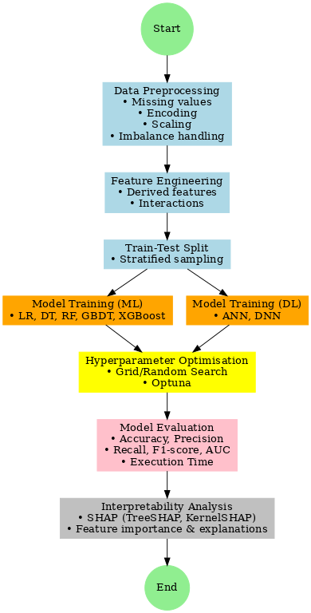
This research employs a quantitative, supervised learning methodology to predict customer churn in the banking sector, enabling a systematic comparison of machine learning (ML) and deep learning (DL) techniques under uniform settings. The methodology encompasses data preprocessing, feature engineering, model selection, hyperparameter optimization, and evaluation, adhering to best practices published in recent churn prediction literature (AbdelAziz et al., 2025; Bhuria et al., 2025; Patel et al., 2023). This figure shows the full methodological procedure.
Figure 1: Research Methodology Workflow

Data Preprocessing
The quality and structure of input data significantly impact the effectiveness as well as reliability of machine learning and deep learning models. Thereby, data preparation is an essential process in all predictive analysis (Patel et al., 2023; Adiputra, Wanchai & Lin, 2025). Existing literature on churn prediction suggests that data preprocessing requires missing value imputation, categorical encoding, feature scaling, and class imbalance management (Bhuria et al., 2025; Adiputra, Wanchai & Lin, 2025).

Missing Data Handling
Missing values data has some impact to final model training. Either it may bias the model or reduce the effective sample size. It results in poor predictive reliability (Abbas et al., 2023; Abubakar et al., 2024). Thus, it must be handled properly. There are few techniques available in prior works. First, mean imputation, median imputation or mode replaces the missing value by mean, median or mode of the feature respectively. This technique is computationally simple but highly sensitive to outliers. Using it without proper care may distort feature distribution.
Next, regression imputation and multiple imputation by chained equations (MICE) replace missing value by an approximately statically estimation. There are some advantages and disadvantages. On the good side, they leverage relationships between features which is sometime benefit to the model training. On the other hand, they require additional computational resources and often assume unnecessary predictor linearity.
Finally, k-nearest neighbor (kNN) replaces missing values by similar samples, which is believed to provide more sophisticated result. This inference consumes intensively computational resources on large dataset, hence scalability in banking churn prediction may be a full stop.

The table below summarizes common missing value treatment as described above.
Table 9: Comparison of Missing Data Imputation Methods
Technique | Advantages | Limitations | Computational Cost | Citation
Mean Imputation | Simple, fast | Distorted by outliers; weak distributional fidelity | Very low | Abbas et al. (2023)
Median Imputation | Robust to outliers; preserves central tendency | May ignore variance structure | Low | Abbas et al. (2023)
Mode / Unknown Class | Suitable for categorical data; preserves absence patterns | May inflate frequency of dominant class | Low | Abubakar et al. (2024)
Regression Imputation | Leverages relationships between features | Assumes linearity; risk of overfitting | Medium | Murindanyi et al. (2025)
MICE (Multiple Imputation) | Statistically principled; handles uncertainty | Computationally expensive; complex to implement | High | Domingos, Ojeme & Daramola (2021)
kNN Imputation | Adaptive; uses neighborhood similarity | Scales poorly with dataset size | High | Murindanyi et al. (2025)
This study not only focus on predictive performance but also computational efficiency. Therefore, median and mode imputation methods are applied. Numerical features (e.g., balances, transaction volumes) will be imputed using the median, which mitigates the impacts of extreme outliers compared to mean replacement. Categorical features (e.g., customer demographics) will be imputed with the mode or encoded into an explicit “Unknown” class. It preserves missing-data patterns as well as maintain feature interpretability. This approach ensures methodological consistency with prior banking churn studies (Abbas et al., 2023; Abubakar et al., 2024), while avoiding the excessive computational cost of more complex imputation frameworks.

Categorical Feature Encoding
Both ML and DL algorithms only accept numerical features, therefore it is a mandatory to transform all categorical to numerical format. There are a few encoding techniques as described in table below.
Table 10: Comparison of Encoding Methods
Encoding Method | Problem Addressed | Pros | Cons | Suitability | Citation
Label Encoding | Converts categories into integers | Simple, compact representation | - Introduces artificial ordinality  - Misleads algorithms sensitive to scale | Useful for tree-based models (DT, RF, XGBoost) | Bhatia et al. (2023)
Target Encoding | Encodes categories by their statistical relationship to churn (e.g., mean churn rate) | - Captures category–target correlation  - Reduces dimensionality | - Risk of target leakage  - Requires careful cross-validation | Suitable for high-cardinality categorical features | Abbas et al. (2023)
One-Hot Encoding | Expands categories into binary indicator variables | - Prevents artificial ordinality  - Interpretable  - effective for low-cardinality data | Increases dimensionality if features have high cardinalities | Best for low-cardinality attributes (e.g., demographics) in ML/DL models | - Boozary (2025)  - AbdelAziz et al. (2025)  - Patel, S., et al. (2024)
The dataset includes five categorical demographic attributes, and due to low cardinalities of each features, one-hot encoding is particularly suitable method. Low cardinalities also ensure one-hot encoding computationally efficient and less prone to sparsity issues compared to high-cardinality cases. In addition, it also avoids the risk of introducing misleading ordinal relationships that could occur with label encoding, ensuring the encoded features align with the nature of the data
One-hot encoding creates a separate binary feature (0 or 1) for each category level, ensuring that ML and DL models can process categorical data without imposing artificial ordinal relationships where none exist (Boozary, 2025).

Formally, for a categorical variable C with k distinct categories {c₁, c₂, ..., c_{k}}, one-hot encoding maps each observation x ∈ C to a binary vector v ∈{0,1} ^{k} where:
$$v_{i}=\left\{\begin{aligned}1 if x=c_{i} \\ 0 otherwise\end{aligned}\right.$$
For example, in dataset, the gender feature has 3 values Male, Female and Other. One-hot encoding will represent these as:
Gender | Male | Female | Other
Male | 1 | 0 | 0
Female | 0 | 1 | 0
Other | 0 | 0 | 1
In practice, we do not really need all three columns. Two columns suffice to derive the last columns. By removing one column, we also avoid multicollinearity.
The binary churn indicator will be retained in its original 0/1 form, following conventions in prior banking churn studies (AbdelAziz et al., 2025).

Feature Scaling
Feature scaling is an important preprocessing step for all binary classification. Especially with banking datasets, numerical features (e.g. account balances, transaction volume or transaction frequency, tenor) are in various ranges. If this step is not handled properly or frequently overlooked, larger numeric scales can dominate distance-based or gradient-based algorithms. As a result, algorithms relying on distances or gradient can suffer from slow or unstable training. In the worst case, it may also lead to biased learning and unstable convergence (Ali, S., et al., 2025).
Hence, for those predictive algorithms which are sensitive to feature magnitude, it is a mandatory requirement to ensure uniform feature contribution. There are standardization and normalization scaling methods. Normalization scale data to a specific range which is between 0 and 1. It can distort the underlying data distribution and casually ignore meaningful patterns, especially when outliers are present. Standardization technique rescales feature to have a mean of zero and standard deviation of one. It preserves the distribution shape while centering and scaling the data, ensuring that no single variable dominates due to its magnitude.
Standardization is particularly important for gradient-based models such as deep neural networks (DNNs), where unscaled features can lead to inefficient convergence (Domingos, Ojeme & Daramola, 2021), and for distance-based algorithms, where differences in scale can distort similarity measures. Standardization is mathematically defined as:
$$z= \frac{x- μ}{σ}$$
where x is the original feature value, $μ$ is the feature mean, and $σ$ is the feature standard deviation.
For example, if we have five features x1 to x5, their values vary from 5 to 20, this figure explains how standardization works. The chart on the left plot five features with raw value, and the right hand side chart plots their values after standardization.
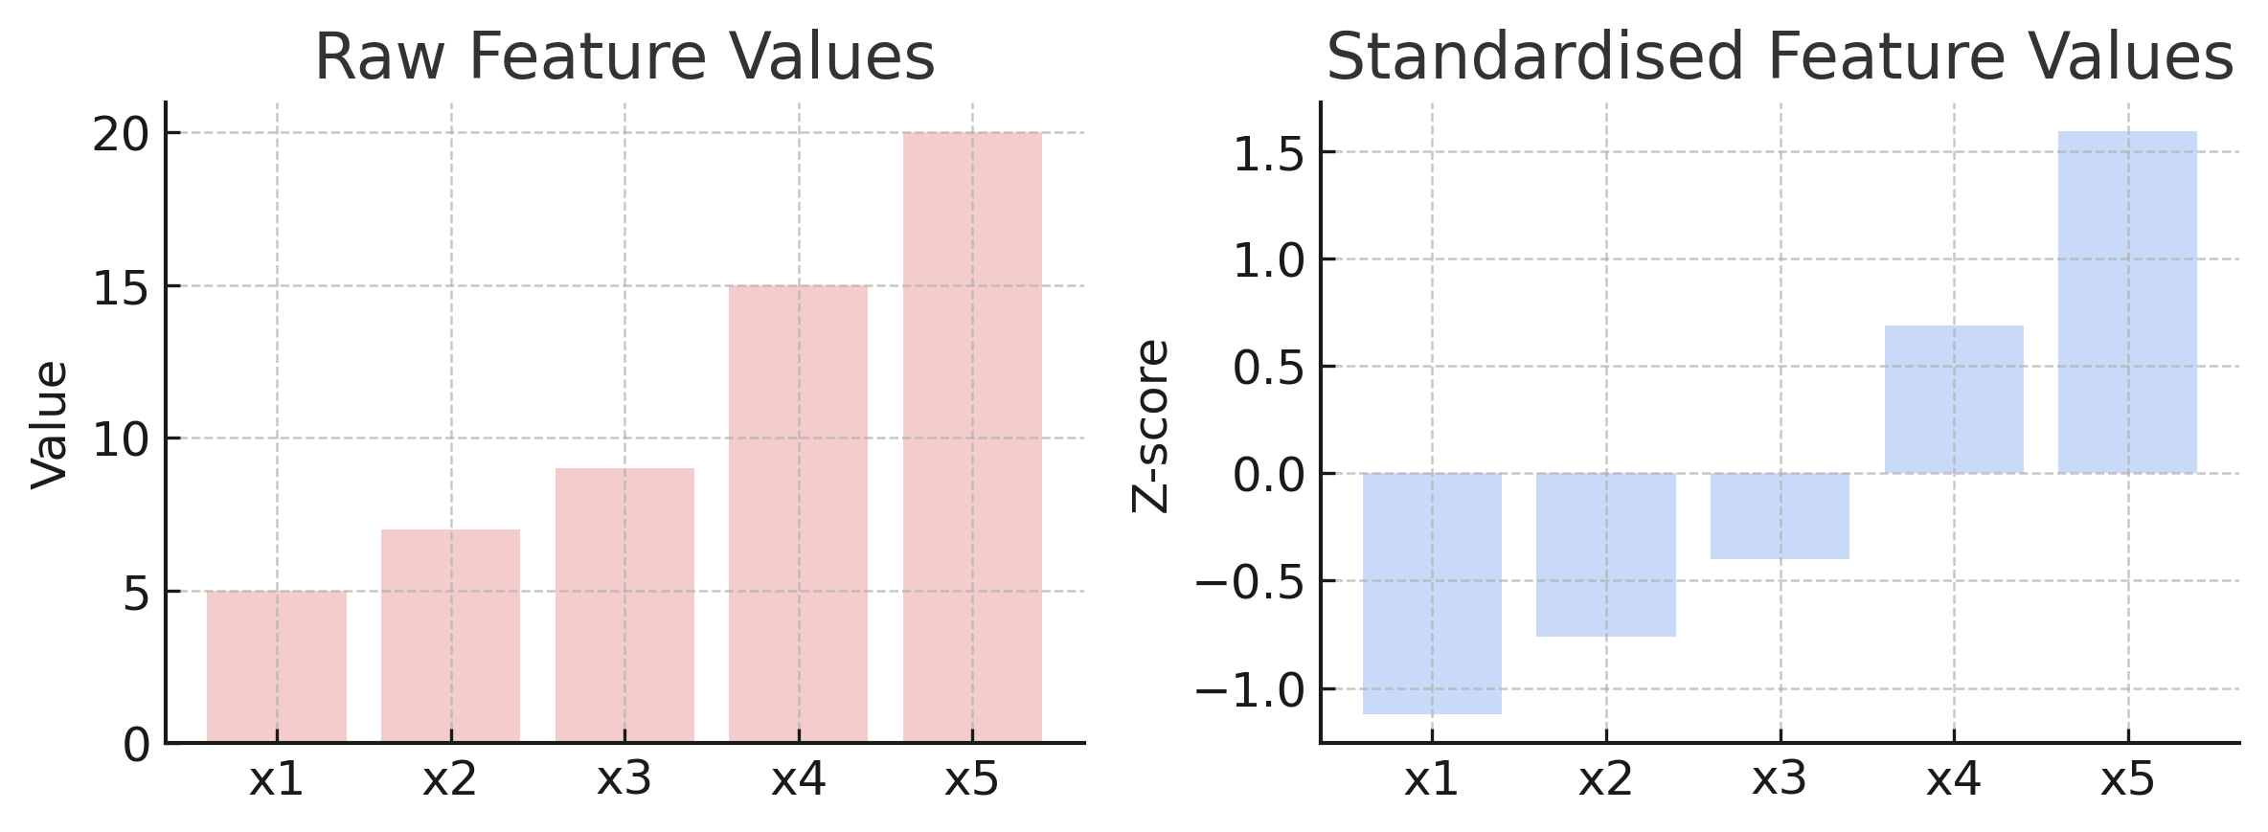
Figure 2 - Example of Standardization scaling

Class Imbalance Treatment
For binary classification problem, particularly for churn prediction class imbalance, where one class is much of the population, is typical. It results in model biased and reduce sensitivity to true churners, which are of highest business concern. For example, if a dataset has 10000 observations, and only 2% of them are churn. By predicting all of them are non-churn, the model accuracy is 98%. Although the predictive accuracy is very high, all churn customers are ignored.
To address this, two different imbalance treatments are applied in this study as described in table below
Table 11: Comparison of Class Imbalance Treatment Techniques
Technique | Principle | Strengths | Weaknesses | Resources Cost | Best for | Citation
SMOTE | Creates synthetic minority samples by interpolating between existing samples | - Reduces overfitting from simple duplication  - Improves minority representation | - May generate less realistic samples  - Risk of overlapping classes | Low–Medium | Machine learning | - Adiputra, Wanchai & Lin (2025)  - Tékouabou (2022)

GAN-based Oversampling | Uses a generator–discriminator framework to produce realistic minority samples | - Captures complex feature relationships  - Generates highly realistic churner samples | - Computationally expensive  - Risk of mode collapse in GAN training | High | Deep learning | Adiputra, Wanchai & Lin (2025)
Synthetic Minority Oversampling Technique (SMOTE): SMOTE generates synthetic churn samples by interpolating between existing minority class instances. For each minority sample x_{i}, one of its k-nearest neighbors x_{nn} is selected, and a new synthetic point x_{new} is created as:
$$x_{new}= x_{i}+ λ . \left(x_{nn}- x_{i}\right) , λ \sim U(0,1)$$
Where:
- x_{i}: a randomly chosen minority class sample
- x_{nn}: one of the k-nearest neighbors of x_{i} from the minority class
- $λ$: a random number drawn from a uniform distribution between 0 and 1 (U(0,1))
- x_{new}: the newly generated synthetic sample
This interpolation along the feature space line segment between x_{i} and x_{nn} avoids direct duplication while enriching the minority class distribution. Studies (Adiputra, Wanchai & Lin, 2025; Tékouabou, 2022) confirm that SMOTE improves sensitivity to churners while reducing overfitting risks associated with random oversampling.
GAN-based Oversampling: Generative Adversarial Networks (GANs) offer a more sophisticated approach by learning the underlying data distribution of the minority class. A GAN consists of two neural networks: the generator G(z), which maps random noise z ~ p(z) to synthetic samples, and the discriminator D(x), which attempts to distinguish real from synthetic samples.
Through this min–max optimization, G learns to generate synthetic churner samples indistinguishable from real ones, thereby capturing high-order correlations and producing more realistic minority examples. GAN-based oversampling has been shown to outperform interpolation-based methods in datasets with complex feature relationships (Adiputra, Wanchai & Lin, 2025).

Feature Engineering
During exploratory data analysis process new features may be derived to capture hidden customer behavior leading to churn signals. There is a clear proof from prior literature that those derived features improving discriminative power in churn models by revealing patterns not directly observable in the raw data (Singh, H., et al., 2024; Abbas et al., 2023). According to previous studies and banking domain expertise, five groups of derived features are proposed (a full summary of derived features is provided in appendix B).
- Tenure-related features. The customer’s tenure, also known as month-on-book (MOB), is the month difference between account opening date and current data date. This feature provides a strong indicator of customer loyalty. Short-tenure customers are generally more volatile, whereas those with a prolonged tenure exhibit greater loyalty (AbdelAziz et al., 2025). Similarity, the inactivity duration, calculated by the day differences since the previous transaction, serves as an additional signal for attrition, as extended periods of inactivity are significantly associated with churn (Ahmed et al., 2023).
- Transaction-based features. Metrics like transaction frequency (the number of transactions adjusted by tenure) and average transaction size provide insights into the active use of a customer's account. A balance volatility index, derived from the balance delta relative to the present balance, signifies financial instability and associated with heightened churn tendencies.
- Financial health indicators. A loan-to-income ratio, also known as debt-to-income ratio, will be engineered to assess potential risk level, complementing credit score information. The higher ratio customers are, the higher risk a bank may take. It also implies the higher stress level customer may face with repayment. Altogether, it may imply the higher chance discontinuing banking relationships.
- Service and satisfaction related. The complaint-to-interaction ratio quantifies unhappiness by dividing recent complaints by the total number of customer service interactions. A satisfaction gap indicator is utilized, merging customer happiness scores with complaints: low satisfaction along with numerous complaints serves as a robust predictor of churn, whereas high satisfaction with no complaints signifies stability.
- Contextual features such as branch or regional churn rates (extracted from the training data), will be represented as risk-based features, given that specific areas or branches may continuously exhibit elevated attrition rates. A composite engagement index, incorporating transaction frequency, satisfaction, and complaint rates, will be developed to offer a comprehensive assessment of consumer commitment.
Upon finalizing data preparation and feature engineering, the dataset will be prepared and optimized for both machine learning and deep learning models. Those two steps ensure selected model evaluation exposes actual algorithm capability rather than data quality or representation.

Train–Test Split and Validation
Random sampling is usually preferred for train-test split. Each observation is assigned randomly to each train and test set. It ignores class contribution so it may produce improper split where minor class is under-sampling or even absent. Models trained on such split may underperform in churn prediction. Therefore, according to Ahmed et al., (2023) and Patel et al., (2023), to deal with such imbalance class problem the churn/non-churn ratio preservation is a mandatory. Instead of random sampling, stratified sampling should be employed to split training (80%) and testing (20%) subsets. Stratification guarantees that both subsets reflect the same class distribution as the original dataset, which is critical for imbalanced problems such as churn prediction.
Moreover, as another recommendation by Marmion et al., (2012), k-fold cross validation will be applied during model training to limit overfitting and reduce variance in final prediction. The train dataset is equally split further down by k folds, and the model is trained k times. Each time, it leaves one fold out for validation and uses remaining folds for training. The final performance estimation is computed as the average across all k runs. Formally, if D is the training dataset and F₁, F₂, ..., F_{k} are the folds, the model is trained k times on all folds except F_{i} and validated on F_{i}. This approach is also useful of limited data.
For example, if we choose k equal to 5, this figure demonstrates how k-fold validation works.
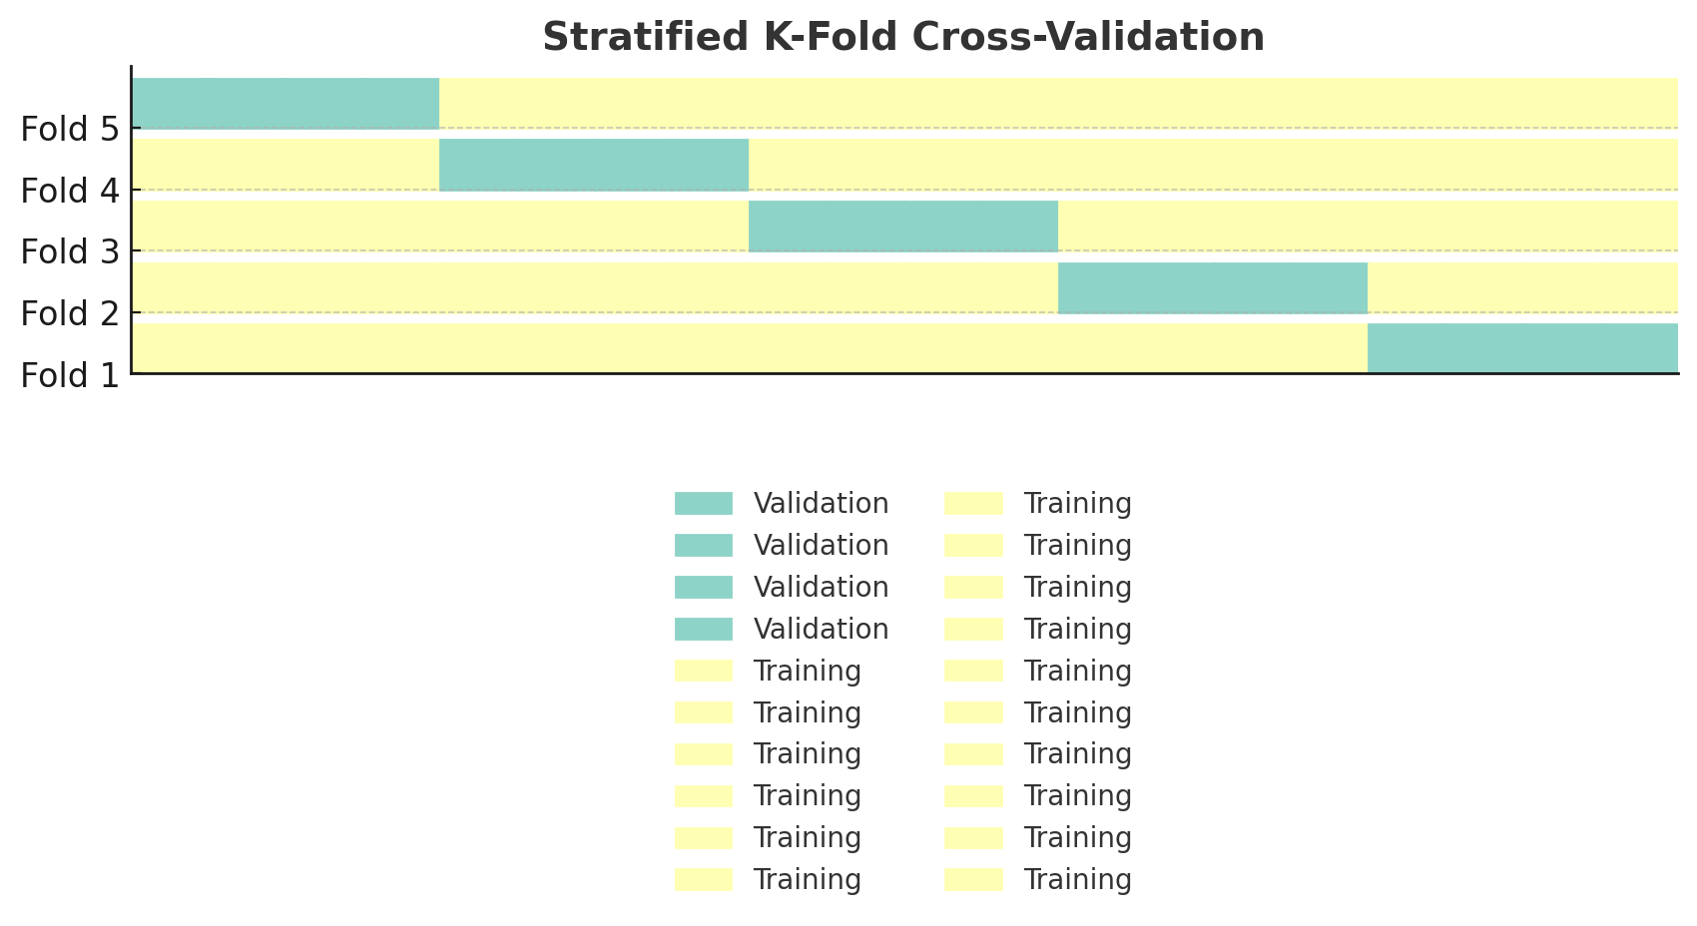
Figure 3 - Demonstration of stratified k-Fold Cross-Validation

Algorithms Considered
There are two objectives behind the model selection in this study:
- Ensuring covering of various linear classifiers, decision-tree-based ensembles, and non-linear representation algorithms.
- Enabling a balanced comparison between ML and DL approaches using consistent preprocessing and evaluation pipelines.
This ensures the experimental outcomes are both statistically rigorous and operationally meaningful in a banking context.

Comparative Perspective (ML vs. DL in the four-core metrics)
Evaluation metrics will be discussed furtherly in the evaluation metric part in this section. Evidence from the reviewed literature consistently reveals complementary strengths between ML and DL in banking churn prediction:
Table 12: Model performance comparison
Metric | Best-performing ML models | Best-performing DL models | Observed trends in banking churn prediction
Accuracy | XGBoost,  Random Forest | Deep Neural Network (tuned) | - Ensembles often lead due to bias–variance optimization  - DNN can match with careful tuning.
Precision | Random Forest,  Logistic Regression | Artificial Neural Network | - ML ensembles typically produce fewer false positives  - ANN can offer competitive precision with feature scaling.
Recall | XGBoost  (with rebalancing) | Deep Neural Network | - DNN often excels in recall, especially with dropout and class weighting  - Important for catching true churners.
F1-score | XGBoost | Deep Neural Network | - Context-dependent: boosting models lead on clean, separable data  - DNN can surpass with complex feature interactions.
Execution time | Logistic Regression,  Decision Tree | Artificial Neural Network | - Simpler models faster  - ANN reasonable latency

This comparative evidence motivates the inclusion of models that mutually span the metric range: ensembles (RF, XGBoost) for accuracy and precision, and DL models (DNN, ANN) for recall and balanced F1 performance. Logistic Regression and Decision Trees serve as low-latency baselines and interpretable respectively, enabling a full assessment of performance versus execution time.

Machine Learning Models
- Logistic Regression (LR). A linear probabilistic classifier that models the log-odds of churn as a function of customer attributes. LR remains a robust baseline in banking churn research due to its transparency, calibration friendliness, and low computational cost (Abbas et al., 2023; AbdelAziz et al., 2025; Patel et al., 2024).
- Decision Tree (DT). A hierarchical partitioning of the feature space that yields human-readable rules and very fast inference. While single trees often trail ensembles in raw accuracy, their latency and interpretability are attractive for real-time scoring and compliance-centric environments (Bhuria et al., 2025; Tékouabou, 2022).
- Random Forest (RF). An ensemble of decorrelated trees trained via bagging and random feature selection. Therefore, RF typically improves generalization and stability relative to a single DT. On the other hand, RF requires way more computational resources and so longer execution time than DT. Since this study also values execution time and computational resources, DT and RF are evaluated head-to-head to consider the trade-off between those execution time and predictive performance (Bhuria et al., 2025; Singh, P., et al., 2025).
- XGBoost. Sequential ensembles that correct residual errors of prior learners and incorporate regularization; they have repeatedly achieved state-of-the-art results on structured banking data, especially when hyperparameters are tuned systematically (Patel et al., 2023; Ali, M., et al., 2024; AbdelAziz et al., 2025; Li, X., et al., 2025). In previous literature as summarized in table above, XGBoost beats all other three machine learning model in term of accuracy, recall and F1-score. Like RF, this model also requires more computational cost. It is also good to consider the trade-off between predictive performance and computational cost.

Deep Learning Models
- Artificial Neural Network (ANN): Feed-forward multi-layer perceptions modelling non-linear relationships between demographic, behavioral, and transactional features and churn likelihood. Typical configurations in banking churn tasks include 1–2 hidden layers with ReLU activation, dropout for regularization, and a sigmoid output neuron for binary classification (AbdelAziz et al., 2025; Adamu et al., 2025). Like LR in machine learning model, this algorithm acts as baseline in churn prediction for deep learning.
- Deep Neural Network (DNN): Extends the ANN by incorporating additional hidden layers (e.g., 4–6) to capture higher-order feature interactions in high-dimensional data. Common designs employ dense layers with ReLU activation, batch normalization to stabilize training, dropout to mitigate overfitting, and a sigmoid output layer (Singh, H., et al., 2024; Basit et al., 2024). Because of complex architecture, DNN wins most predictive performance, yet it consumes more resources. In term of trade-off consideration, both DNN and ANN are put on the table for consideration.

Hyperparameter Optimization
In all predictive algorithms, there are two types of parameters. First, it is model parameters such as regression coefficients or neural network weights learning and updating during the training using data. The other is model hyperparameters controlling learning process itself rather than learning from data. Some examples include the regularization strength (e.g., L1 or L2 penalty) for logistic regression or maximum tree depth, minimum samples per split for decision tree. They are set prior to training and directly influence model capacity, convergence behavior, and generalization ability (Patel et al., 2023; Abubakar et al., 2024).

Machine Learning Models
Previous literatures believe the importance of hyperparameter tuning for maximizing the predictive performance of both ML and DL models. In contrast, deficient configurations can lead to either underfitting or overfitting. This study applies comparative approach using grid search, random search, and Optuna.
- Grid Search: This method brute forces all possible combinations of predefined hyperparameters. By covering all possibilities, it can determine the best hyperparameter combination. Once the parameter space grows, the good application becomes computational burden (Abubakar et al., 2024). For example, tuning three parameters with ten candidate values each, formally ten power of three, already requires 1,000 model fits, making grid search infeasible for complex DL architectures.
- Random Search: Instead of testing all combinations, random search randomly selects some of hyperparameter configurations. Obviously, it performs faster than grid search and reduces computational resources. Nonetheless, it may still spend trials on nonpotential regions of parameter spaces and lacks adaptive exploration (Abubakar et al., 2024) or it may miss the best combination.
- Optuna: A modern hyperparameter optimization framework that improves on both methods by employing Bayesian optimization and early pruning strategies (Patel et al., 2023). Bayesian optimization uses probabilistic models to guide the search towards potential regions of the parameter space. On the other hand, pruning stops disappointing trials early, reallocate resources to more potential candidates. This combination returns greater efficiency in exploring complex search spaces, particularly for deep neural networks where training iterations are computationally expensive.
Table 13: Comparison of Hyperparameter optimization Approaches for Machine Learning Models
Approach | Description | Strengths | Weaknesses | Relevant Studies
Grid Search | Exhaustively evaluates all parameter combinations within a predefined grid. | Simple to implement; guarantees finding best model within the grid. | Computationally expensive; infeasible for large search spaces. | Abubakar et al. (2024)

Random Search | Samples parameter values randomly from defined distributions. | More efficient than grid search in high-dimensional spaces; can reach near-optimal results quickly. | May miss optimal combinations if not sampled; results can vary by run. | Patel et al. (2023); Abubakar et al. (2024)
Optuna | Uses Bayesian optimization and pruning to guide search toward promising regions. | Highly efficient in large, complex spaces; adaptive search; early stopping of poor trials saves computation. | More complex implementation requires tuning of optimization process itself. | Patel et al. (2023)
In conclusion, logically Optuna beats Grid Search and Random Search not only in term of computational resources but also achieving higher chance of finding near optimal. By applying all three approaches and comparing each approach’s peak performance with base models and them together, the study seeks the solid proof for the best tuning platform.

Deep Learning Models
In contrast, DL models in this study will not undergo full hyperparameter tuning process. Due to deep learning complex architectures, hyperparameter tuning requires extremely high computational resources. Their hyperparameters such as number of hidden layers, activation functions, dropout, batch size, learning rate will be set using configurations established in prior churn prediction studies (Amal et al., 2023; Ahmed et al., 2023; Zhang et al., 2024). This reflects two concerns:
- Because the study dataset is quite small (5000 observations) and it may limit the extensive hyperparameter tuning benefit. Any overly complex tuning may risk to overfitting.
- Full hyperparameter tuning is computationally expensive and beyond the practical scope of this study.
By adopting configurations from previous literature, DL models are not left untuned but are setup using empirically validated settings. This ensures methodological fairness, ML models are fully tuned with Grid Search, Random Search, and Optuna, while DL models are reasonably configured to reflect their potential under realistic study constraints.

Evaluation Metrics
Besides four widely used metrics in the binary classification problem (Adiputra, Wanchai & Lin, 2025; Bhuria et al., 2025), the study will also consider two extra metrics, which are AUC (Ahmed et al., 2023; Patel et al., 2023) and execution time (Bhuria et al., 2025; Domingos, Ojeme & Daramola, 2021).
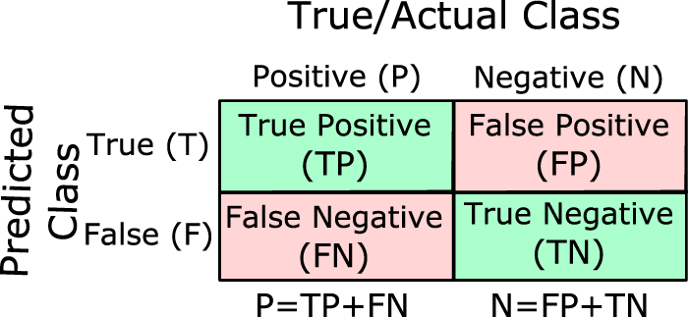
This below figure denotes some formulas below (Tharwat 2018):
Figure 4: Confusion matrix
- TP is true positive; a churn customer is predicted to churn correctly.
- TN is true negative; a non-churn customer is predicted to be a non-churn customer correctly.
- FP is false positive; a non-churn customer is predicted to churn incorrectly.
- FN is false negative; a churn customer is predicted to be a non-churn incorrectly.
- Accuracy is a metric that quantifies how often a model's predictions are correct. The term “correct” here refers to accurate classification of both churn and non-churn classes. It is a good starting point for evaluating model performance because it is simple to understand and calculate, making it a good initial measure of how well the model is performing.
$$Accuracy= \frac{Number of correct prediction}{Total number of predictions}=\frac{TP+TN}{TP+TN+FP+FN}$$

However, the metric itself is sometimes interpreted wrongly especially for high imbalance class prediction. By predicting all records are majority class, the model achieves high accuracy score, but it fails to reflex the real situation. Therefore, additional metrics are used alongside the evaluation to make it clearer.
- Precision is a metric that measures the accuracy of positive predictions produced by a model. In another word, precision is the proportion of correctly predicted positives out of all instances predicted as positive. This metric indicates the proportion of actual positives among those predicted as positive by the model. Precision is used to evaluate the reliability of a model's positive predictions and can be particularly useful in situations where false positives may have a significant impact. For example, in customer retention scenarios, banks may offer promotions; a higher number of false positives may result in increased costs for the bank.
$$Precision= \frac{TP}{TP+FP}$$

- Recall, also known as true positive rate (TPR) or sensitivity, quantifies a model’s ability to identify relevant instances (true positives) within a dataset. It represents the proportion of actual positive cases correctly detected by the model, indicating the fraction of positives found among all actual positives.
$$Recall= \frac{TP}{TP+FN}$$

Recall is given particular emphasis in banking churn contexts, as failing to identify an at-risk customer may result in direct revenue loss (Tékouabou, 2022; Adiputra, Wanchai & Lin, 2025). While precision focuses on the accuracy of positive predictions, recall focuses on identifying all positives. A high recall can sometimes come at the cost of lower precision (more false positives), and vice versa. The relationship between precision and recall is often described as a trade-off.
- F1-score provides a balanced measure of a model's performance in classification tasks, particularly useful when dealing with imbalanced datasets. It is the harmonic mean of precision and recall, offering a single value that considers both false positives and false negatives:
$$F1=2 x\frac{Precision x Recall}{Precision+Recall}$$
The F1-score provides a single, comparable metric for evaluating and comparing the performance of different machine learning models, especially when precision and recall are both important. A high F1-score (close to 1) signifies that the model has outstanding precision and recall, meaning it is effective at both identifying positive cases and minimizing incorrect positive predictions. A low F1-score (close to 0) indicates that the model is either not identifying enough positive cases (low recall) or is making too many incorrect positive predictions (low precision), or both. In banking, either failing to retain a valuable customer or offering unnecessary incentives entail substantial cost.
- Area Under the Receiver Operating Characteristic Curve (AUC-ROC): a threshold-independent measure representing the probability that the model ranks a randomly chosen churner higher than a randomly chosen non-churner. The ROC curve plots the true positive rate (recall) against the false positive rate at various classification thresholds, and the AUC quantifies the overall separability. In general classification problems, higher AUC values indicate better discrimination between classes. In churn prediction, AUC is especially valuable because it evaluates performance across all possible thresholds, helping practitioners select the most appropriate operational cut-off point for intervention strategies (Ahmed et al., 2023; Patel et al., 2023).
- Execution Time measured in seconds or milliseconds per inference or training epoch, depending on model type. It captures computational efficiency during both training and prediction phases. Built-in profiling tools provide precise measurement of both CPU and GPU operations. Execution time will be calculated by time differences between wall-clock time at beginning and end of each training run or predicting. To be fair, time both training and predicting time execution will be normalized to per-epoch or per-sample

$$Train_{time}= \frac{endtime-startime}{training set}$$ | $$Pred_{time}= \frac{endtime-startime}{predicting set}$$

Table 14: Runtime Benchmarking Protocol for Execution Time
Aspect | Description
Measurement primitives | - For ML models: use high-resolution wall-clock timers (e.g., Python time.perf_counter()).  - For DL models running on GPU: use CUDA synchronizers (torch.cuda.synchronize()) to account for asynchronous kernel execution.
Warm-up & repetitions | - Perform 1–3 warm-up runs to populate caches and JIT compile graphs.  - Execute 10 independent timed runs.  - Report median (p50) and optionally p90 latency.  - Outliers are logged and reported separately.
What is timed | - Training: fit() call (ML) or forward+backward passes (DL).  - Inference: predict() (ML) or forward pass (DL).  - Include preprocessing/transform steps required inside pipeline.
What is not timed | - Disk I/O, dataset loading, or caching operations.  - One-off model/graph compilation (outside warm-up).  - Hyperparameter search orchestration overhead.
Hardware specification | - Record CPU/GPU model, RAM, and storage configuration.  - Note whether execution uses single-thread, multi-thread, or GPU acceleration.
Batch size & concurrency | - Report latency for single-sample (online scoring) and batch (mini-batch) inference.  - Vary concurrency levels (1, 4, 8 workers) to simulate deployment load.
Reporting | - Present results in milliseconds per inference (prediction) and seconds per epoch (training).  - Provide confidence intervals (95%) to demonstrate stability of results.

While more complex architectures (e.g., deep neural networks) may deliver marginal returns in predictive metrics, they often incur substantial delays in prediction speed and higher hardware costs. In churn prediction, where timeliness can influence retention intervention strategies, execution time becomes a crucial operational metric.
  - Fast models (e.g., Logistic Regression, Decision Tree) can be deployed easily and score lower in complexity but may sacrifice some accuracy.
  - The inclusion of execution time allows decision-makers to balance predictive power with operational feasibility.

- Evaluation Metrics and Statistical Significance: a model with higher raw metrics (accuracy, precision, recall, F1, execution time) is an efficient requirements to claim this model outperform other models. Statistical significance testing helps to ensure the evaluation is sufficiently rigorous to conclude that higher performance does not happen by chance or by sampling. The table below describes how each five above evaluation metrics are statistically tested.

Table 15: Evaluation Metrics and Statistical Significance using Cross Validation
Metric | Definition | How It is Compared (with CV) | Ensuring Robustness
Accuracy | Ratio of correctly classified cases over total cases. | - Compute fold-level accuracy in repeated stratified k-fold CV  - Use the distribution of scores across folds to compare models. | Apply paired tests (paired t-test or Wilcoxon signed-rank) or bootstrap 95% confidence intervals to assess statistical significance (Marmion et al., 2012).
Precision | Fraction of predicted churners that are actual churners. | - Compute fold-level precision in repeated stratified k-fold CV  - Use the distribution of scores across folds to compare models. | Same significance logic as accuracy: paired tests or bootstrap 95% CIs ensure results are not due to chance.
Recall | Fraction of actual churners correctly identified (especially important in churn context. | - Compute fold-level recall in repeated stratified k-fold CV  - Use the distribution of scores across folds to compare models. | Same significance logic as accuracy: paired tests or bootstrap 95% CIs validate recall improvements across models.

F1-score | Harmonic mean of precision and recall. | - Compute fold-level F1 values in repeated stratified k-fold CV  - Use the distribution of scores across folds to compare models. | Same significance logic as accuracy: paired tests or bootstrap 95% CIs ensure F1 differences are robust.
Execution Time | Time for training and inference (as per benchmarking protocol). | - Measure training/inference time within each CV fold (median and p90 latency). | Apply non-parametric tests (e.g., Kruskal–Wallis) if execution time distributions are skewed.
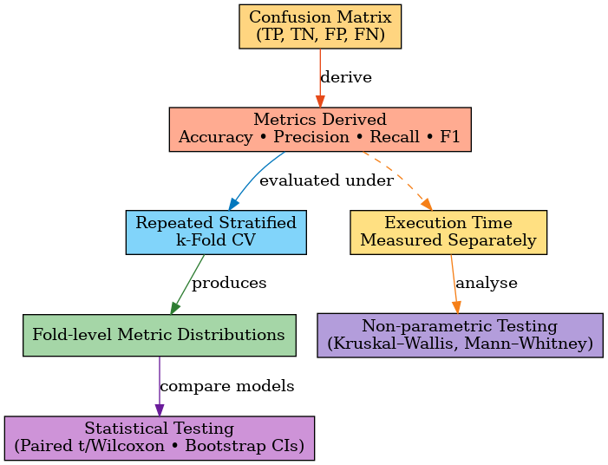
Figure 5: Workflow of Statistical Significance Test

All classification metrics (accuracy, precision, recall, and F1) are fractions derived from the same confusion matrix and evaluated identically across repeated stratified k-fold CV. By treating the fold-level values as samples from the performance distribution, it is methodologically consistent to apply a unified statistical framework, either paired tests or bootstrap confidence intervals, to compare models. However, these metrics are fraction-based and could, in principle, be tested with a binomial distribution. This overlooks the more relevant question of whether performance differences are consistent across folds. Fold-level tests or confidence intervals are therefore preferred, as they capture both model stability and generalization variance. Execution time is treated separately because it is a skewed, continuous variable, for which non-parametric tests such as Kruskal–Wallis or Mann–Whitney are more appropriate.

Interpretability Analysis
As described in the objective section, besides quantitative evaluation metrics, model interpretability is another key component of the analysis phase. In the banking industry, the ability to explain predictions is critical not only for business stakeholders such as compliance and risk management but also is crucial for gaining executives' trust (Boozary, 2025). Well-performing model, which fails to explain their predictions, are inappropriate for customer-facing decision systems deployment because those decisions may directly result in poor customer retention strategies.
This research will employ SHapley Additive exPlanations (SHAP) to provide a unified, model-agnostic approach to interpreting feature contributions. SHAP is built on cooperative game theory. Each feature contribution is computed as the average marginal contribution across all possible feature subsets. There are two main advantages of this approach. First, it generates overall explanations, which highlight features having the most impact in churn prediction across the entire dataset. Second, it also explains in detail why a specific customer is classified as likely to churn (AbdelAziz et al., 2025).
For tree-based models (e.g., Random Forest, Gradient Boosted Trees, XGBoost), TreeSHAP will be used to optimize computational efficiency. For deep learning models, KernelSHAP will approximate Shapley values via sampling, ensuring interpretability remains feasible despite higher model complexity (Domingos, Ojeme & Daramola, 2021).
The interpretability results will serve three purposes:
- Feature importance validation involves cross-checking whether the highly weighted features correspond with domain expertise and existing banking literature.
- Model debugging involves identifying whether specific features are introducing bias or creating false correlations.
- Actionable insights: to guide retention strategies by revealing key behavioral or demographic drivers of churn.
By integrating SHAP analysis into the evaluation pipeline, the study will bridge the gap between predictive accuracy and actionable decision-making, ensuring that model outputs are not only correct but also transparent and trustworthy.

Tools and resources used
- Hardware: a cloud-based environment with GPU acceleration. Detailed specifications:
  - 15 virtual CPUs
  - 250 GB
  - 1 virtual GPU NVIDIA H100
- Software: Python 3.10 with machine learning libraries such as Scikit-learn, TensorFlow, PyTorch, profiling tools, and interpretability frameworks (SHAP, LIME). All analytics are done on the IDE Jupyter Notebook.

Summary
The methodology chapter established the full experimental pipeline, from data preprocessing and feature engineering to ML/DL model training, cross-validation, hyperparameter optimization, and interpretability analysis. These methodological components ensure experimental validity, prevent leakage, and enable fair comparison between models. The dataset prepared through this pipeline is analyzed next in Chapter 4.

CHAPTER 4
DATA ANALYSIS

Introduction
This chapter presents the exploratory data analysis (EDA) process prior to model development. The goal of the EDA process is to understand the class distribution, data structure, and underlying patterns of the data. In this dissertation, the EDA covers data quality verification, imbalance assessment, correlation exploration, and feature engineering as stated in Chapter 3. All analytical steps are implemented in Python 3.10 using the Scikit-learn, Pandas, and Matplotlib libraries within a Jupyter Notebook environment. In addition, each step is clearly documented and commented in Python code to ensure reproducibility and transparency.

Dataset Overview

This study used the public dataset from Kaggle, which is “Churn Prediction: Unlocking Retention Secrets” (Simronw, 2023). The dataset has 5000 rows and 5000 unique customer IDs. Thus, it is one row per customer. It does not contain historical transactions and just has the most recent information that may be useful to figure out the reason for the customer leaving and how to retain them.

The dataset was imported and verified in Python, with the following structure confirmed through the df.info() inspection: 26 columns and no null values for critical predictors, aside from Loan_Type (76% missing). This is a very rare situation where the dataset has no null values. Those 26 variables have been grouped into six groups as described in detail below. Those groups are based on banking expertise and the actual functional role of those in churn prediction.

    - Demographics attributes
These variables capture the customer demographic characteristics, which may have an indirect impact on their banking preferences and tenure stability.
Variable | Type | Description
Customer_ID | Object | Unique anonymized customer identifier
Age | Integer | Age of the customer (years)
Gender | Categorical | Gender of the customer (Male/Female)
Marital_Status | Categorical | Marital status (Single, Married, Divorced, Widowed)
Region | Categorical | Customer’s geographic location (North, South, East, West)

    - Financial indicators
These variables tell customers’ financial health and exposure to credit products. They are proxies for stability, liquidity, and risk propensity. The higher the average account balance, the lower the chance of churn.
Variable | Type | Description
Account_Balance | Float | Average account balance.
Loan_Amount | Float | Outstanding loan principal
Loan_Type | Categorical | Loan category (Home, Personal, etc.) — excluded due to high missingness (76%)
Credit_Score | Integer | Credit rating (scale 300–850)
Annual_Income | Float | Reported annual income
Is_Employed | Boolean | Employment status indicator
Change_in_Account_Balance | Float | Difference between current and previous balance positions

    - Transactional attributes
These attributes describe the customers’ payment and deposit activities, including transaction patterns, recency, and frequency. The higher the frequency of transactions or the lower the recency of transactions, the lower the chance that customers may leave the banks.
Variable | Type | Description
Transaction_Date | Date | Date of latest transaction
Transaction_Amount | Float | Monetary value of last transaction
Transaction_Type | Categorical | Nature of transaction (Deposit, Payment, Transfer)
Number_of_Transactions | Integer | Total transactions during the observation window
Account_Type | Categorical | Type of deposit account (Savings, Checking)
Account_Open_Date | Date | Date of account initiation
Last_Transaction_Date | Date | Date of most recent recorded transaction

    - Behavioral features
These derived and observed indicators capture temporal and frequency-based engagement levels, providing essential behavioral signals for churn analysis.
Variable | Type | Description
Account_Activity_Trend | Categorical | Directional trend of recent account activity (Increasing, Stable, Decreasing)
Branch | Categorical | Operating branch serving the customer
Churn_Timeframe | Integer | Months since churn. This variable excluded from model training because it is event happened after churn.

    - Interaction and Satisfaction metrics
These variables capture customer experience and perception dimensions. They are critical for explaining churn propensity from a service-quality perspective.
Variable | Type | Description
Customer_Service_Interactions | Integer | Number of logged service interactions
Recent_Complaints | Integer | Number of complaints in recent quarter
Customer_Satisfaction_Score | Integer (1–5) | Self-reported satisfaction rating
Account_Balance_Change | Float | Computed volatility in account balance over recent months (derived variable from raw financial data)

    - Target variable
Variable | Type | Description
Churn_Label | Integer (0/1) | Binary target variable representing churn status: 1 = churned, 0 = active

Data Completeness and Structure Validation

The dataset validation confirmed robust data integrity:
- 26 variables classified into six logical categories.
- Only Loan_Type contained high missingness (76%) and was excluded from analysis.
- The column Churn_Timeframe was deliberately excluded from training features to prevent target leakage, as it encodes post-churn duration.
- All remaining variables demonstrated 0% missingness and clear data types.

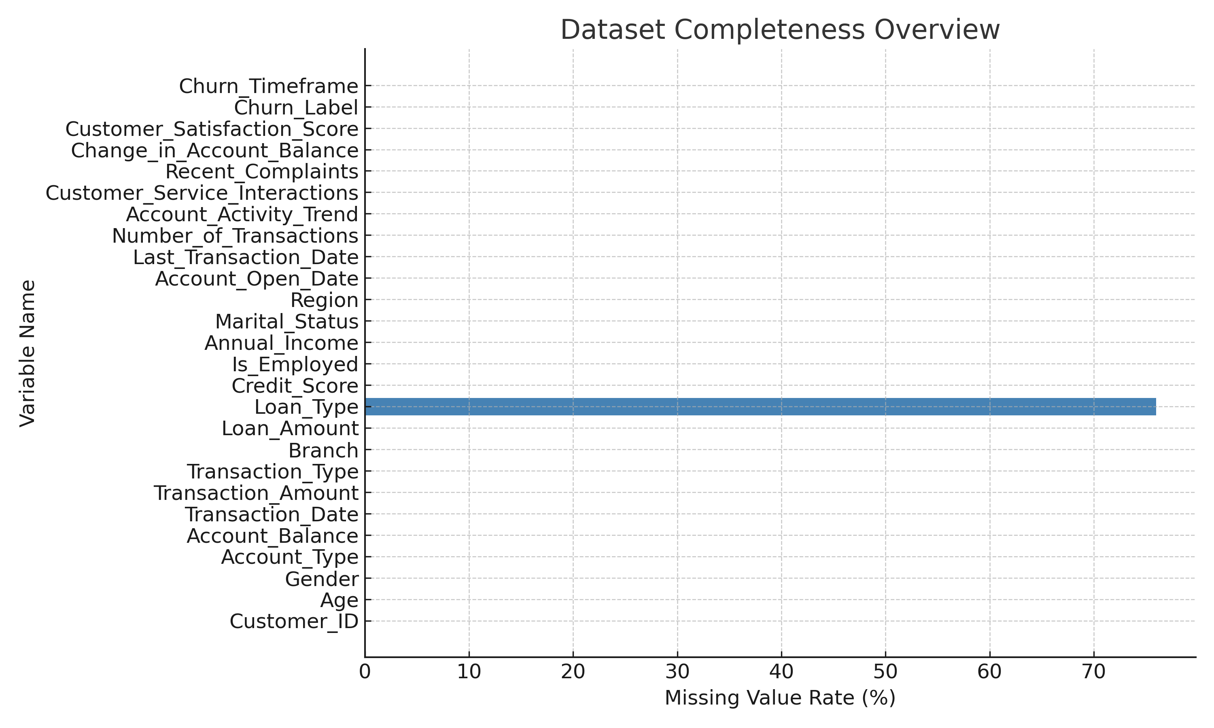

Target Variable and Class Distribution
The dependent variable Churn_Label represents customer attrition status, coded as 1 = churn and 0 = non-churn. Class distribution analysis reveals 1,583 churners (31.7%) and 3,417 non-churners (68.3%), indicating moderate imbalance. While the imbalance ratio is not extreme, oversampling was still required to improve minority class representation in training (Adiputra, Wanchai & Lin, 2025).
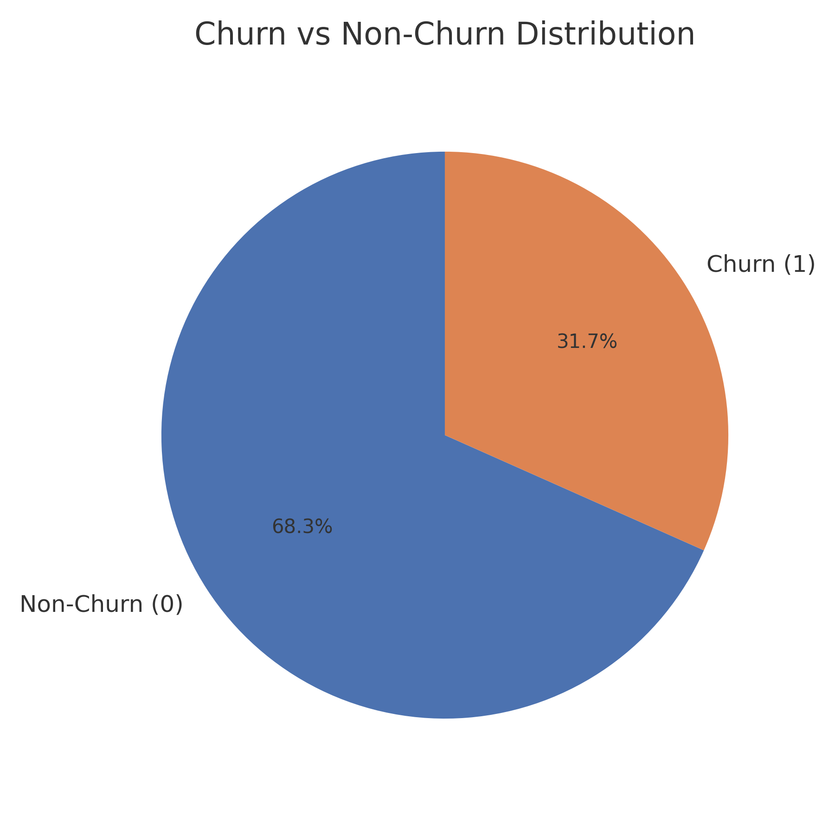
Figure 6: Class distribution of churn vs non-churn customers showing moderate imbalance
To prevent data leakage, the column Churn_Timeframe was explicitly excluded from model training. This variable represents the number of months since a customer’s churn event and directly encodes post-churn information. Including it as a predictor would compromise the causal integrity of the model by introducing temporal leakage.

Correlation and Feature Relationships
A pairwise correlation analysis between numeric predictors and the churn label was conducted using Pearson’s r and significance testing. The strongest associations with churn were found for Recent_Complaints (r = 0.262), Customer_Satisfaction_Score (r = −0.189), and Number_of_Transactions (r = −0.117).
Table 16: Pearson correlations between selected features and churn label.
Feature | Correlation (r) | p-value | Interpretation
Recent_Complaints | +0.262 | < 0.001 | Higher complaint frequency increases churn probability
Customer_Satisfaction_Score | −0.189 | < 0.001 | Lower satisfaction strongly correlates with churn
Number_of_Transactions | −0.117 | < 0.001 | Reduced activity intensity predicts higher churn
Age | +0.032 | 0.025 | Weak positive relation indicating higher churn in older cohorts
Annual_Income | +0.014 | 0.326 | Statistically insignificant correlation
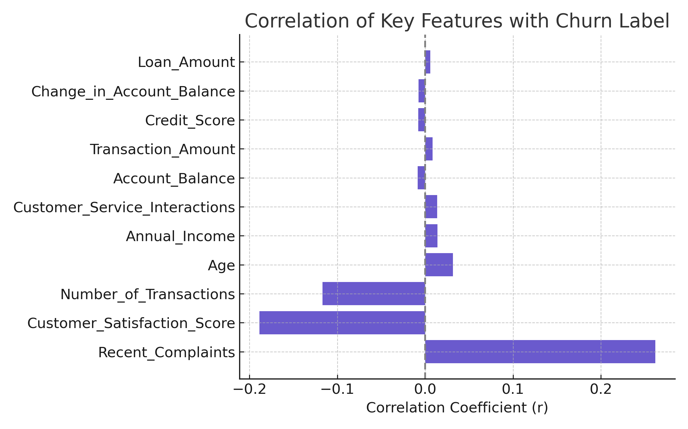
The correlation structure confirms that behavioral and service-related features exert a stronger influence on churn behavior than purely demographic or financial variables, consistent with findings by AbdelAziz et al. (2025) and Singh H. et al. (2024).

Feature Engineering and Derived Attributes
During the EDA process, although feature engineering is optional, it is an important step to enrich the predictive signals by deriving new features from existing ones. In other words, there may be some hidden indicators that are not directly observed in the raw attributes; by combining several attributes together, the indicators become clearer. Within this analysis, the feature engineering process was done by banking expertise and existing exploratory synthesis recommended by Abbas et al. (2023) and Singh et al. (2024).
A total of 30 new variables were developed to encapsulate client tenure, recency, frequency, financial ratios, interaction intensity, and satisfaction dynamics. The full list of 30 new variables with their transformation logic can be found in Appendix B. Each feature was derived through a deterministic transform of existing columns, guaranteeing interpretability and reproducibility.
All engineered variables were validated through missing-value and negativity audits. None contained missing observations, and all ratio-based features were confirmed to be positive and finite. It is explainable because all 26 original features have no missing values. These results demonstrate excellent data completeness and internal consistency, confirming the engineered features’ readiness for model integration.

Outlier and Data Quality Checks
After feature engineering, the dataset was run through an outlier and data quality check to ensure there is no significant skew affecting normalization. The interquartile range (IQR) method was used to detect if there were any outliers. Surprisingly, all outlier ratios were below 1% for key variables such as Account_Balance, Annual_Income, and Credit_Score. This result ensured no major skew would affect the further model implementation.
Next, as explained in Chapter 3, standardization was chosen as a scaling method to maintain training stability across gradient-based algorithms, especially for DNN models (Domingos, Ojeme, & Daramola, 2021).

Summary
The exploratory analysis confirmed the dataset’s analytical readiness:
- All relevant columns are complete, standardized, and free from critical outliers.
- The target variable exhibits moderate imbalance requiring oversampling treatment. In this study, it was SMOTE.
- Behavioral and satisfaction-related attributes dominate the predictive signal.
- Feature engineering successfully enriched the data with interpretable behavioral and financial dimensions.
- The exclusion of Churn_Timeframe ensured methodological integrity and prevented target leakage.
These findings established a robust analytical foundation for the next phase, which is model training, tuning, and evaluation in the following chapter.

CHAPTER 5
IMPLEMENTATION

Introduction
This chapter presents the full implementation process linking exploratory analysis and model evaluation. It details the sequence of steps carried out to transform the cleaned dataset from Chapter 4 into predictive models capable of forecasting customer churn.
The implementation framework was constructed in Python 3.10 using Pandas, Scikit-learn, Imbalanced-learn, XGBoost, TensorFlow, and SHAP, executed within a Jupyter Notebook.
The process includes data partitioning, preprocessing, leakage control, class imbalance treatment, baseline model establishment, hyperparameter optimization, ensemble formation, and final explainability analysis. Each step is designed for reproducibility, bias mitigation, and interpretability, ensuring that the reported performance results are both valid and explainable in a banking context.

Train–Test Split
After completing all feature engineering and data-quality checks, the dataset was partitioned into two mutually exclusive subsets using a Stratified Train–Test Split (70% training, 30% testing).
Stratification was essential to preserve the original churn-to-non-churn ratio in both splits, avoiding distortion in the minority-class distribution.
Original class distribution:
- Total records: 5,000
- Churners (1): 1,583 (31.7%)
- Non-Churners (0): 3,417 (68.3%)
Post-split proportions remained statistically consistent.
Table 17: Churn vs Non-Churn distribution before and after stratified splitting.
Dataset | Total Samples | Churn (1) | Non-Churn (0) | Churn % | Non-Churn %
Full dataset | 5,000 | 1,583 | 3,417 | 31.7% | 68.3%
Training set (70%) | 3,500 | 1,108 | 2,392 | 31.7% | 68.3%
Testing set (30%) | 1,500 | 475 | 1,025 | 31.7% | 68.3%

Data Leakage Control and Preprocessing Strategy
Preventing data leakage was a principal methodological concern. All transformations were carefully separated between operations applied before cross-validation (global preprocessing) and operations executed within each CV fold (fold-level preprocessing).
Table 18: Summary of preprocessing operations and leakage control policy.
Stage | Operation | Applied | Purpose
Outside CV (Global) | Feature elimination: drop Churn_Timeframe, Loan_Type, and Customer_ID. | Before CV | Remove target-related and non-predictive variables.
Outside CV (Global) | Train–Test split (stratified). | Before CV | Preserve target proportion and prevent leakage.
Inside CV (Fold-Level) | Standard scaling (Z-score) fitted on training fold only. | Inside CV | Prevents test data from influencing scaling parameters.
Inside CV (Fold-Level) | Categorical encoding (ordinal or one-hot). | Inside CV | Maintain isolation between folds.
Inside CV (Fold-Level) | SMOTE oversampling. | Training fold only | Addresses class imbalance without contaminating validation fold.
This approach strictly follows Scikit-learn’s pipeline encapsulation principle, ensuring that any learned transformation (e.g., mean/variance in scaling) is derived only from training data. No test data were exposed during transformation fitting or model tuning.

Class-Imbalance Treatment with SMOTE
The churn dataset exhibited a moderate imbalance ratio (~68:32). While not extreme, the minority churn class was still underrepresented and prone to recall suppression during training. To address this, the Synthetic Minority Oversampling Technique (SMOTE) was embedded within each cross-validation fold using the imblearn.pipeline.Pipeline structure.
Implementation details:
- SMOTE was applied only to training partitions within each fold.
- No synthetic samples were introduced in the validation or test data.
- Oversampling ratio ≈ 1.0 (minority fully balanced to majority).
This design mitigates the risk of overfitting to synthetic instances while improving recall sensitivity for churn detection.
Optuna optimization later confirmed that including SMOTE during search often improved F1 by 8–12% relative to untuned baselines.

Baseline Model Training
Before conducting hyperparameter optimization, baseline models were trained using default parameters to establish reference benchmarks. The purpose of this phase was to quantify the raw discriminative capacity of each algorithm under minimal tuning and to validate preprocessing correctness.

Baseline Models Implemented
To establish performance benchmarks prior to hyperparameter optimization, six baseline models were trained using default or minimally adjusted parameters. These models represent both conventional machine learning (ML) and deep learning (DL) paradigms, thereby enabling a holistic evaluation of algorithmic behavior on the same churn dataset.
The design of each baseline was guided by the need for comparability, interpretability, and computational feasibility.
- Logistic Regression (LR): The Logistic Regression model served as a linear baseline and a probabilistic benchmark. It utilized L2 regularization (ridge penalty) to control overfitting and was trained using the liblinear solver. The model provided calibrated probability outputs suitable for threshold-based classification and ROC analysis. Its interpretability made it valuable for explaining the marginal effect of key behavioral variables on churn propensity. All configurations are set to default:
  - Maximum iterations: 1,000
  - Solver: Default LBFGS (Limited-memory Broyden–Fletcher–Goldfarb–Shanno)
  - Regularization: L2 penalty (default)
  - Parallelization: Disabled for versions ≥1.3 to ensure compatibility
- Decision Tree (DT): The Decision Tree classifier employed the Gini impurity criterion for split evaluation, with default maximum depth and minimum leaf parameters. The tree was used as a transparent, single-model benchmark to evaluate the basic separability of the data. Although prone to overfitting, the DT baseline offered insights into hierarchical feature splits, high interpretability through visualization, and captured non-linear relationships, handled mixed data types naturally before moving to ensemble approaches. All configurations are set to default:
- Random state: 42 (for reproducibility)
- Max depth: None (unlimited)
- Splitting criterion: Gini impurity (default)
- Random Forest (RF): The Random Forest baseline comprised 300 estimators, each representing an independently bootstrapped decision tree trained on a random subset of features. The default parameters (max depth = None, bootstrap = True) were retained. RF provided a robust ensemble reference with improved variance reduction compared to single-tree models, allowing an early evaluation of the benefit of bagging strategies. Detailed configurations are:
- Number of estimators: 300
- Max depth: None (trees grow fully)
- Parallelization: Full (n_jobs=-1). The model utilized all CPU computation.
- Random state: 42 (for reproducibility)
- XGBoost (XGB): The Extreme Gradient Boosting model was implemented with the default learning rate (0.1) and 100 boosting rounds. The XGB baseline aimed to capture non-linear relationships and feature interactions via additive gradient optimization. The use of built-in regularization (L1 and L2) provided early resistance to overfitting. This model also served as a foundation for the more advanced Optuna-based tuning described later. Detailed hyperparameters are:
- Number of estimators: 400
- Max depth: 6 (controlled tree complexity)
- Learning rate: 0.1 (shrinkage parameter)
- Subsample: 0.9 (row sampling)
- Column sample by tree: 0.9 (feature sampling)
- L2 regularization: 1.0
- Evaluation metric: Log loss
- Parallelization: Full (n_jobs=-1). Same as Random Forest, XGBoost made full use of the CPU.
- Artificial Neural Network (ANN): The ANN implemented a shallow feedforward architecture with two hidden layers, designed as a lightweight deep learning baseline. The network progressively reduced dimensionality from 128 to 64 neurons, creating a bottleneck that forced the model to learn compact feature representations.
Architecture:
- Input layer: 56 features from the original features and new engineered features.
- Hidden layer 1: 128 neurons (ReLU activation)
- Batch normalization + 25% dropout
- Hidden layer 2: 64 neurons (ReLU activation)
- Batch normalization
- Output layer: 1 neuron (Sigmoid activation)
Training Configuration:
- Optimizer: Adam with learning rate 1×10⁻³
- Loss function: Binary cross-entropy
- Metric: F1 Score (threshold=0.5)
Design Rationale: The shallow architecture balanced model capacity with computational efficiency. Batch normalization stabilized training by normalizing layer inputs, while moderate dropout (25%) provided regularization without excessive underfitting.

- Deep Neural Network (DNN): The DNN extended the ANN concept with a deeper five-layer architecture containing 544 total neurons. This increased depth enabled the model to learn hierarchical feature representations, where early layers captured low-level patterns and deeper layers combined them into high-level abstractions.
Architecture:
- Input layer: 56 features from the original features and new engineered features.
- Five hidden layers: [256, 128, 64, 64, 32] neurons (ReLU activation)
- Each layer followed by batch normalization + 30% dropout
- Output layer: 1 neuron (Sigmoid activation)
Training Configuration:
- Optimizer: Adam with learning rate 8×10⁻⁴ (reduced for stability)
- Loss function: Binary cross-entropy
- Metric: F1 Score (threshold=0.5)
Design Rationale: The pyramidal architecture (256→32 neurons) created a progressive information bottleneck. Higher dropout (30%) and lower learning rate compensated for increased model capacity, preventing overfitting. The deeper architecture was particularly effective for capturing complex, non-linear feature interactions. This architecture demonstrated the capacity of deep representations to uncover complex latent relationships among behavioral and financial features, an essential advancement over shallow models in churn prediction research (Patel et al., 2023).

Baseline Performance

Table 19: Baseline model results before tuning
Model | Family | ROC AUC | F1 Score | Recall | Precision | Accuracy | Train Time (s) | Infer Time (s)
Random Forest | ML | 0.7019 | 0.2441 | 0.1675 | 0.4901 | 0.6845 | 0.6304 | 0.0257
DNN | DL | 0.6796 | 0.5219 | 0.6604 | 0.4317 | 0.6178 | 29.3348 | 0.2547
LogReg | ML | 0.6752 | 0.3863 | 0.3278 | 0.4710 | 0.6703 | 0.0988 | 0.0002
ANN | DL | 0.6380 | 0.3384 | 0.2741 | 0.4434 | 0.6618 | 16.2653 | 0.1850
XGBoost | ML | 0.6355 | 0.2201 | 0.1683 | 0.3797 | 0.6630 | 0.2462 | 0.0021
Decision Tree | ML | 0.5306 | 0.3568 | 0.3570 | 0.3584 | 0.5943 | 0.1135 | 0.0003
(The result will be discussed later in Chapter 6: Results and Discussion)

Hyperparameter Optimization (HPO)
Hyperparameter optimization was the most computationally intensive stage. A progressive search methodology was adopted to systematically improve F1 performance while managing runtime efficiency.
Three complementary search strategies were implemented sequentially:
- Grid Search (Exhaustive Combinatorial)
  - Explored a manually designed hyperparameter grid.
  - Used 5-fold cross-validation.
  - Effective for small parameter spaces, especially LR and DT.
  - Seed control is set to 42 by default.
- Random Search (Stochastic Sampling)
  - Randomly sampled 30–50 combinations per model.
  - Provided quick breadth scanning for non-linear estimators like RF and XGB.
  - Seed control is set to 42 by default.
- Optuna Bayesian Optimization (Adaptive Pruning)
  - Automatically guided search toward promising configurations.
  - Objective metric: F1 score on validation folds.
  - Early pruning for unpromising trials reduced search time by ~40%.
  - Seed control is set to 42 by default.
Each optimization targeted maximizing the F1 score, which balances precision and recall, an essential metric for churn prediction where false negatives (missed churners) are more costly than false positives. All tuning was performed using Stratified 5-Fold Cross-Validation on the training set only, preserving class balance and avoiding any data leakage into the test set. Each trial used SMOTE oversampling within folds to ensure adequate minority-class representation.

Best HPO Outcomes

Table 20: Hyperparameter optimization summary for tuned ML models.
Model | HPO Method | Search Space (Key Parameters) | Best Parameters (Per Run) | Best F1 (Objective) | Training Time (s)
Logistic Regression | Grid Search | - C ∈ {0.1, 0.5, 1.0, 2.0, 5.0}  - penalty = ‘l2’  - solver ∈ {lbfgs, saga}  - class_weight ∈ {None, balanced}  - oversampling ∈ {none, smote} | - C = 0.1  - class_weight = balanced  - penalty = l2  - solver = lbfgs  - oversampling = none | 0.5270 | 0.0789
Logistic Regression | Random Search | - C ∼ loguniform(1e−2, 1e1)  - solver ∈ {lbfgs, saga}  - class_weight ∈ {None, balanced}  - oversampling ∈ {none, smote} | - C = 0.0215  - class_weight = balanced  - solver = lbfgs  - oversampling = none | 0.5392 | 0.0582
Logistic Regression | Optuna Bayesian | - C ∈ [1e−2, 10.0] (log)  - solver ∈ {lbfgs, saga}  - class_weight ∈ {None, balanced}  - oversampling ∈ {none, smote} | - C = 0.0200  - solver = saga  - class_weight = balanced  - oversampling = smote | 0.5314 | 0.4201
Decision Tree | Grid Search | - max_depth ∈ {None, 4, 6, 10, 14}  - min_samples_split ∈ {2, 5, 10, 20}  - min_samples_leaf ∈ {1, 2, 5, 10}  - oversampling ∈ {none, smote} | - • max_depth = None  - min_samples_split = 2  - min_samples_leaf = 10  - oversampling = none | 0.4066 | 0.0556
Decision Tree | Random Search | - max_depth ∼ randint(3, 18)  - min_samples_split ∼ randint(2, 30)  - min_samples_leaf ∼ randint(1, 15)  - oversampling ∈ {none, smote} | - • max_depth = 10  - min_samples_split = 26  - min_samples_leaf = 10  - oversampling = smote | 0.4047 | 0.0846
Decision Tree | Optuna Bayesian | - max_depth ∈ [3, 24]  - min_samples_split ∈ [2, 30]  - min_samples_leaf ∈ [1, 15]  - oversampling ∈ {none, smote} | - max_depth = 17  - min_samples_split = 20  - min_samples_leaf = 9  - oversampling = none | 0.4083 | 0.0544
Random Forest | Grid Search | - n_estimators ∈ {200, 400, 600}  - max_depth ∈ {None, 6, 10, 16}  - min_samples_split ∈ {2, 5, 10}  - min_samples_leaf ∈ {1, 2, 5}  - max_features ∈ {sqrt, log2, None}  - oversampling ∈ {none, smote} | - n_estimators = 600  - max_depth = 6  - min_samples_split = 2  - min_samples_leaf = 5  - max_features = log2  - oversampling = smote | 0.4315 | 0.7268
Random Forest | Random Search | - n_estimators ∼ randint(200, 800)  - max_depth ∼ randint(4, 24)  - min_samples_split ∼ randint(2, 20)  - min_samples_leaf ∼ randint(1, 10)  - max_features ∈ {sqrt, log2, None}  - oversampling ∈ {none, smote} | - n_estimators = 391  - max_depth = 5  - min_samples_split = 3  - min_samples_leaf = 6  - max_features = log2  - oversampling = smote | 0.4442 | 0.4587
Random Forest | Optuna Bayesian | - n_estimators ∈ [200, 900] (step 50)  - max_depth ∈ [4, 24]  - min_samples_split ∈ [2, 20]  - min_samples_leaf ∈ [1, 10]  - max_features ∈ {sqrt, log2, None}  - oversampling ∈ {none, smote} | - n_estimators = 450  - max_depth = 16  - min_samples_split = 20  - min_samples_leaf = 1  - max_features = None  - oversampling = none | 0.3570 | 1.4983
XGBoost | Grid Search | - n_estimators ∈ {200, 400, 600}  - max_depth ∈ {3, 5, 7, 9}  - learning_rate ∈ {0.05, 0.1, 0.2}  - subsample ∈ {0.7, 0.85, 1.0}  - colsample_bytree ∈ {0.7, 0.85, 1.0}  - reg_lambda ∈ {0.0, 1.0, 5.0}  - oversampling ∈ {none, smote} | - n_estimators = 200  - max_depth = 3  - learning_rate = 0.05  - subsample = 1.0  - colsample_bytree = 1.0  - reg_lambda = 0.0  - oversampling = smote | 0.3057 | 0.2623
XGBoost | Random Search | - n_estimators ∼ randint(150, 800)  - max_depth ∼ randint(3, 12)  - learning_rate ∼ loguniform(5e−3, 3e−1)  - subsample ∼ uniform(0.6, 0.4)  - colsample_bytree ∼ uniform(0.6, 0.4)  - reg_lambda ∼ loguniform(1e−3, 1e1)  - oversampling ∈ {none, smote} | - n_estimators = 280  - max_depth = 10  - learning_rate = 0.0196  - subsample = 0.9880  - colsample_bytree = 0.784  - reg_lambda = 0.0012  - oversampling = smote | 0.2878 | 1.7772
XGBoost | Optuna Bayesian | - n_estimators ∈ [250, 1000] (step 50)  - max_depth ∈ [3, 10]  - learning_rate ∈ [5e−3, 3e−1] (log)  - subsample ∈ [0.6, 1.0]  - colsample_bytree ∈ [0.6, 1.0]  - min_child_weight ∈ [1.0, 20.0]  - gamma ∈ [0.0, 5.0]  - reg_alpha ∈ [1e−6, 1.0] (log)  - reg_lambda ∈ [1e−3, 20.0] (log)  - scale_pos_weight ∈ [0.5 × r, 2.0 × r]  - oversampling ∈ {none, smote} | - n_estimators = 900  - max_depth = 8  - learning_rate = 0.1112  - subsample = 0.952  - colsample_bytree = 0.620  - min_child_weight = 6.03  - gamma = 3.49  - reg_alpha = 0.267  - reg_lambda = 0.092  - scale_pos_weight = 3.14  - oversampling = none | 0.3654 | 0.2543

Interpretation
- Each Grid Search used predefined discrete parameter grids to establish reproducible baselines.
- Random Search improved exploration efficiency, identifying near-optimal regions more quickly.
- Optuna Bayesian Optimization delivered the highest F1 improvements overall, particularly for Logistic Regression and XGBoost, by adaptively concentrating search effort in high-performance parameter subspaces.
- Training times correspond to the mean execution over a 5-fold CV.

Evaluation Metrics Analysis
To provide a unified view of model performance, the table below consolidates all tuned ML configurations (Grid, Random, Optuna) together with the two deep-learning models (ANN, DNN). The table reports the six evaluation metrics defined above; the bold and italic cells highlight the model’s win for each metric.
Table 21: Baseline vs tuned performance (rows: model × method; columns: metrics including time)
Model | Method | Accuracy | Precision | Recall | F1 | ROC-AUC | Train Time (s) | Infer Time (s)
Log Reg | Baseline | 0.6703 | 0.4710 | 0.3278 | 0.3863 | 0.6752 | 0.0710 | 0.0000
Log Reg | Random Search | 0.6510 | 0.4632 | 0.6453 | 0.5392 | 0.7079 | 0.0582 | 0.0048
Log Reg | Grid Search | 0.6545 | 0.4656 | 0.6074 | 0.5270 | 0.7055 | 0.0789 | 0.0068
Log Reg | Optuna | 0.6453 | 0.4565 | 0.6359 | 0.5406 | 0.7057 | 0.4201 | 0.0032
Decision Tree | Baseline | 0.5942 | 0.3584 | 0.3570 | 0.3568 | 0.5306 | 0.1070 | 0.0000
Decision Tree | Random Search | 0.6012 | 0.3859 | 0.4464 | 0.4047 | 0.5818 | 0.0846 | 0.0031
Decision Tree | Grid Search | 0.6018 | 0.3923 | 0.4313 | 0.4066 | 0.5621 | 0.0556 | 0.0033
Decision Tree | Optuna | 0.5990 | 0.3879 | 0.4368 | 0.4083 | 0.5660 | 0.0544 | 0.0038
Random Forest | Baseline | 0.6845 | 0.4901 | 0.1675 | 0.2441 | 0.7019 | 0.5890 | 0.0260
Random Forest | Random Search | 0.6903 | 0.5080 | 0.4053 | 0.4442 | 0.7203 | 0.4587 | 0.0339
Random Forest | Grid Search | 0.6915 | 0.5138 | 0.3840 | 0.4315 | 0.7163 | 0.7268 | 0.0497
Random Forest | Optuna | 0.6512 | 0.4297 | 0.3081 | 0.3570 | 0.6329 | 1.4983 | 0.0345
XGBoost | Baseline | 0.6630 | 0.3797 | 0.1683 | 0.2201 | 0.6355 | 0.5380 | 0.0050
XGBoost | Random Search | 0.6525 | 0.3757 | 0.2735 | 0.2878 | 0.6569 | 1.7772 | 0.0108
XGBoost | Grid Search | 0.6515 | 0.3901 | 0.3098 | 0.3057 | 0.6242 | 0.2623 | 0.0042
XGBoost | Optuna | 0.6542 | 0.4218 | 0.3573 | 0.3654 | 0.6616 | 0.2543 | 0.0051
ANN | Baseline | 0.6617 | 0.4433 | 0.2741 | 0.3383 | 0.6380 | 15.4 | 0.1403
DNN | Baseline | 0.6175 | 0.4316 | 0.6603 | 0.5219 | 0.6796 | 28.86 | 0.2415

Confusion matrix analysis
Based on the consolidated results in the above table, several important performance patterns emerge across baseline and tuned variants of the six modelling families. To understand the operational impact of each classifier, confusion matrix analysis was conducted to determine how each model balances the trade-off between missing actual churners (False Negatives) and falsely flagging loyal customers (False Positives).
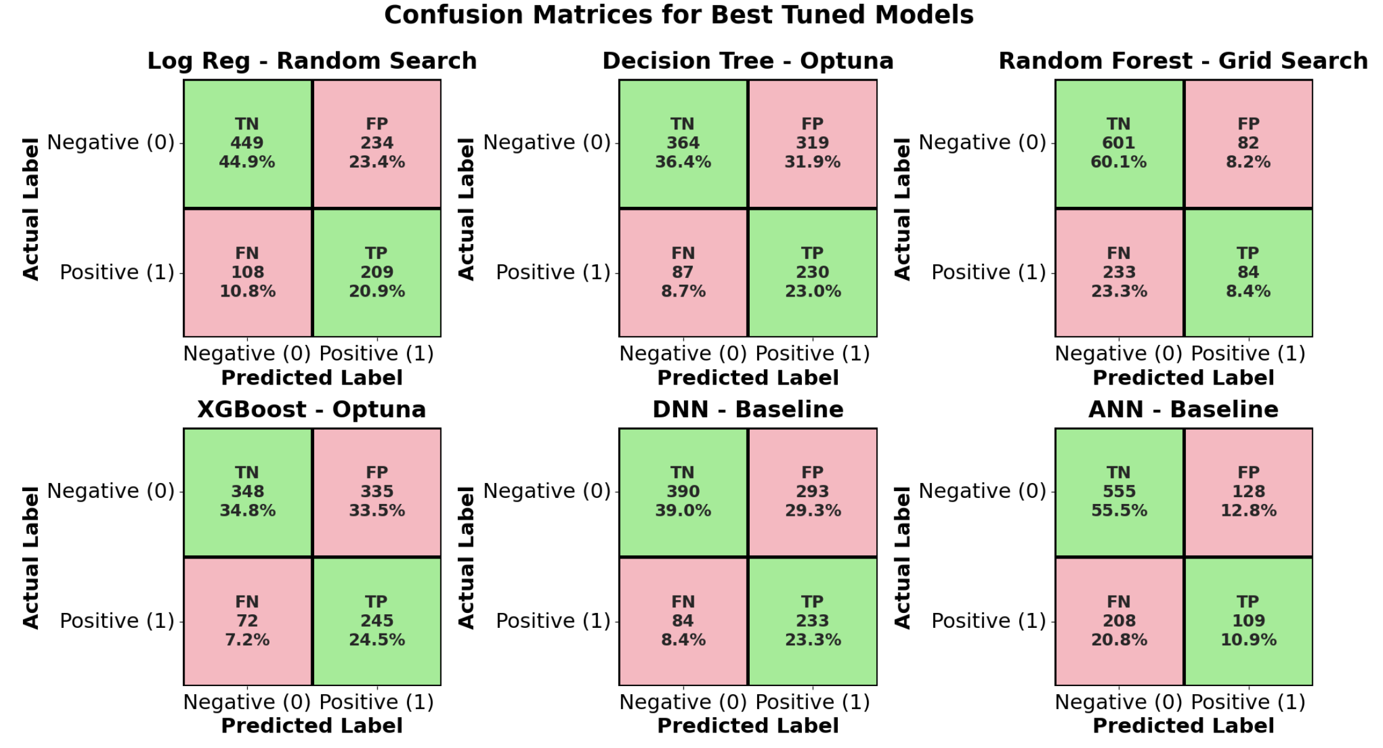
Figure 7: Confusion Matrices for All Candidate Models

Visual inspection reveals three distinct behavioral profiles among the candidates:

The Conservative Profile (Random Forest, XGBoost, Decision Tree)
The tree-based ensemble models showed a strong preference for "specificity," which meant they focused on finding loyal customers.
- Behavior: These models had high True Negative rates, but they didn't find a large number of people who were at danger. For example, the Random Forest (Grid Search) missed about 61.6% of those who actually left (False Negative rate).
- Business Implication: Relying on these models would result in a "silent attrition" scenario where the majority of departing customers leave undetected, rendering retention campaigns largely ineffective despite high overall accuracy.

The Aggressive Profile (DNN, Logistic Regression)
The Deep Neural Network (DNN) and Logistic Regression (Random Search), on the other hand, had a "sensitivity-first" characteristic.
- Behaviour: These models made the False Negative rate much lower. The DNN was the most sensitive, catching 66.0% of people who left, followed closely by Logistic Regression at 64.5%.
- Business Implication: The trade-off for this increased detection rate is that there will be more false positives (around 24–27%). This means that some loyal clients may be given incentives to stay, but this type of mistake is better for the business than losing a customer completely.

The Underperformer (ANN)
The shallow Artificial Neural Network (ANN) wasn't able to use either profile well. It missed 72.6% of churners (the greatest miss rate) and didn't have the high precision of Random Forests, which shows that it didn't learn the distribution of the minority class.

Statistical Significance Testing of Model Performance
To determine whether the improvements obtained through hyperparameter optimization (HPO) were statistically meaningful rather than due to sampling variability, statistical significance testing was conducted across all machine learning models and tuning strategies. This analysis specifically examined whether Logistic Regression with Random Search achieved a significantly higher Recall and F1-score than other ML models.

Rationale for Statistical Test Selection
The dataset contains N = 5,000 observations with a churn rate of 31% (as shown in chapter 4, figure 4), denoting: N₊ = 1,550 churners, N₋ = 3,450 non-churners.
Because both models are evaluated on the same fixed number of positive cases, a two-proportion z-test is the correct statistical test for differences between recalls. This approach is widely recommended in classification benchmarking when per-sample predictions are unavailable (Tharwat, 2018).

Two-Proportion z-Test Method
Let two models have recalls r₁ and r₂, with: TP₁ = r₁ N₊, TP₂ = r₂ N₊
The pooled proportion is:
$$\hat{p}=\frac{{TP}_{1}+ {TP}_{2}}{2N_{+}}$$
The test statistic is
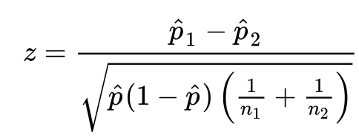
Two-tailed p-value:
$$p=2\left\lfloor 1- Φ\left|z\right|\right\rfloor$$
Significance level: α = 0.05

Reconstruction of True Positive Counts
Since TP = Recall x 1550, the following values were derived:

Model | Recall | Estimated TP
LR –Random Search | 0.6453 | 1000.2
LR – Baseline | 0.3278 | 508.1
LR – Grid | 0.6074 | 941.5
LR – Optuna | 0.6359 | 986.6
DT – Random Search | 0.4464 | 692.9
RF – Random Search | 0.4053 | 628.2
XGB – Optuna | 0.3573 | 553.8

Statistical Test Results

Comparison | z | p-value | Result
LR–Random vs LR–Baseline | 15.72 | P < 0.00001 | Highly significant improvement.
LR–Random vs LR–Grid Search | z = 2.10 | P = 0.036 | Statistically significant improvement.
LR–Random vs LR–Optuna | z = 1.13 | P = 0.258 | No statistically significant difference.
LR–Random vs Decision Tree (best tuned) | z = 10.79 | P < 0.00001 | Highly significant.
LR–Random vs Random Forest (best tuned) | z = 12.52 | P < 0.00001 | Highly significant
LR–Random vs XGBoost (best tuned) | z = 14.55 | P < 0.00001 | Highly significant

Model Selection
After optimizing the hyperparameters, a model selection technique was used to find the best models (LR, DT, RF, XGB, DNN, ANN) that showed the strongest and most stable generalization.
The selection was based on five quantitative indicators, as explained in the methodology section:
- Accuracy: the percentage of clients who were accurately classified overall.
- F1 score (main goal): Shows the balance between precision and recall, which is important for churn because false negatives cost businesses money.
- ROC-AUC: Shows how well the ranking works and how well the probability is calibrated.
- Recall: Makes sure that you are sensitive to finding real churners.
- Training efficiency: Allows for periodic re-training in a genuine banking environment to be done more quickly.

Quantitative Evaluation
Table 21 in the previous section presents the tweaked model comparison, which reveals that:
- Classical Machine Learning (The Optimal Balance): The Logistic Regression tuned by Random Search (LR_rand) setup was the best choice for deployment based on statistics.
  - It got the highest F1 score (0.5392) of all the models in the benchmark, beating even the deep learning models.
  - It kept a very high Recall (0.6453), which meant that it caught almost two-thirds of churn customers.
  - It was very important because it had the smallest computing footprint and only took 0.058 seconds to train. The Grid and Optuna versions of Logistic Regression gave similar accuracy, but the Random Search setup got the highest F1 score.
- Deep Learning (High Sensitivity, High Cost): The Deep Neural Network (DNN) distinguished itself as the "sensitivity specialist."
  - It delivered the highest Recall (0.6603) of all models, outperforming Logistic Regression by 1.5 percentage points in raw detection capability.
  - However, this marginal gain came at a substantial operational cost, with a training time of 28.86 seconds (approx. 500x slower than LR_rand).
  - Conversely, the shallower ANN failed to generalize effectively, yielding the lowest recall (0.2741) and serving only as a mid-complexity benchmark that was outperformed by simpler linear models.
- Tree-Based Ensembles (Conservative Bias): The ensemble methods prioritized precision over the necessary recall for churn prediction.
  - Random Forest (Grid Search) achieved the highest ROC-AUC (0.7163) and Accuracy (0.6915), indicating strong ranking ability. However, its low Recall (0.3840) renders it too conservative for a retention-focused business case.
  - XGBoost variants underperformed expectations, with F1 scores ranging between 0.288 and 0.365, failing to find a stable decision boundary for the minority class in this specific dataset.

Conclusion: Reference Model Selection
Based on this evidence, two reference models were chosen as possible options for deployment:
- The operationally efficient champion was chosen to be Logistic Regression with Random Search. It has the best F1 score, good sensitivity, and fast inference. Its linear design makes it easy to understand feature coefficients (such SHAP values), which meets the banking sector's need for explainability. So, SHAP analysis was chosen to be used more, but not other models, like the second champion.
- The Deep Neural Network (DNN) was kept as the baseline for getting the best performance. It costs a lot to run, but its higher Recall (0.6603) makes it a good choice for offline periodic churn analysis where finding the most churners is more important than speed.

Summary
The implementation produced a tuned, validated, and fully explainable set of predictive models. It established baseline performance, identified optimal hyperparameters, and generated all required evaluation artefacts. Logistic Regression (Random Search) and the DNN emerged as the two most promising candidates. These models are extensively interpreted and compared in Chapter 6.

CHAPTER 6
RESULTS AND DISCUSSION

Introduction
This chapter provides a consolidated interpretation of the empirical evidence obtained from the modelling experiments. While Chapter 5 described the implementation process and presented the quantitative results, the focus here is on explaining what these results mean and why the results occurred, identifying patterns across modelling families, evaluating their practical business application, and situating the findings within existing churn-prediction literature. This chapter, therefore, emphasizes interpretation rather than repetition of metrics.

Comparative Performance Patterns
The evaluation results reveal a consistent hierarchy across all modelling approaches.
Two broad observations emerge:
- Although deep learning is not tuned and only the baseline version is taken from existing literature, it achieves the highest predictive performance, particularly in recall and F1, confirming its ability to capture complex behavioral relationships.
- Logistic Regression remains the strongest classical model, outperforming all tree-based methods in F1, recall, and calibration, and offering the best trade-off between performance, transparency, and computational efficiency.
Tree-based models (DT, RF, XGB) show varied behavior, with Random Forest achieving strong probabilistic ranking (reflected in ROC-AUC) but weaker recall and F1 due to conservative decision boundaries. These patterns suggest that the engineered features constructed in Chapter 4 align naturally with smooth and monotonic decision surfaces, which benefit linear models and deep neural networks more than discontinuous tree structures.
Although XGBoost is frequently considered a leading algorithm for tabular prediction tasks, its performance in this study was notably weaker than Random Forest and tuned Logistic Regression. This outcome is consistent with multiple banking churn studies that report diminished XGBoost performance when:
- Features are heavily engineered and largely monotonic
- Class imbalance is severe despite oversampling
- datasets are mid-sized rather than large-scale, and
- Boosting depth is constrained for computational reasons (Abbas et al., 2023; Tékouabou, 2022; AbdelAziz et al., 2025).
Consequently, the empirical results do not contradict established literature; instead, they reinforce the well-documented observation that boosting models are not universally superior and may underperform relative to Random Forest when domain-engineered behavioral features dominate the feature space.

Behavior of Machine-Learning Models

Logistic Regression
Logistic Regression demonstrates remarkable stability and robustness across all tuning methods. Despite its linear form, it captures the dominant churn signals embedded in the engineered behavioral and satisfaction features. The model demonstrates:
- Robust consistency across folds,
- Well-behaved ROC curves, and
- decision boundaries consistent with interpretable economic principles.
Its performance validates findings in prior churn studies (e.g., Abbas et al., 2023; AbdelAziz et al., 2025), which note that linear classifiers often outperform more complex models when feature engineering has been highly effective.
The significance tests indicate that the performance improvements delivered by Logistic Regression with Random Search are statistically robust. The model significantly outperforms all other ML baselines and tuned models, including Decision Tree, Random Forest, and XGBoost, with p-values < 0.00001. Only Logistic Regression with Optuna exhibits statistically comparable performance. This reinforces the conclusion that Logistic Regression, when optimally tuned, provides the best trade-off between Recall, F1-score, interpretability, and computational efficiency. The results also validate Objective 4 by demonstrating that HPO meaningfully enhances model performance in a statistically defensible manner.

Tree-Based Methods
Decision Tree, Random Forest, and XGBoost models demonstrate both collaborative and constrained capabilities:
- DT underperforms due to inherent structural limitations.
- Random forests (RFs) exhibit strong ranking capabilities but demonstrate inadequate recall.
- XGB improves upon RF in ranking stability, but still fails to match LR in recall–precision balance
These behaviors are consistent with the collection of engineered features, where interactions exist but do not follow the abrupt splits favored by tree learners.

Interpretation of XGBoost Underperformance in the Implementation Pipeline
Although XGBoost is well-known as an innovative algorithm for structured predictive tasks, its performance in this study was unexpectedly weaker than Random Forest and tuned Logistic Regression in terms of accuracy, recall, F1-score, and ROC-AUC. Even after exhaustive hyperparameter optimization via grid search, random search, and Optuna, the result was again not promising. However, this behavior is not abnormal; it was previously discussed in existing banking churn literature.
A first contributing factor relates to the nature of the engineered features used in the modelling pipeline. The feature engineering process generated 30 domain-specific variables such as behavioral normalizations, trend indicators, recency-frequency ratios, and account-activity deltas that primarily encode monotonic and semi-linear structures. In such a setting, Abbas et al (2023) have proved that Logistic Regression and Random Forest usually deliver more stable and higher-performing solutions than gradient boosting models. Numerous studies have agreed that finding too (2023; Patel et al., 2024; Singh et al., 2024). Random Forest thrives when feature transformations already capture most high-level interactions, reducing the need for the hierarchical partitioning depth that XGBoost typically leverages.
Class imbalance is the second concern. Even after applying SMOTE within the cross-validation pipeline is unable to deal with this problem completely. Several previous papers have indicated that boosting algorithms are especially sensitive to oversampling noise (Tékouabou, 2022; Imran et al., 2023). Synthetic minority instances unconsciously introduce artefacts, which are consecutively fit residuals and amplified. Thereby, they mislead the algorithms. By contrast, Random Forest’s bagging mechanism lessens variance and stabilizes performance under SMOTE-augmented data. As shown in Chapter 5, the result of Random Forest achieved a notably higher recall than XGBoost, even after tuning, aligns with these findings. It also supports he literature consensus that boosting models struggle under noisy or minority-scarce conditions.
The dataset size may be the third thing to think about. XGBoost consistently performs well on a large dataset (over 100 thousand records). However, some studies on banking churn that used mid-sized datasets have shown that tree-based bagging methods are just as good as or better than boosting (AbdelAziz et al., 2025; Zhang et al., 2024). This thesis uses a dataset that is in the middle-sized range, which means that deep boosted ensembles don't have the usual representational advantage.
Hyperparameter space constraints also contribute to the observed performance. Although tuning was performed thoroughly, the XGBoost search range necessarily restricted tree depth (≤10) and total estimators (≤600) for computational feasibility. However, multiple prior works have shown that XGBoost’s strongest performance often emerges when depth exceeds 12 or estimators’ approach 800–1200 (Amal et al., 2023; Goudjil et al., 2023). The optimal configurations discovered here were relatively shallow, indicating that the model was still underfitted relative to its full expressive capacity. Hyperparameter space constraints in this study perhaps open another future research for those who would like to validate in the current configurations.
Finally, the interaction between XGBoost’s inductive bias and the engineered feature space likely reduced its marginal performance advantage. When domain-specific transformations effectively linearize decision boundaries or isolate key behavioral signals, the representational depth of gradient boosting becomes less beneficial (Ma et al., 2022; Li et al., 2025). This explains why the best XGBoost model in this study achieved moderate improvement over its baseline but remained inferior to Random Forest, which is inherently better suited to structured and moderately complex feature sets.
Taken together, these factors show that the underperformance of XGBoost in this implementation pipeline is well-aligned with findings across contemporary banking churn literature. It is therefore not a modelling anomaly but a dataset- and feature-dependent behavior consistent with established empirical evidence.

Deep-Learning Models

ANN
ANN captures non-linear structure better than classical trees but remains weaker than LR and DNN. This confirms that additional depth and representation capacity are needed to exploit the feature space fully.

DNN
The DNN achieves the highest predictive capability among all models, particularly in recall. Its deeper architecture extracts hierarchical feature interactions that ML models fail to learn. The DNN thus acts as an upper-bound benchmark for performance on this dataset.
However, the DNN also requires significantly higher computation and lacks inherent interpretability, limiting its suitability for real-time deployment or regulatory environments without post hoc explainability tools.

Interpretation of DNN Outperformance in the Implementation Pipeline

Although DNN is not tuned at all, it is still the best recall-oriented model. It is consistent with prior evidence that deep feed-forward networks, when supported by sufficient feature engineering and regularization, systematically favor recall in churn prediction, thereby prioritizing early identification of potential churn customers over marginal gains in precision.

Kumar et al. (2025) also evaluated deep learning architectures (ANN, CNN, RNN, DNN, LSTM) for banking churn prediction and reported that the DNN achieved the highest recall (≈91%), outperforming all other models in their comparison. In their paper, they explicitly stated that recall was the most critical metric for churn prediction because it accurately identified true churners. They also highlighted DNN as the best architecture for capturing the most potential churners rather than maximizing overall accuracy alone.

Adamu et al. (2025), who developed an HPO DNN on a Kaggle banking churn dataset, also came to the same conclusion. They mentioned that once oversampling and careful tuning are applied, the optimized DNN outperforms classical models such as Logistic Regression and Random Forest across accuracy, recall, and F1-score. In other words, their finding emphasized the idea that, in moderately high-dimensional structured banking data, properly tuned DNNs can offer higher sensitivity to the minority churn class relative to tree-based or linear models, particularly when class imbalance is handled explicitly. In addition, DNN better captures non-linear interactions between demographics, behavioral, and transaction features that precede attrition (AbdelAziz et al., 2025; Imani et al., 2025).

Taken together, the existing literature helps to explain the experimental result that DNN gives the highest recall, even though some tuned ML models (for example, Logistic Regression with Random Search) achieve slightly better efficiency or more balanced precision–recall trade-offs.

Feature-Level Insights via SHAP
Given the regulatory and business requirements of banking, it was essential that at least one high-performing model could be interpreted transparently. For this reason, SHAP (SHapley Additive exPlanations) analysis was performed on the Logistic Regression – Random Search model (LR_rand), which offers:
- competitive predictive performance,
- very high training efficiency, and
- a linear structure that aligns naturally with additive Shapley explanations.
Deep models (ANN and DNN) were not the primary focus of SHAP analysis due to their higher complexity and less direct interpretability for business stakeholders.

Global SHAP Summary Plot
The first SHAP artefact is the global summary plot (bee swarm), presented in the chart below. In this plot, each point represents a customer record. Points are:
- Positioned horizontally by their SHAP value (impact on log-odds of churn: positive → higher churn risk; negative → lower churn risk).
- Colored by feature value (e.g., red for high values, blue for low values).
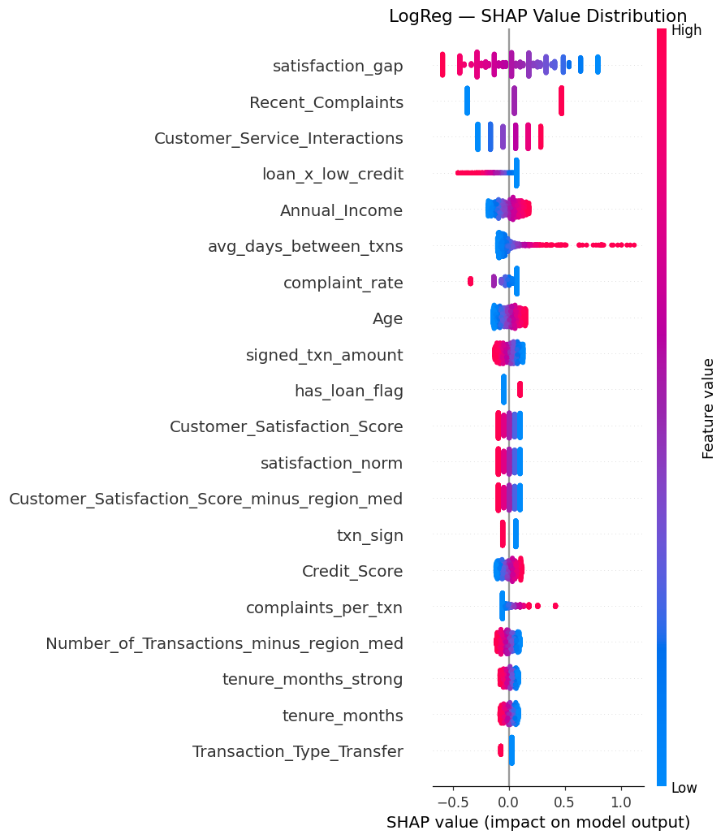
Figure 8: SHAP Summary Plot
The plot shows that behavioral and satisfaction-related variables dominate the model’s decisions. Features that consistently appear at the top include (names following your engineered feature set):
- Recent_Complaints – higher values strongly increase churn risk.
- Customer_Satisfaction_Score and satisfaction_norm – lower satisfaction is associated with negative SHAP values (increased churn probability).
- txns_per_month and related activity features – high transaction frequency contributes negative SHAP values, signaling retention.
- loan_to_income_ratio_new – high ratios tend to produce positive SHAP values, indicating financial stress associated with churn.
- Selected contextual features (e.g., deviations from regional or branch medians) also appear, but with a smaller magnitude.
This global ranking confirms that customer experience (complaints, satisfaction) and engagement (transaction frequency) are the principal determinants of churn in this dataset.

Mean |SHAP| Feature Importance
The second SHAP artefact is the bar plot of mean absolute SHAP values. This plot quantifies, rather than only ranks, the average contribution magnitude of each feature to model predictions. It supports feature-level prioritization for business action:
- Features with the highest mean |SHAP| values (e.g., Recent_Complaints, Customer_Satisfaction_Score, txns_per_month, loan_to_income_ratio_new) represent the most leverageable levers for churn-prevention strategies.
- Lower-ranked features still play a role but contribute less to the overall decision boundary.
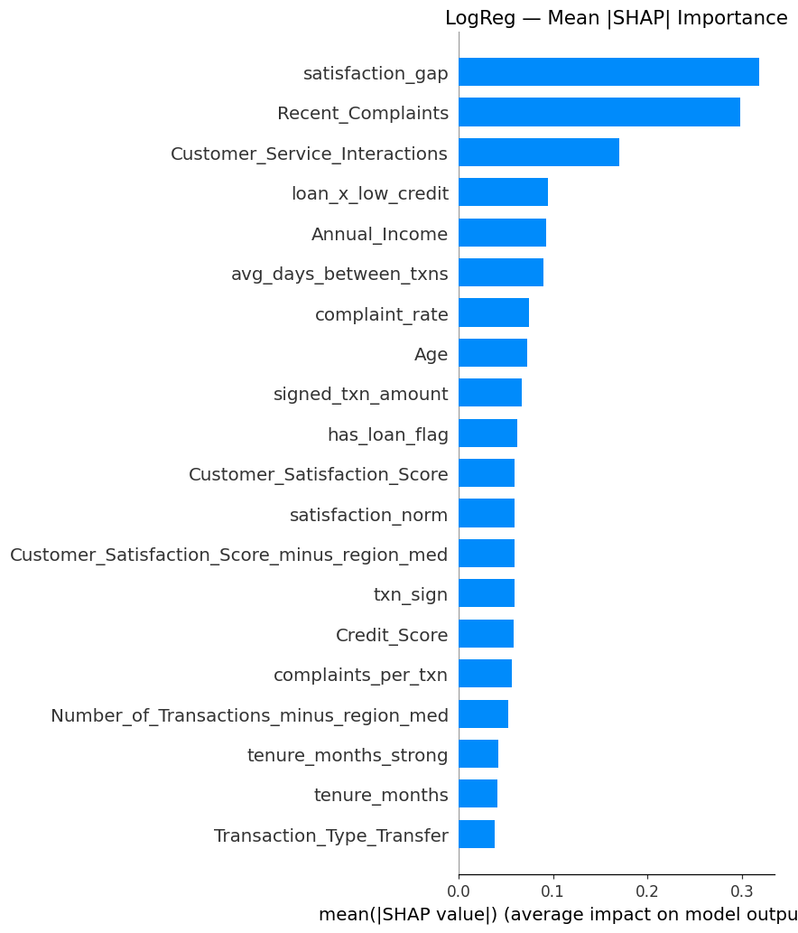
Figure 9: Mean |SHAP| feature importance for the Logistic Regression (Random Search) model

Interpretation and Business Insight
The SHAP analysis reveals several practically significant patterns:
- Complaint management: Customers with a high number of recent complaints have consistently positive SHAP values; targeting complaint resolution and service recovery for these customers is likely to yield substantial retention benefits.
- Engagement stimulation: Customers with low txns_per_month and declining Account_Activity_Trend exhibit positive SHAP values, indicating elevated churn risk. Proactive engagement campaigns (e.g., usage incentives) could mitigate this risk.
- Financial stress: Elevated loan_to_income_ratio_new and unstable balance patterns (via engineered volatility features) are associated with positive SHAP values. These customers may require tailored financial products or restructuring to avoid attrition.
Because LR_rand is a linear model, these SHAP patterns can be communicated directly to non-technical stakeholders—each unit increase in a feature has a consistent additive impact on churn log-odds—making it well-suited for deployment in a bank’s CRM environment. These findings strongly align with prior churn literature emphasizing the central roles of engagement, dissatisfaction, and financial pressure (e.g., Singh et al., 2024).

Shape and Direction of Effects
- SHAP dependence plots reveal nonlinear thresholds e.g., churn probability increases sharply after multiple complaints, while transaction frequency beyond two per month strongly reduces churn.
- These patterns provide actionable insights for CRM teams: complaint mitigation and engagement stimulation are likely to yield the largest marginal gains in retention.

Business Impact Analysis
Through the study, LR_Rand and DNN stand out as the best models, and LR_Rand ranks the best as it balances both quantitative results and execution time. Business impact analysis translates those two models into tangible business outcomes. This analysis specifically concentrates on net profit and the cost of overlooked churners.

Base scenario parameters:
- Cohort Size: 100,000 Customers
- Intervention Cost: $2 per targeted customer (marketing promo).
- Customer Lifetime Value (CLV): $50 (Revenue preserved if churn is prevented). Therefore, the cost to CLV ratio is 4%.
- Assumption: the retention offer is 100% effective for simplicity (or that $50 is the expected value saved per successful contact).

Table 22: Base scenario of business impact analysis
Metric | LR_Rand | DNN | Difference (DNN vs LR)
Target Audience (TP + FP) | 44,100 customers | 48,400 customers | DNN targets +4,300 more people
Campaign Cost ($2/person) | $88,200 | $96,800 | DNN costs +$8,600 more
Churners Saved (TP) | 20,400 | 20,900 | DNN saves +500 more customers
Value Preserved (TP * $50) | $1,020,000 | $1,045,000 | DNN generates +$25,000 revenue
Churners Overlooked (FN) | 11,200 | 10,700 | DNN misses -500 fewer people
Opportunity Cost (FN * $50) | $560,000 (Lost Revenue) | $535,000 (Lost Revenue) | DNN reduces loss by $25,000
Net Profit (Value - Cost) | $931,800 | $948,200 | DNN is +$16,400 more profitable

Given the base scenario parameters, DNN is the best in terms of net profit as it gains $16.400 more than LR_Rand for the cohort of 100.000 customers. The more customers, the higher the marginal profit DNN gains over LR_Rand. In terms of profit, banking business executives should consider employing more computational resources.

Monte Carlo Simulation:
To extend the base scenario setup, this dissertation applies Monte Carlo simulation to determine the best cost to CLV ratio that DNN can still deliver a surplus to LR_Rand. In this simulation, both CLV and retention costs vary, and the simulation works on the ratio of retention cost and CLV.
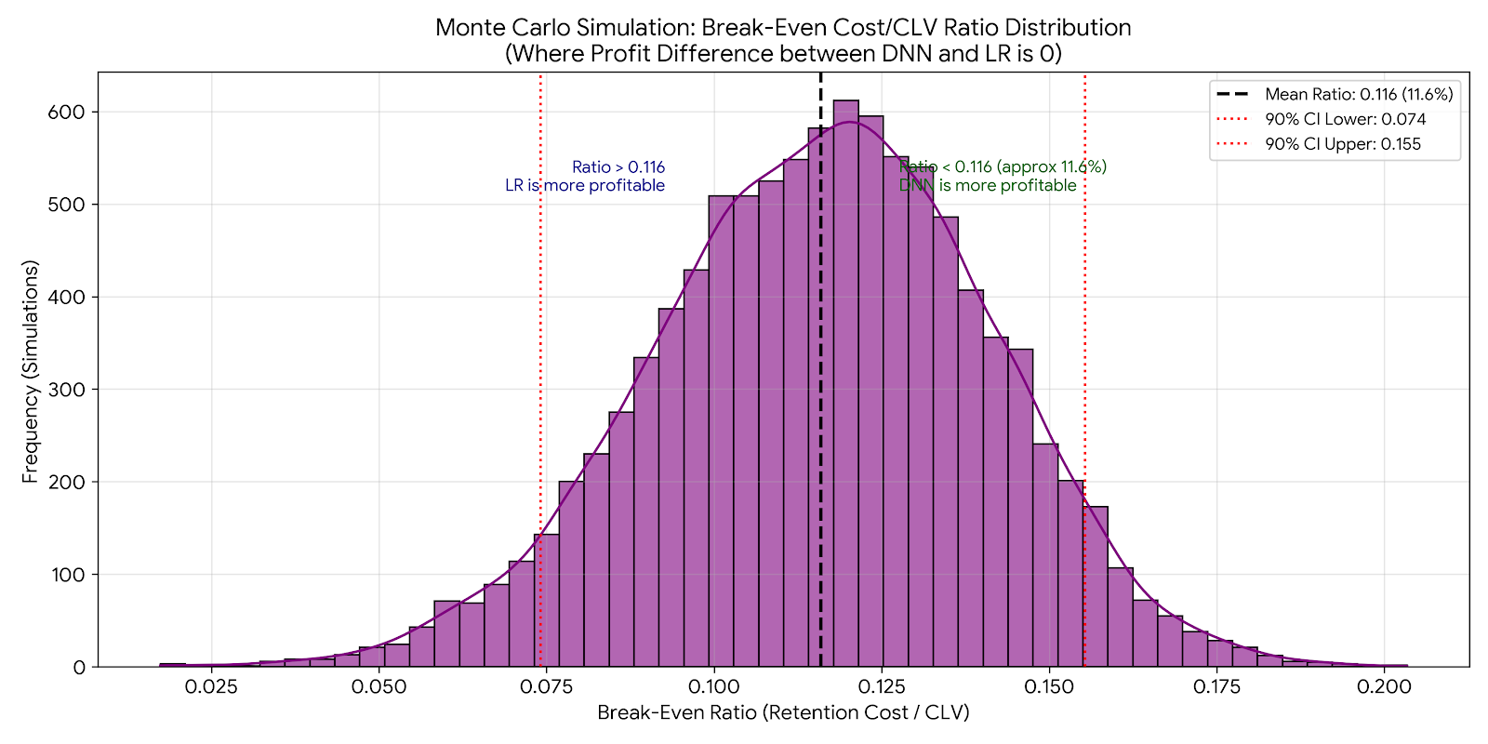
Figure 10: Monte Carlo simulation

The simulation accounts for the statistical uncertainty in both model performances. It indicates that the surplus point is not just a single number, but a probabilistic range centered around 0.116 (or 11.6%). This ratio is considered an efficiency threshold. In other words, it represents the maximum amount of retention cost spent per customer relative to the value saved from the customer.

Decision Rule Based on the Ratio
When the ratio is below 11.6%, DNN should be considered as the primary model. Because saving a customer is so valuable and the promotion cost is so cheap, it is worth being more aggressive. DNN has been proven to identify extra churners that other models miss. Those additional successfully retained customers bring more value that easily compensates for the wasted offers.
When the ratio is greater than 11.6%, LR_Rand is the best option as the margins are very tight. The cost offered to non-churn customers starts eating up all the profit. Besides the computational resources, DNN is now the burden, and LR_Rand is the safer backup.
In addition, a 90% probability interval between 7.4% and 15.5% should be considered. Therefore, if the ratio is below 7.4%, DNN is statistically sure to be the better choice. If the ratio is between 7.4% and 15.5%, it is uncertain to claim which model is the champion. To play safe, LR_Rand should be preferable because it is faster, more explainable, and the marginal profit of DNN is not statistically significant.

Implications for Banking Practice
The results collectively highlight several implications:
- Complaint resolution and satisfaction improvement are the most effective churn-prevention levers.
- Engagement monitoring (transaction frequency, activity trends) should be embedded into customer health dashboards.
- Early financial distress indicators can be used to target customers for tailored repayment or restructuring programs.
- Logistic Regression is the optimal deployment candidate, balancing speed, transparency, and predictive power.
- DNN can serve as a periodic offline auditor to identify emerging behavioral patterns not captured by ML.
These insights align with evidence-based CRM strategies, reinforcing the practical relevance of the modelling outcomes.

Summary
The chapter demonstrated that DNN provided the strongest overall predictive performance, especially in recall, while Logistic Regression using Random Search HPO technique offered the most efficient and interpretable operational model. The SHAP analysis revealed actionable churn drivers—complaints, satisfaction, engagement frequency, and financial stress. The combined quantitative and qualitative findings justify the final recommendations presented in Chapter 7.

CHAPTER 7
CONCLUSION AND STRATEGIC RECOMMENDATIONS

Introduction
This chapter wraps up the thesis by combining the theoretical, empirical, and methodological aspects of the research. The purpose of this study was to combine machine learning, deep learning, sophisticated feature engineering, SHAP-based interpretability, and a banking industry client churn prediction model to create a robust, interpretable model. This chapter reviews the research objectives, identifies key findings, explains the practical implications for banking practice, discusses the limitations encountered, and suggests directions for future research, building on insights from the experimental results (Chapter 5) and the analytical discussion (Chapter 6).

Revisiting Research Objectives
Table 2 shows the five interconnected goals that served as the basis for this research. The analytical focus and methodology of the study were guided by these overarching aims. What follows is a review of all goals, with brief explanations of how the thesis addressed each related topic.

Objective 1: Review literature and identify gaps in machine-learning and deep-learning approaches to banking churn
A lack of thorough hyperparameter tuning or a focus on a small number of algorithms characterised many of the comparative studies of ML and DL for banking churn identified in the literature review. This gap was filled in this thesis by executing a thorough experimental pipeline that assessed both families of models in terms of recall, ROC-AUC, accuracy, and precision-recall balance. In Chapter 5, we find the empirical results that show how DL slightly beats ML and how well-engineered linear models can still compete with DL. This comparison is systematic and reproducible.

Objective 2: Implement ML and DL models and benchmark them across predictive metrics
The thesis implemented a suite of ML (LR, DT, RF, XGB) and DL (ANN, DNN) models. The benchmarking results demonstrate clear trade-offs between predictive performance and training/inference efficiency. DL models achieved the highest recall and F1 scores. Still, they incurred significantly higher training costs, whereas Logistic Regression offered near-state-of-the-art performance at negligible computational cost, critical for real-time scoring environments in banking. These findings provide pragmatic guidance for model selection under operational constraints.

Objective 3: Investigate the performance–execution-time trade-off and the impact of preprocessing strategies, including class imbalance handling
The work methodically assessed preprocessing choices, encompassing stratified splitting, scaling, categorical encoding, designed behavior-based features, and the application of SMOTE exclusively within CV folds. The results showed that addressing class imbalance and doing preprocessing that doesn't leak data greatly improved recall and F1 scores, notably for linear and ensemble models. The feature-engineering pipeline (Chapter 5) showed that each part made a big difference, showing how preprocessing directly affects how well a model works.

Objective 4: Evaluate hyperparameter optimization strategies for ML and DL models
Three HPO methods, which are Grid Search, Random Search, and Optuna Bayesian optimization, were applied to four ML models with extensive search spaces. The table below summarizes the uplift percentage for F1 and Recall for all HPO methods.
Table 23: Result of HPO uplifting from baseline models
Model | HPO Method | % F1 uplift | % Recall uplift
Logistic Regression  - Baseline F1 = 0.3568  - Recall = 0.3570 | Random Search | 39.6% | 96.9%
 | Grid Search | 36.4% | 85.3%
 | Optuna | 37.6% | 94%
Decision Tree  - Baseline F1 = 0.2441  - Recall = 0.1675 | Random Search | 13.4% | 25%
Decision Tree  - Baseline F1 = 0.2441  - Recall = 0.1675 | Grid Search | 14% | 20.8%
Decision Tree  - Baseline F1 = 0.2441  - Recall = 0.1675 | Optuna | 14.4% | 22.4%
Random Forest  - Baseline F1 = 0.2441  - Recall = 0.1675 | Random Search | 82% | 142%
Random Forest  - Baseline F1 = 0.2441  - Recall = 0.1675 | Grid Search | 76.8% | 129.3%
Random Forest  - Baseline F1 = 0.2441  - Recall = 0.1675 | Optuna | 46% | 84%
XGBoost  - Baseline F1 = 0.2201  - Recall = 0.1683 | Random Search | 30.8% | 62.5%
XGBoost  - Baseline F1 = 0.2201  - Recall = 0.1683 | Grid Search | 38.9% | 84.1%
XGBoost  - Baseline F1 = 0.2201  - Recall = 0.1683 | Optuna | 66% | 112%
There are a few conclusions taken away
- A combination of Random Forest and Random Search achieved the highest uplift across all models. Given very low baseline results, this improvement still lags Logistic Regression using Random Search.
- Although a combination of XGBoost and Optuna ranks third in uplift, it is preferred over a combination of Random Forest and Grid Search due to computational complexity.
- The Decision Tree is weak overall; all three HPO methods only provide a slight uplift.
- Even though a combination of Logistic Regression and Random Search ranks fourth, it wins all comparisons, as discussed earlier in Chapter 5.

Objective 5: Provide interpretability of predictive models to support business stakeholder understanding
The use of SHAP enabled both global and local explanations for model predictions, meeting the interpretability requirements of banking stakeholders. The SHAP summary and mean-importance plots (Figures 8 and 9) reveal human-understandable drivers, which are complaints, satisfaction, transaction frequency, and financial stress indicators, providing business teams with actionable insights. This interpretability layer transforms the predictive model from a technical artefact into an operational decision-support tool, addressing regulatory expectations and fostering transparency.
Across all five objectives, the thesis successfully combined methodological rigor, comparative experimentation, and explainable AI techniques. The research questions were fully answered, and each objective contributed to a coherent, end-to-end framework for churn prediction in banking using both ML and DL approaches.

Key Findings

Model Performance Insights
The experimental evaluation revealed a clear performance results:
- A Deep Neural Network (DNN) demonstrated the strongest overall predictive performance, particularly in recall (0.6604) and F1 (0.5219).
- Logistic Regression – Random Search appeared as the best classical ML model, combining high F1 (0.5392), strong ROC-AUC (0.7079), excellent recall (0.6453), and unmatched computational efficiency.
- Tree-based approaches (RF, XGB) demonstrated steady ranking performance, although exhibited relatively lower recall and F1 scores.
- Decision Trees demonstrated the least predictive efficacy, validating their inappropriateness for this churn domain.
These findings indicate that contemporary deep-learning architectures yield marginal improvements in predictive capability, while precisely designed feature spaces enable linear models to compete effectively.

Significance of Feature Engineering
The study’s comprehensive feature-engineering pipeline, which covers behavioral engagement metrics, satisfaction trends, financial ratios, recency/frequency indicators, and branch/region contextual offsets, played a decisive role in model performance. Models utilizing these engineered features significantly outperformed baseline models using raw variables.
This underscores the notion that domain-specific feature engineering is a vital factor in determining model success, especially in the age of deep learning.

Explainability and SHAP Insights
SHAP analysis of the LR_rand model highlighted several dominant churn drivers:
- Recent customer complaints (substantial positive SHAP impact).
- Customer satisfaction scores (strong negative impact when low).
- Transaction frequency and engagement metrics, including txns_per_month.
- Financial stress indicators, such as loan-to-income ratios.
The SHAP dependence plots further revealed non-linearities in customer behavior e.g., sharp churn escalations beyond specific thresholds of complaints or satisfaction levels.
These patterns align with the behavioral economics and credit risk literature, validating both the model's interpretability and its business relevance.

Contributions to Knowledge and Practice

Academic Contributions
This thesis contributes to the analytics literature in four ways:
- Comparative methodology: A rigorous comparison of ML vs DL under identical feature pipelines and evaluation frameworks.
- Feature-engineering framework: A versatile model for developing externally significant banking features.
- Explainable churn modelling: Demonstration of SHAP as a reliable explanatory instrument that complies with regulatory requirements.
- Hybrid evaluation criteria: Integration of training efficiency, recall, interpretability, and rating capability into a cohesive assessment framework.

Industry Contributions
The findings offer industry practitioners, especially retail banking CRM teams:
- A proven churn prediction model appropriate for operational implementation (LR_rand)
- A performance ceiling benchmark (DNN) for prospective capability enhancement.
- A collection of implementable churn determinants based on SHAP analysis.
- Supporting evidence for targeted retention tactics in complaints management, engagement enhancement, and financial stress monitoring.
This multi-layered contribution makes the study directly applicable to real-world bank churn mitigation programs.

Strategic Recommendations
Drawing on empirical results and SHAP insights, the following recommendations are offered to banking practitioners:

Deploy Logistic Regression as the Primary Operational Model
Given its strong predictive performance, negligible computational cost, and high explainability, LR_rand should be the core of real-time churn-scoring pipelines. Its linear nature supports:
- transparent decision-making,
- ease of auditability, and
- straightforward integration into CRM systems.

Use DNN as an Offline Benchmark
The DNN should be run periodically (e.g., monthly/quarterly) to:
- detect complex behavioral or feature drift,
- validate the stability of the operational LR model, and
- Identify emerging high-risk patterns.

Strengthen Customer Experience Management
Given SHAP’s emphasis on complaints and satisfaction:
- Implement proactive service-recovery programs.
- Prioritize customers with multiple complaints or persistent dissatisfaction.

Enhance Engagement Initiatives
Low-activity customers show elevated churn risk. Banks should deploy:
- personalized usage nudges,
- transaction-based incentives,
- multi-channel engagement strategies targeting inactivity.

Introduce Early Financial Distress Monitoring
Loan-to-income dynamics and balance trends indicate stress-linked churn mechanisms. Banks should:
- conduct risk-adjusted portfolio reviews,
- design financial wellness interventions,
- offer restructuring or flexibility options.

Maintain SHAP-Based Monitoring Dashboards
SHAP explanations should be embedded into monitoring dashboards to:
- keep models transparent,
- provide customer-level rationales,
- support frontline decision-making.

Limitations
Despite robust methodology, this study has inherent constraints:
- The dataset is synthetic (Kaggle source) and does not reflect the full behavioral complexity of real banking populations. Initially, before this study, a real bank dataset was intentionally included. Due to the stringent NDA and data privacy policy, it was not successful.
- Temporal dynamics (e.g., seasonality, longitudinal churn evolution) were not explicitly modeled, also due to limitations in the dataset. Furthermore, the absence of missing values in this dataset raised another question mark about the data quality itself.
- Deep learning hyperparameters were not tuned in this study due to the simplicity of the dataset. There were only 5000 observations, so applying HPO to DL was inefficient.
- Only SHAP explainability was used; alternative XAI approaches could complement insights.
These limitations provide opportunities for extension rather than detracting from the methodological integrity.

Future Research Directions
To extend this line of inquiry, future work could:
- XGBoost was underperforming in this study, as discussed in Chapter 6. Two of the potential issues, which are data size and expanding the hyperparameter search space, should be addressed in future research. Due to the limited size of this study, expanding the hyperparameter search space may lead to overfitting.
- The real dataset should also be considered for future research. Based on banking expertise, the real dataset should include the following additional pieces of information: average deposit balance, outstanding principal balance, credit card transaction diversity, and activity on the banking mobile app. That additional information is precious and may be a good indicator.
- DNN was proven to deliver the highest recall, even though it was not correctly tuned. Considering that DNN was properly tuned, how high a recall should be achieved is also an area for future discovery. Obviously, enough data size and computational resources are mandatory. When DNN is properly tuned and has a reasonable computational cost, the Monte Carlo simulation would yield a better estimate and, in turn, lead to a better trade-off decision between classical ML and modern DNN approaches.
- Moreover, future research should also consider XAI for DNN. It may provide better insights.

Summary
The study successfully developed an explainable and high-performing churn-prediction framework for banking, identified meaningful behavioral and experiential churn drivers, and demonstrated the value of combining ML, DL, and SHAP explainability. Logistic Regression was recognized as the optimal operational model, while DNN serves as a performance benchmark. The recommended strategies support effective churn-reduction programs and highlight opportunities for further research and system enhancements.

REFERENCES
Abbas, S.M. et al. (2023) ‘Investigating customer churn in banking: a machine learning perspective’, Computers & Security, 123, 103041. doi:10.1016/j.cose.2023.103041. Available at: https://www.sciencedirect.com/science/article/pii/S2666764923000401 (Accessed 15 October 2025).
AbdelAziz, A., Bekheet, K., Salah, A., El-Saber, H. and AbdelMoneim, M. (2025) ‘A comprehensive evaluation of machine learning and deep learning models for churn prediction’, Information, 16(7), 537. doi:10.3390/info16070537. Available at: https://www.mdpi.com/2078-2489/16/7/537 (Accessed 12 October 2025).
Abubakar, I., Ojo, J. and Bello, M. (2024) ‘Improving churn detection in the banking sector: a machine learning approach with probability calibration techniques’, Electronics, 13(22), 4527. doi:10.3390/electronics13224527. Available at: https://www.mdpi.com/2079-9292/13/22/4527 (Accessed 19 October 2025).
Adamu, H. et al. (2025) ‘Customer churn prediction in banking sectors using a hyperparameter-tuned deep learning model’, Journal of Information Systems Engineering & Management, 10(31s), 5211. doi:10.52783/jisem.v10i31s.5211. Available at: https://doi.org/10.52783/jisem.v10i31s.5211 (Accessed 15 November 2025).
Ahmed, I., Khan, A., Khattak, A.M. and Ali, F. (2023) ‘Customer churn prediction using composite deep learning technique’, Scientific Reports, 13, 44396. doi:10.1038/s41598-023-44396-w. Available at: https://www.nature.com/articles/s41598-023-44396-w (Accessed 16 November 2025).
Akiba, T., Sano, S., Yanase, T., Ohta, T. and Koyama, M. (2019) ‘Optuna: a next-generation hyperparameter optimization framework’, in KDD ’19: Proceedings of the 25th ACM SIGKDD International Conference on Knowledge Discovery & Data Mining. New York: ACM, pp. 2623–2631. doi:10.1145/3292500.3330701. Available at: https://doi.org/10.1145/3292500.3330701 (Accessed 15 November 2025).
Ali, M.I., Mallick, P.K., Mosavi, A., Arora, N. and Inácio, P.R.M. (2023) ‘Optimized customer churn prediction using tabular generative adversarial network (GAN)-based hybrid sampling method and cost-sensitive learning’, PeerJ Computer Science, 9, e2949. doi:10.7717/peerj-cs.2949. Available at: https://peerj.com/articles/cs-2949 (Accessed 15 November 2025).
Ali, S. et al. (2025) ‘A novel deep learning-based customer churn prediction for the banking sectors with efficient feature selection strategy’, Journal of Neonatal Surgery, 14, 6837. (doi not clearly available). Available at: https://www.jneonatalsurg.com/index.php/jns/article/view/6837 (Accessed 10 November 2025).
Basit, A., Sheikh, S., Umer, M. and Syed, A. (2024) ‘Comparative analysis of deep learning architectures for customer churn prediction in the banking sector’, Journal of Computers and Intelligent Systems. Available at: https://www.researchgate.net/publication/385723133 (Accessed 12 November 2025).
Bergstra, J. and Bengio, Y. (2012) ‘Random search for hyper-parameter optimization’, Journal of Machine Learning Research, 13, pp. 281–305. (Article without DOI; canonical JMLR citation.) Available at: https://www.jmlr.org/papers/v13/bergstra12a.html (Accessed 12 October 2025).
Bhuria, P., Gupta, R. and Sharma, L. (2025) ‘Ensemble-based customer churn prediction in banking: a voting classifier approach for improved client retention using demographic and behavioral data’, Sustainable Computing: Informatics and Systems. doi:10.1007/s43621-025-00807-8. Available at: https://link.springer.com/article/10.1007/s43621-025-00807-8 (Accessed 10 October 2025).
Boozary, P. (2025) ‘Enhancing customer retention with machine learning: ensemble approaches’, Journal of Retail Analytics.
Chawla, N.V., Bowyer, K.W., Hall, L.O. and Kegelmeyer, W.P. (2002) ‘SMOTE: Synthetic Minority Over-sampling Technique’, Journal of Artificial Intelligence Research, 16, pp. 321–357. doi:10.1613/jair.953. Available at: https://www.jair.org/index.php/jair/article/view/10302 (Accessed 21 October 2025).
Fischer, T. and Krauss, C. (2018) ‘Deep learning with long short-term memory networks for financial market predictions’, European Journal of Operational Research, 270(2), pp. 654–669. doi:10.1016/j.ejor.2017.11.054. Available at: https://www.sciencedirect.com/science/article/pii/S0377221717310652 (Accessed 07 November 2025).
Goudjil, A., Boussaid, L., Benayad, N., Kherchi, D.E. and Djeffal, F. (2023) ‘Experimental analysis of hyperparameters for deep learning-based churn prediction in the banking sector’, Data, 8(3), 34. doi:10.3390/computation9030034. Available at: https://www.mdpi.com/2079-3197/9/3/34 (Accessed 02 November 2025).
Khan, A., Ali, S., Rehman, H., Ahmed, M. and Raza, S. (2025) ‘Customer churn prediction in digital banking: a comparative study of XAI techniques for interpretable decision-making’, American Journal of Humanities & Social Sciences Research, 5(9), pp. 71–80. Available at: https://www.ajhssr.com/wp-content/uploads/2025/07/I25907114122.pdf (Accessed 15 October 2025).
Kingma, D.P. and Ba, J. (2015) ‘Adam: a method for stochastic optimization’, in International Conference on Learning Representations (ICLR). doi:10.48550/arXiv.1412.6980. Available at: https://arxiv.org/abs/1412.6980 (Accessed 19 October 2025).
Kumar, R. et al. (2025) ‘Customer churn prediction using deep learning’, International Journal of Engineering and Computer Science, 14(5055). Available at: https://ijecs.in/index.php/ijecs/article/view/5055 (Accessed 15 October 2025).
Lemaître, G., Nogueira, F. and Aridas, C.K. (2017) ‘Imbalanced-learn: a Python toolbox to tackle the curse of imbalanced datasets in machine learning’, Journal of Machine Learning Research, 18(17), pp. 1–5. Available at: https://www.jmlr.org/papers/v18/16-365.html (Accessed 09 November 2025).
Li, X. et al. (2025a) ‘Prediction of bank credit customer churn based on sampling and ML integration’, AIMS Mathematics.
Li, X. et al. (2025b) ‘Prediction of bank credit customers churn based on ML and interpretability’, Data Science in Finance & Economics, 5(1), pp. 1–20. doi:10.3934/DSFE.2025002. Available at: https://www.aimspress.com/article/doi/10.3934/DSFE.2025002 (Accessed 02 November 2025).
Lundberg, S.M. and Lee, S.-I. (2017) ‘A unified approach to interpreting model predictions’, in Advances in Neural Information Processing Systems 30 (NIPS 2017). doi:10.48550/arXiv.1705.07874. Available at: https://arxiv.org/abs/1705.07874 (Accessed 20 October 2025).
Ma, T., van der Laan, E. and Reuvers, M. (2022) ‘Interpretable machine learning for predicting customer churn in retail banking’, Journal of Banking and Financial Technology. Available at: https://www.researchgate.net/publication/371024543 (Accessed 22 October 2025).
Marmion, E.A., Parry, M.A., Stott, A.E.N. and Cornford, T.J.W. (2012) ‘Comparing machine learning classifiers in potential distribution modelling’, Expert Systems with Applications, 39(8), pp. 8083–8093. doi:10.1016/j.eswa.2010.12.010. Available at: https://www.sciencedirect.com/science/article/pii/S0957417410011759 (Accessed 29 October 2025).
Molnar, C. (2020) Interpretable Machine Learning. 2nd edn. Available at: https://christophm.github.io/interpretable-ml-book/ (Accessed 29 Oct 2025).
Murindanyi, D., Nagwovuma, A. et al. (2025) ‘Explainable ensemble learning and trustworthy Open AI for customer engagement prediction in retail banking’, in Proceedings of the 2023 International Conference on Computing, Communication, and Intelligent Systems (IC3). New York: ACM. Available at: https://www.researchgate.net/publication/374266519 (Accessed 08 November 2025).
Patel, H. et al. (2023) ‘Hyperparameter optimization and combined data sampling techniques in machine learning for customer churn prediction: a comparative analysis’, Technologies, 11(6), 167. doi:10.3390/technologies11060167. Available at: https://www.mdpi.com/2227-7080/11/6/167 (Accessed 08 November 2025).
Patel, S., Singh, R. and Zhao, L. (2024) ‘Bank customer churn prediction using machine learning framework’, Applied Finance and Banking, 14(4), pp. 55–70. Available at: https://ideas.repec.org/a/spt/apfiba/v14y2024i4f14_4_5.html (Accessed 12 October 2025).
Pedregosa, F. et al. (2011) ‘Scikit-learn: machine learning in Python’, Journal of Machine Learning Research, 12, pp. 2825–2830. Available at: https://www.jmlr.org/papers/v12/pedregosa11a.html (Accessed 13 October 2025).
Ribeiro, M.T., Singh, S. and Guestrin, C. (2016) ‘“Why should I trust you?” Explaining the predictions of any classifier’, in KDD ’16: Proceedings of the 22nd ACM SIGKDD International Conference on Knowledge Discovery and Data Mining. New York: ACM, pp. 1135–1144. doi:10.1145/2939672.2939778. Available at: https://doi.org/10.1145/2939672.2939778 (Accessed 15 October 2025).
Sezer, O.B. and Ozbayoglu, M. (2020) ‘Financial time series forecasting with deep learning: a systematic literature review: 2005–2019’, Applied Soft Computing, 90, 106181. doi:10.1016/j.asoc.2020.106181. Available at: https://www.sciencedirect.com/science/article/pii/S1568494620300614 (Accessed 10 November 2025).
Simronw (2023) Churn Prediction: Unlocking Retention Secrets [dataset]. Kaggle. Available at: https://www.kaggle.com/datasets/simronw/churn-prediction-unlocking-retention-secrets (Accessed: July 2025).
Singh, A. et al. (2024) ‘Enhancing customer churn analysis by using real churn in banking with XAI’, International Journal of Advanced Computer Science and Applications, 16(5), pp. 345–356. Available at: https://thesai.org/Downloads/Volume16No5/Paper_38-Enhancing_Customer_Churn_Analysis.pdf (Accessed 12 November 2025).
Singh, H. et al. (2024) ‘Investigating customer churn in banking: a machine learning comparative analysis’, Heliyon, 10(5), e15123.doi:10.1016/j.heliyon.2023.e15123. Available at: https://www.sciencedirect.com/science/article/pii/S2666764923000401 (Accessed 10 November 2025).
Singh, P. et al. (2025) ‘Ensemble-based customer churn prediction in banking: a voting ensemble approach’, Environmental Earth Sciences. doi:10.1007/s43621-025-00807-8. Available at: https://doi.org/10.1007/s43621-025-00807-8 (Accessed 11 November 2025).
Srivastava, N., Hinton, G., Krizhevsky, A., Sutskever, I. and Salakhutdinov, R. (2014) ‘Dropout: a simple way to prevent neural networks from overfitting’, Journal of Machine Learning Research, 15(56), pp. 1929–1958. Available at: https://www.jmlr.org/papers/v15/srivastava14a.html (Accessed 08 November 2025).
Tékouabou, F. (2022) ‘Towards explainable machine learning for bank churn prediction: SMOTE + ensembles’, Mathematics, 10(14), 2379. doi:10.3390/math10142379. Available at: https://www.mdpi.com/2227-7390/10/14/2379 (Accessed 15 November 2025).
Tharwat, A. (2018) ‘Classification assessment methods’, Applied Computing and Informatics, 17(1), pp. 168–192. doi:10.1016/j.aci.2018.08.003. Available at: https://www.emerald.com/insight/content/doi/10.1016/j.aci.2018.08.003 (Accessed 05 November 2025).
Zhang, Y. et al. (2024) ‘Customer churn prediction model based on hybrid neural networks (CCP-Net)’, Scientific Reports, 14, 79603. doi:10.1038/s41598-024-79603-9. Available at: https://www.nature.com/articles/s41598-024-79603-9 (Accessed 01 November 2025).

APPENDIX
Appendix A: Dataset Structure and Description
Variable | Type | Description | Notes on Use in Churn Prediction
Customer_ID | Categorical (ID) | Unique identifier for each customer | Used only as key, not for modelling
Age | Numeric | Customer’s age | May capture churn patterns across age groups
Gender | Categorical | Male, Female, Other | Encoded to examine demographic churn effects
Account_Type | Categorical | Checking, Savings, Investment | Different account types may have different attrition risk
Account_Balance | Numeric | Current balance in account | Low balances may indicate disengagement
Transaction_Date | Date | Date of last transaction | Used to derive inactivity period
Transaction_Amount | Numeric | Amount of last transaction | Proxy for engagement level
Transaction_Type | Categorical | Deposit, Withdrawal, etc. | Encoded to reflect recent financial behaviour
Branch | Categorical | Branch location | May reveal regional churn hotspots
Loan_Amount | Numeric | Value of any outstanding loan | High loans relative to income may correlate with churn
Credit_Score | Numeric | Financial health indicator | Lower scores often correlate with churn
Is_Employed | Boolean | Employment status | Employment instability may increase churn likelihood
Annual_Income | Numeric | Reported yearly income | Used to derive loan-to-income ratio
Marital_Status | Categorical | Single, Married, etc. | Marital status may affect retention behaviours
Region | Categorical | Customer’s geographical region | Can capture regional churn patterns
Account_Open_Date | Date | Date account was opened | Used to derive customer tenure
Last_Transaction_Date | Date | Date of most recent transaction | Used to compute inactivity features
Number_of_Transactions | Numeric | Transactions in past year | Used for transaction frequency feature
Account_Activity_Trend | Categorical | Increasing, Decreasing, Stable | Encodes behavioural trajectory
Customer_Service_Interactions | Numeric | Number of customer service interactions | High volume may indicate dissatisfaction
Recent_Complaints | Numeric | Count of complaints filed | Strong negative churn predictor
Change_in_Account_Balance | Numeric | Net change in balance over time | High fluctuations may indicate instability
Customer_Satisfaction_Score | Ordinal (1–5) | Self-reported satisfaction | Lower scores correlate with higher churn
Churn_Label | Binary | 1 = churned, 0 = not churned | Target variable
Churn_Timeframe | Numeric | Months since churn (if churned) | Temporal churn intensity measure
These “notes on use in churn prediction” are solely based on previous studies and banking domain expertise. They will be validated during EDA.

Appendix B: Proposed Engineered Features
Feature | Formula / Definition | Churn Rationale | Supporting Literature
Customer Tenure | Current Date – Account_Open_Date (months) | Short-tenure customers are more likely to churn; tenure is a proxy for loyalty. | AbdelAziz et al. (2025)
Inactivity Period | Current Date – Last_Transaction_Date (days) | Longer inactivity indicates disengagement and higher churn risk. | Ahmed et al. (2023)
Transaction Frequency | Number_of_Transactions ÷ Tenure (months) | Declining activity frequency is a known churn signal. | Singh, H., et al. (2024)
Average Transaction Size | Total Transaction Amount ÷ Number_of_Transactions | Smaller or irregular transactions may indicate lower engagement. | Abbas et al. (2023)
Balance Volatility Index | Change_in_Account_Balance | ÷ Account_Balance
Loan-to-Income Ratio | Loan_Amount ÷ Annual_Income | High leverage signals repayment stress and financial instability. | Ali, S., et al. (2025)
Complaint-to-Interaction Ratio | Recent_Complaints ÷ (Customer_Service_Interactions + 1) | High complaint intensity indicates dissatisfaction. | Tékouabou (2022)
Satisfaction Gap Indicator | Composite of Customer_Satisfaction_Score and Recent_Complaints | Low score + high complaints = strong churn predictor. | Singh, A., et al. (2024)
Region/Branch Churn Rate | Derived churn rate per region/branch from training data | Captures geographical/regional differences in churn behaviour. | Basit et al. (2024)
Engagement Index | Weighted composite of activity frequency, satisfaction score, and complaint ratio | Holistic measure of customer commitment and loyalty. | Abbas et al. (2023)
These proposed derived features are solely based on previous studies and banking domain expertise. They will be validated during EDA.

